Dear Colleagues,

Greetings to you in the Lord!

Happy Chinese New Year!

The election is over. However, we all know that the election was rigged. Massive evidences have piled up. Peter Navarro has issued three fact-finding reports to detail massive voting frauds have occurred in at least six swing states. Guiliani has over 450 eyewitnesses and over 10,000 photos and videos documenting voting and counting frauds in multiple states. The 30 states that have been using the Dominion Voting Machines (DVM) showed evidences of frauds. One county showed 68% errors with these DVMs. (The allowable error in voting machines is 1 in 250,000. That is, 0.0004%). DVMs are 75% owned by five companies in CCP China. Therefore, no fair elections were and are possible with these machines. We pray that God will finally bring justice to past and future elections.

Free will elections are fundamental rights guaranteed by the Constitution. When these rights were taken away by foreign powers last November, America has lost her freedom. That’s why Lin Wood said, “It’s 1776 again!”

A new bill in Congress, if passed, will turn America into the land of Satan. This bill will legalize all forms of cheats, deceits, irregularities and frauds in future elections. It would seem to say that “I now cheat you and you can do nothing!” Pray that this evil bill will never be passed by the current Congress.

I now bring you some updates of the election. WeChat does not allow me to transfer either texts or photos to my computer. However, I can use screenshots to pick some interesting facts. Because screenshot limits only one page at a time, only a limit number of pages or photos can be transferred here. There are some overlaps with last month’s collection of links, but they reinforce the contents of the subject matter. This letter has 213 pages. Over 100 pages contain screen-shot color photos. But Yahoo removes all photos. If you want to read the original letter, please go to the following link and download this letter.
The link is http://christcentergospel.org/SermonsFromSciencePowerPointSlides.htm

Select the February 2021 Letter and download the 24-MB letter. You’ll be glad you did!
The Sermons from Science for February are found at the end of the long letter. Be patient, please.

If you want your name deleted from my mailing list, please type your name on the Subject line, and click reply to Sender only. Alternatively, mark this email as spam.
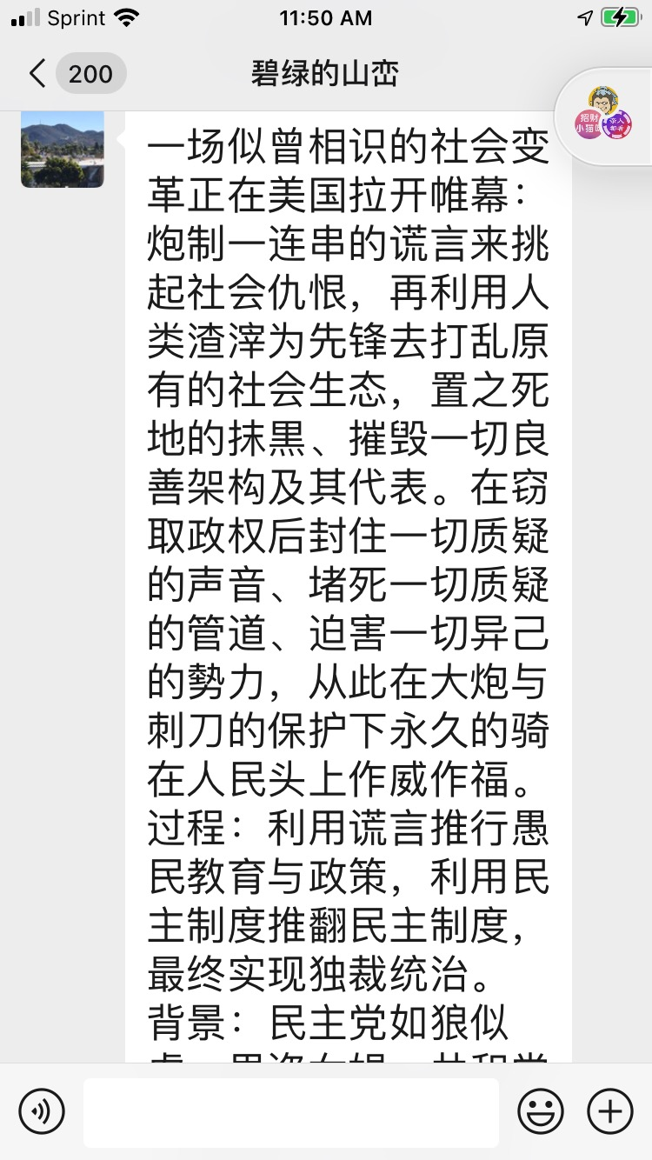
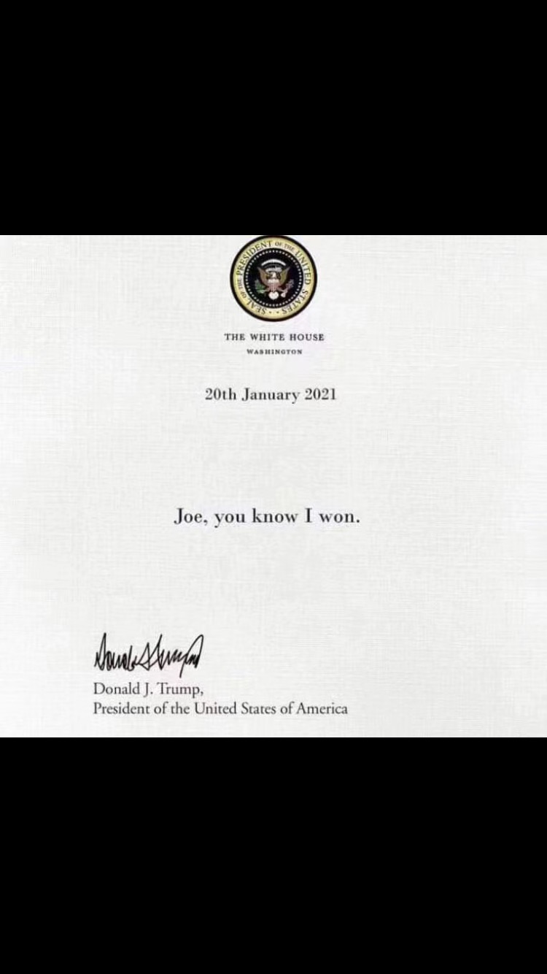
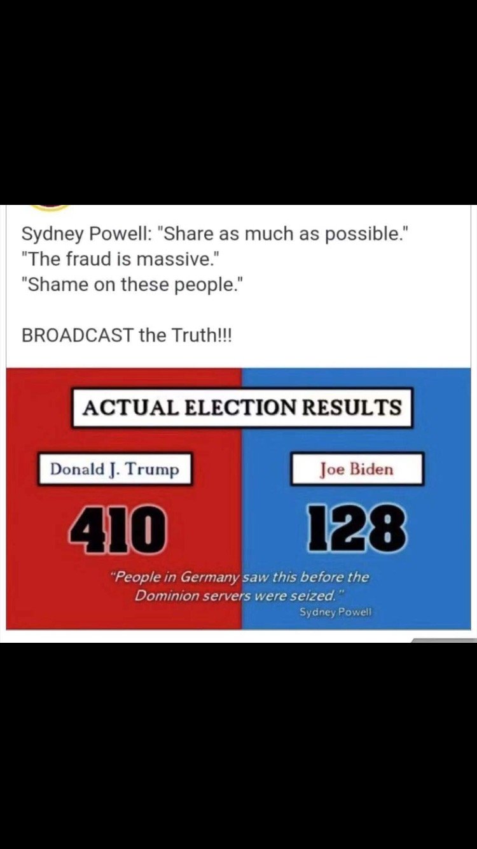

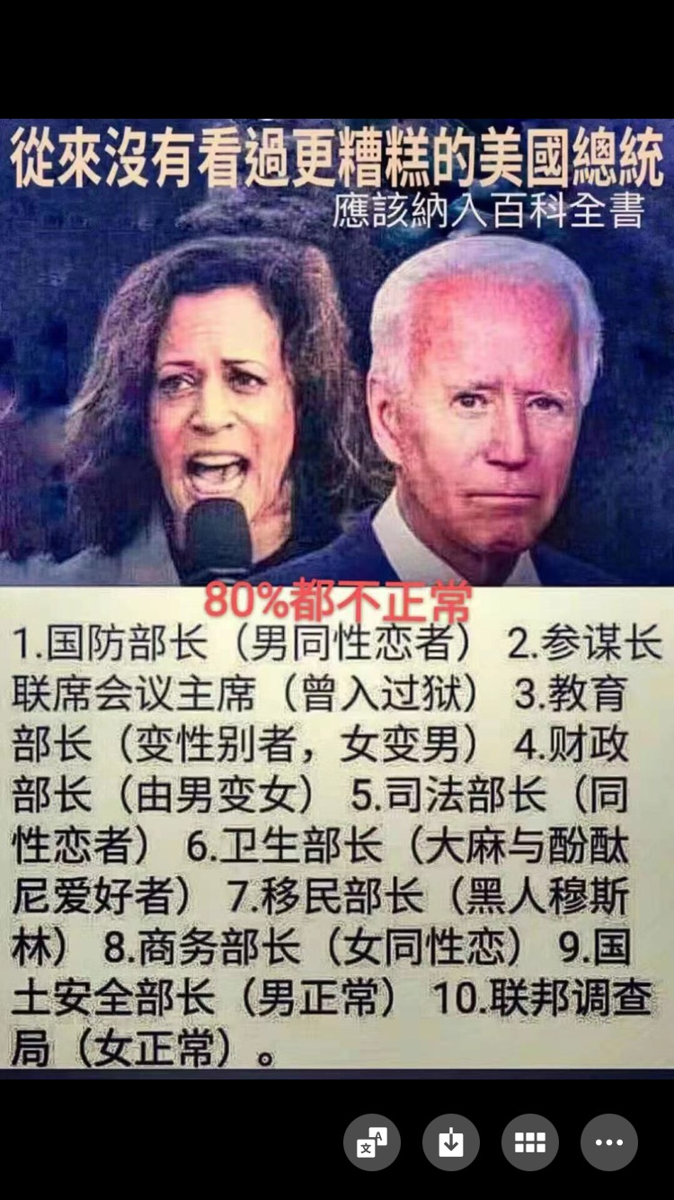
January 29, 2021 Journal article Open Access

A Bayesian analysis concludes beyond a reasonable doubt that SARS-CoV-2 is not a natural zoonosis but instead is laboratory derived
Quay MD PhD, Steven Carl
A Bayesian analysis concludes beyond a reasonable doubt that SARS-CoV-2 is not a natural zoonosis but instead is laboratory derived.
Preview
Files (14.9 MB)
Name | Size
SQuay_Bayesian Analysis of SARS-CoV-2 FINAL V.2.pdf

痛骂川黑
Original 西奈山峰 洛克杂谭 Yesterday 1-25-2021
点击上方 洛克杂谭 关注我

即使真把自己的票投给拜哈的，也基本没有真的喜欢这二货的，他们只是讨厌川普而已，即川黑。
要知道人类较复杂的价值观尽管千奇百怪，但是某些基本审美本能还是高度一致的，如果遇到喜欢其子乱搞、本人痴呆，盗抢950美元以下不判罪，小三上位成高官的人，你必须远离，这就是传说中的垃圾人无疑。
这种人之所以能够无视拜哈团伙那些垃圾行为，可以解释为做大事不拘小节，只要其政策是好的，一些个人品行的小节就可以忽略不计。并且选举反映的是多数民众的意见，多数民众愿意选这样的人，那是民意，是福是祸是垃圾，都与别国人无关，说不定某时某地的恶行，有朝一日能成为人类普遍标准呢。
不过有些东西却不会因国家不同就应该得到尊重的，那就是真与伪的问题。父子腐败、小三上位之人成为大统领，我们可以理解为我们自己智慧不够、爱心不够、道德偏狭、目光浅短……好吧，这些我们都忽略不计，但是如果他们大统领的位子是靠Ｂ选得到的，那性质就彻底变了。
投票之前，对手间的互相攻击、拆台、甚至谩骂揭老底曝丑闻，都属正常，这个过程也是让选民充分看清双方真面目的必需。道德和政治永远都有争议，父子腐败和小三上位都会有人叫好，更何况非法移民、黑命金贵、大麻合法这些事呢？
但这一切都要止步于开始投票，因为道德和政治议题永远混乱争议，而算术问题却是永远公正清晰。
２+２＝４，就是先天地生的无可置疑的真理。
一个人可以因为价值观不同而接受父子腐败、小三上位，甚至他们能把自己的这种行为解释成深谋远虑、自由平等博爱；但如果这个人为了让自己和别人接受父子腐败、小三上位以及他的深谋远虑，连２+２＝４这样的问题都敢否定，那么此人就是应该一棍子打死喂狗的纯牌人渣。
不幸的是，我写美选的原创文章后面就来了一个这样的人渣。看看它的高见；

听闻这样的人渣很多很多，包括一些所谓的法学教授。这个人渣的留言有点儿代表性，就是千方百计把清晰肯定的２+２＝４的问题，扯蛋成争议混乱的道德和政治问题。
米国是不是一个法治社会？那里的法律能不能相信？到底有多少登记选民？为什么短短两年时间众议院就被翻盘？为什么铁杆深红的佐治亚的参议院议席会丢掉而导致丢了参议院？为什么共和党把持一切的那些红州也会被翻蓝？为什么法庭不认可那些“事实”？
这些问题都可以不管，每个问题都会有贺、雪、帆那样的弹头学者扯出一套书的理论分析，他们都有足够的能力，把父子腐败、老年痴呆、小三上位这样的现象，论证成民心所向、道德升华、文明进步，更不用说把上述问题论成板上钉钉、无可置疑、伟大正确了。
跟这帮渣货争论这些问题你就输了，因为他们的目的就是引你忽略２+２＝４这样的前提，直接把你置于２+２＝胡说八道的粪坑里去。
什么是２+２＝４？就是选举日深夜，６个关键州同时停止计票，然后同时以败灯曲线的姿势翻蓝。
６个+关键州+同时+停止计票+同时翻蓝，请初中数学水平的人用一秒钟估算一下，如果不是人为的，出现这种情况的概率有多少？
不解决这个问题，想让我跳过这个问题跟你扯什么美国法律、参众两院、拜川优劣、政治道德、全球变暖、种族问题、同性婚姻……这就是坏Ｂ+傻Ｂ＝２Ｂ呀，滚你母亲的臭鸭蛋去吧！
精彩阅读为什么说“丢了洛克，就丢了美国”白左川普为何最反白左？谁来拯救这位法学家的大脑老川四年得与失谁撕裂了美国川普不是摩西，他比摩西还难

THIS REALLY PISSES ME OFF!

Biden to Cancel Trump’s 1776 Commission That Promotes American Founding Values
BY GQ PAN

January 20, 2021 Updated: January 20, 2021biggersmaller
President Joe Biden plans to cancel the Trump administration’s 1776 Commission, only two days after the advisory panel released a report calling for a U.S. history education centered on the nation’s founding principles.
Biden, who was inaugurated on Wednesday, is expected to sign 17 executive actions, according to a press release. A number of those actions are a direct reversal of Trump-era policies, including the travel ban on seven predominantly Muslim countries, the construction of barriers along the U.S.-Mexican border, and the 1776 Commission to promote a “patriotic education.”
Through his day 1 executive order, Biden will “rescind the Trump administration’s 1776 Commission,” which “has sought to erase America’s history of racial injustice,” the Biden-Harris tradition team said in a press release.
Formed last September by then-President Donald Trump, the 1776 Commission is commonly seen as a direct response to New York Times’ 1619 Project, which portrays the United States as an inherently racist nation. The Pulitzer Prize-winning project consists of a collection of essays that argue, among many other controversial claims, that the primary reason for the American Revolution was to preserve slavery.
The commission, led by a number of prominent scholars including Larry Arnn, Victor David Hanson, and Charles Kesler, released its first report (pdf) this Monday. The report calls for a “national renewal” of education to teach future U.S. citizens the founding principles enshrined in the Declaration of Independence and the Constitution, and identified historical and modern challenges to those key principles.
“Neither America nor any other nation has perfectly lived up to the universal truths of equality, liberty, justice, and government by consent,” the report reads. “But no nation before America ever dared state those truths as the formal basis for its politics, and none has strived harder, or done more, to achieve them.”
U.S. colleges and universities, the report warns, have become “hotbeds of anti-Americanism, libel, and censorship,” with the intention to “manipulate opinions more than educate minds.”
The 1776 report specifically calls out historian Howard Zinn and the 1619 Project for preventing students from seeing the humanity, goodness, and benevolence in America’s historical figures. Young readers are instead being presented with a distorted version of U.S. history, according to the 1776 report.
“Historical revisionism that tramples honest scholarship and historical truth, shames Americans by highlighting only the sins of their ancestors, and teaches claims of systemic racism that can only be eliminated by more discrimination, is an ideology intended to manipulate opinions more than educate minds,” the report reads.
The 1776 report was removed from the White House website following the presidential transition. It can still be found on the archived Trump White House website.

BREAKING EXCLUSIVE: Arizona’s Maricopa Board of Supervisors Is Playing Games – Trying to Block a LEGITIMATE Forensic Audit of 2020 Election Ballots – Why?
By Joe Hoft
Published January 22, 2021 at 5:41pm
836 Comments



What is going on in Arizona? After finally obtaining the right to audit the ballots in Maricopa County, those in power refuse to move forward and allow an audit by a legitimate forensic auditor.

Their actions show their desire to hide invalid ballots rather than identify any issues with the 2020 election in Arizona.
Advertisement - story continues below
We reported on December 30th that concerned citizens in Maricopa County in Arizona got together to look into the election fraud in their state. They performed data analysis and found between 160,000 to 400,000 ‘Phantom’ Ballots and performed door to door canvasing and found up to 30% of the addresses they looked at were fraudulent. Their results were shocking. Liz Harris introduced the project :
00:43 01:28
TRENDING: JUST IN: Chief Justice Roberts Will Not Preside Over Trump Senate Impeachment Trial - Instead It Will Be Democrat Leahy
The Arizona legislature held a hearing in December to discuss the various findings and accusations related to the election in Maricopa County and soon after the hearing the Senate subpoenaed the county. The County Board of Supervisors, who oversee the election in the county, sued the Senate to prevent the audit. Below are the Maricopa Board of Supervisors:
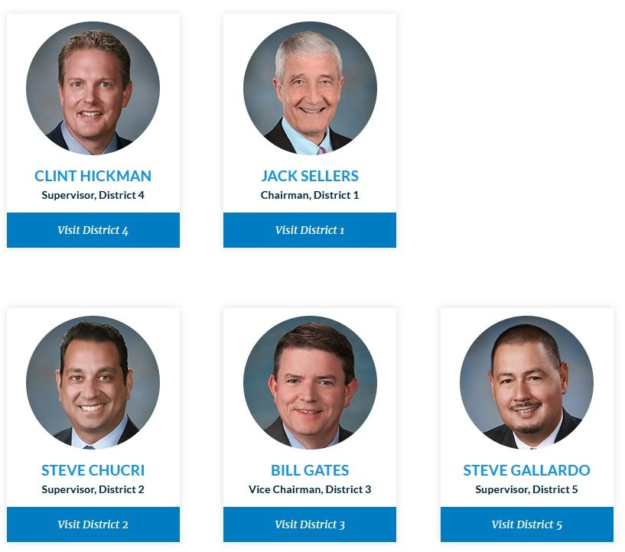
Advertisement - story continues below
But then the following occurred:
The county sued [weeks ago], claiming the Legislature lacked authority to examine ballots. But on Wednesday, the county dropped its opposition, acknowledging the Legislature’s authority. Fann said the county has agreed to turn over all requested materials, provided the auditor is certified by the U.S. Election Assistance Commission and that only authorized parties will have access to the data.
Unfortunately this was all another ruse to prevent an adequate review of the ballots and images in Maricopa County.
According to an interview with Liz Harris, what the Board is not saying is that they want to select who performs the audit of their ballots because they can then prevent the things they don’t want reported through this auditor selection process. Hickman, Sellers and Gates are all Republicans. Gallardo is a Democrat.

Harris asks, “Why would the Board of Supervisors do this?“
Advertisement - story continues below
Harris says that she is afraid the people of Arizona won’t understand the fact that these same people who prevented the forensic audit in the first place want to mandate that the auditor be from the same group that blessed the Dominion machines (the US Election Assistance Commission). She says, “Why does the Board not want to find fraud if there is fraud that exists.

We at the TGP have recommended for months that inventor and expert, Jovan Hutton Pulitzer, should be forensically auditing all the swing states results.
Pulitzer is willing to do this basically for free. He has a process and therefore there is no reason not to use this outsider to review these results of ballots, unless of course you are trying to hide something!
Advertisement - story continues below
At the state level, there have also been roadblocks. Karen Fann, the President of the Senate, Warren Peterson, Chair of the Arizona Judiciary Committee, and Michelle Ugenti-Rita, the Senator involved in Election issues, all need to step to the plate.
Why not have Pulitzer perform the audit alongside the chosen auditor by the Board of Supervisors, since Pultizer will do it basically for free?

Americans are upset. There is an incredible amount of evidence of fraud in Maricopa County Arizona alone. Americans need to see the evidence that the election was fair and free.

Right now it looks like it was not – at least not in Arizona for sure.
Advertisement - story continues below

Americans demand an official audit of the ballots!


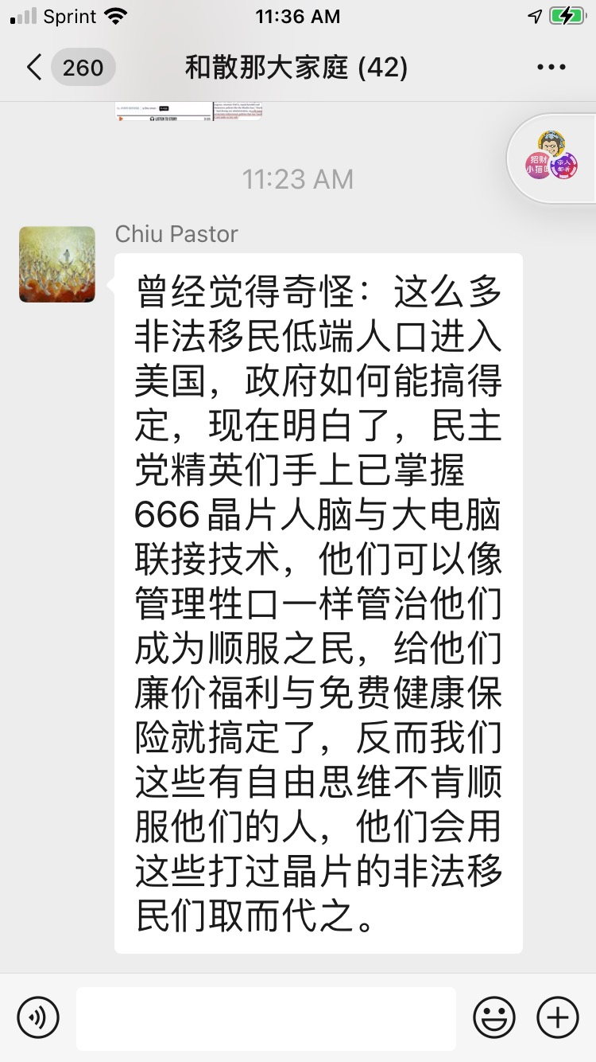

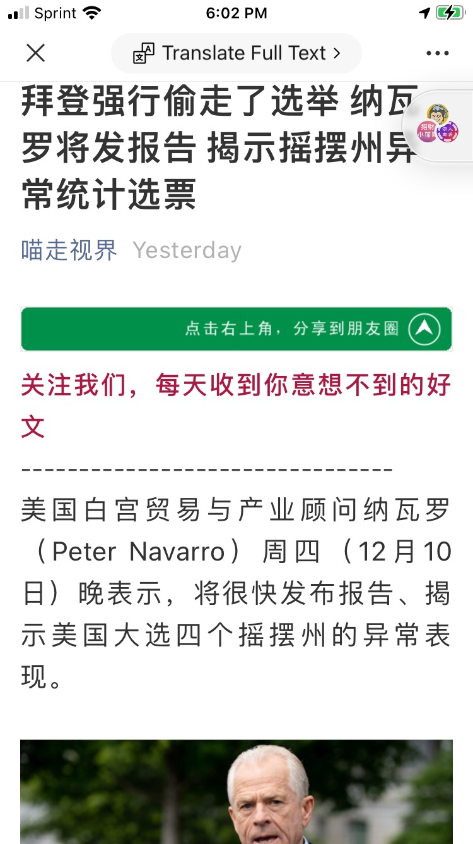

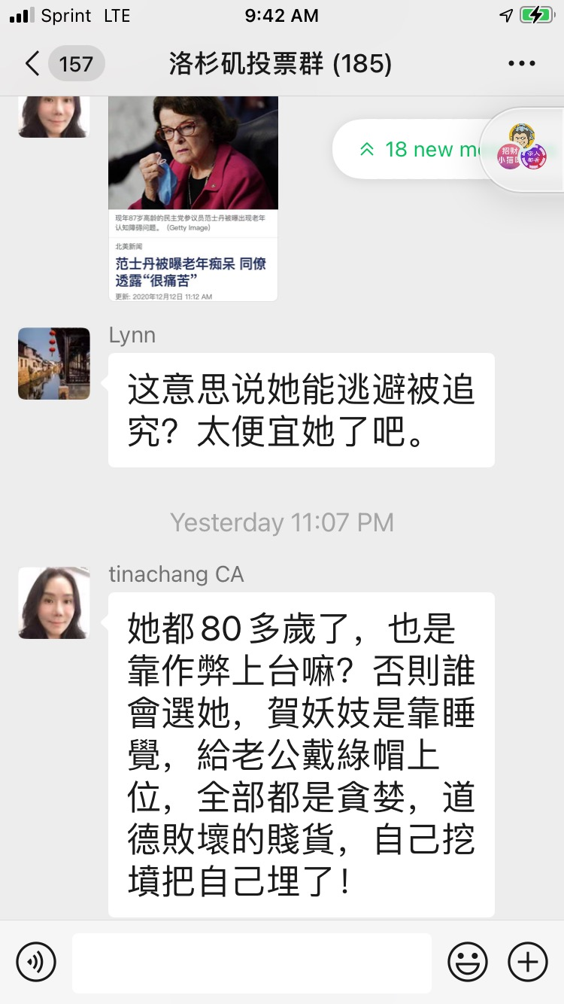

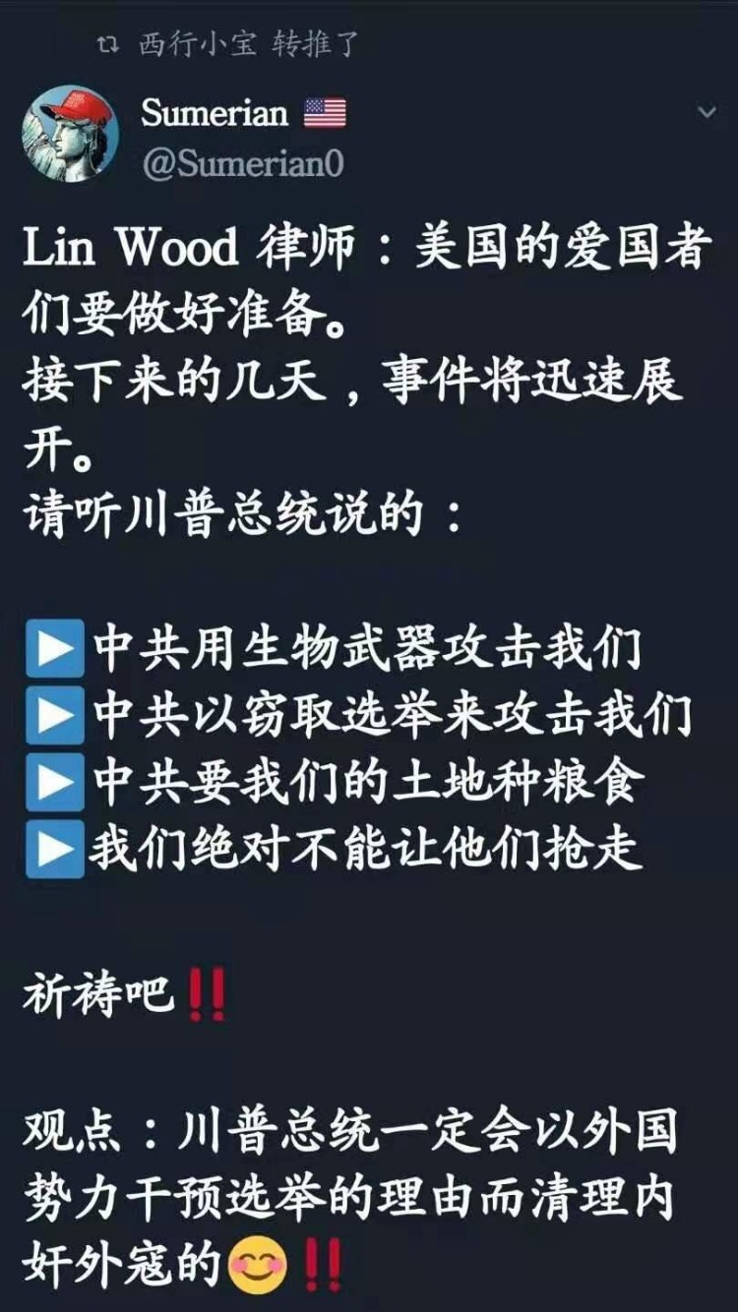






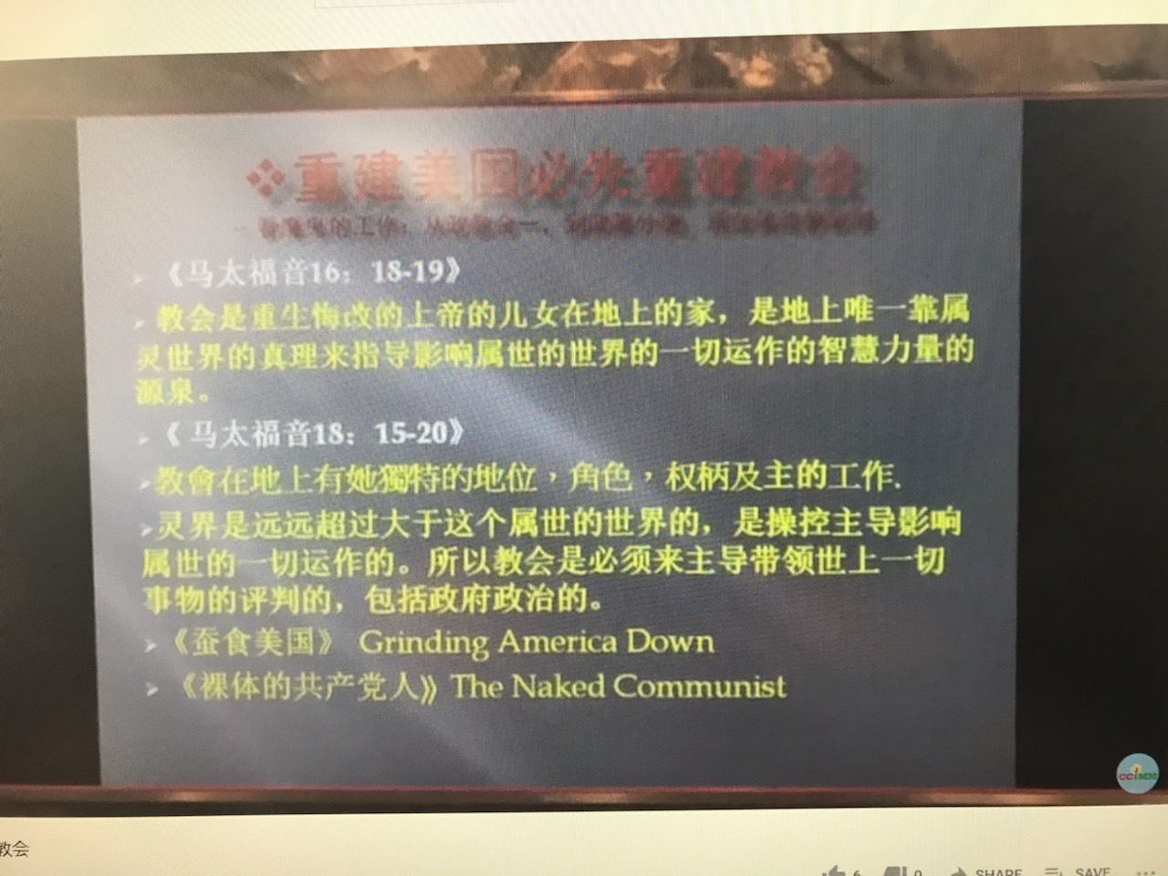
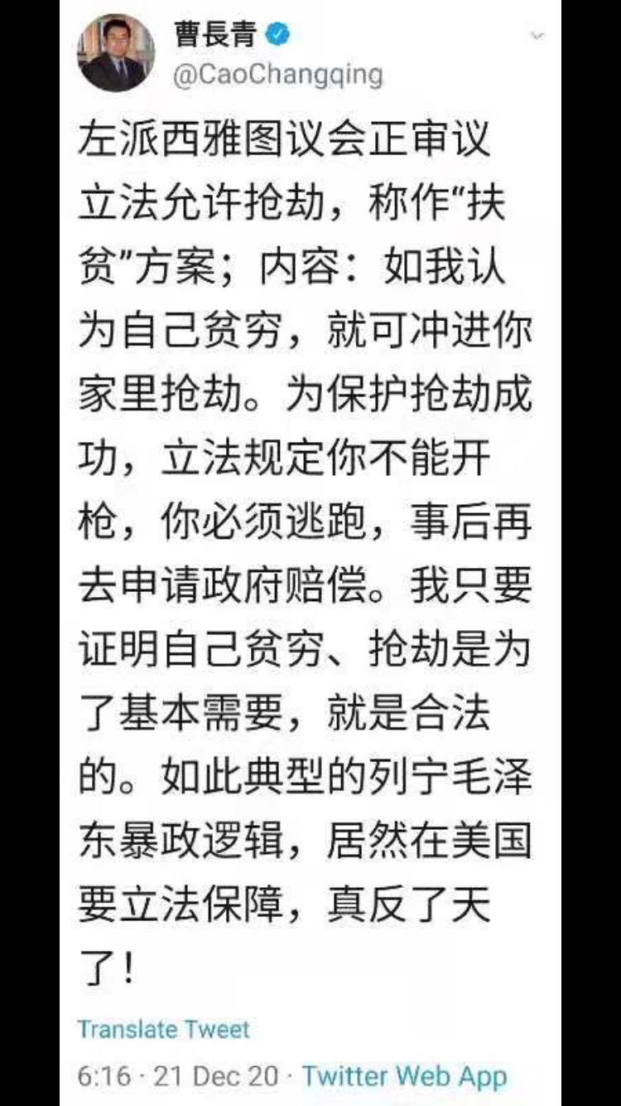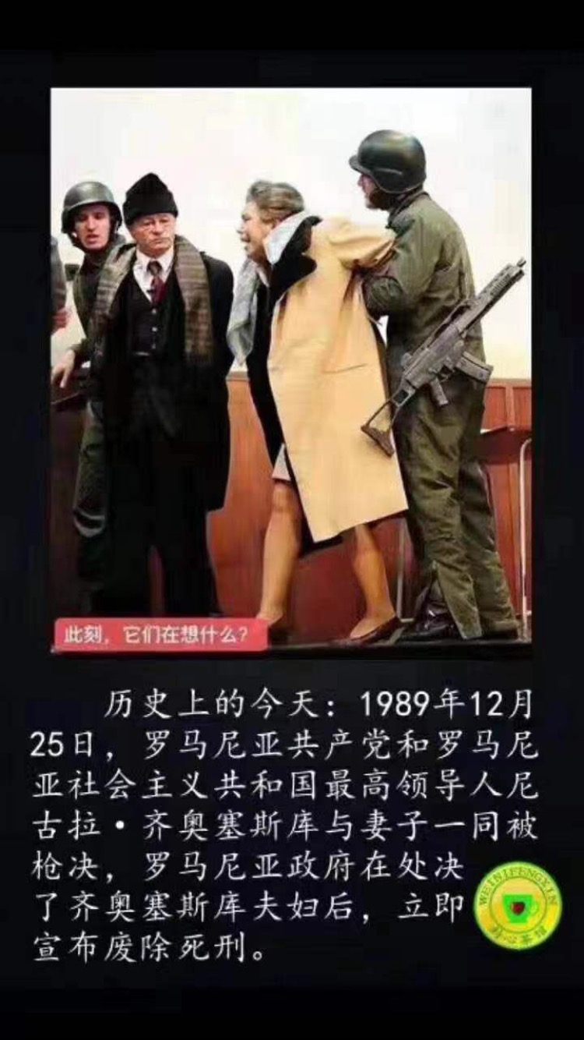

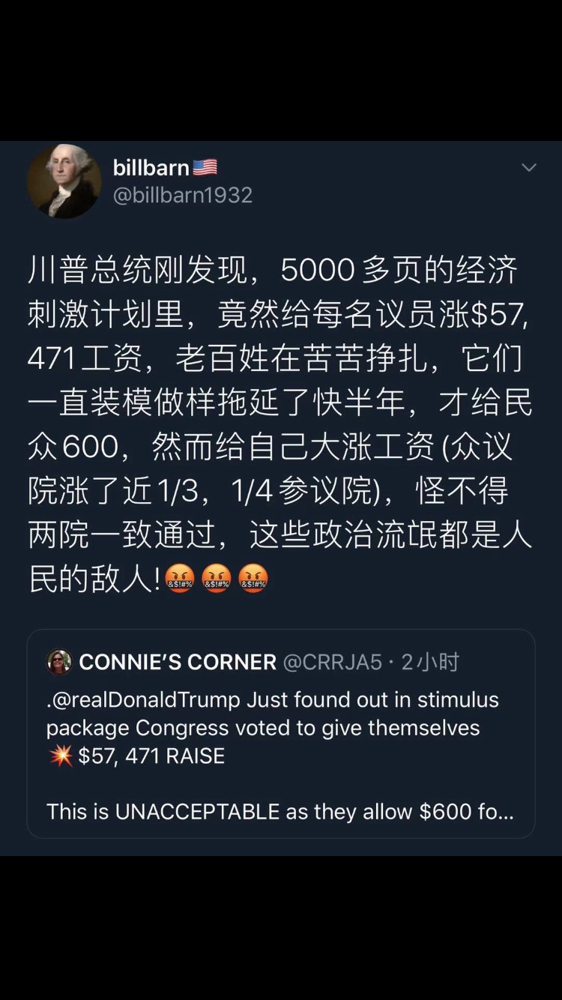

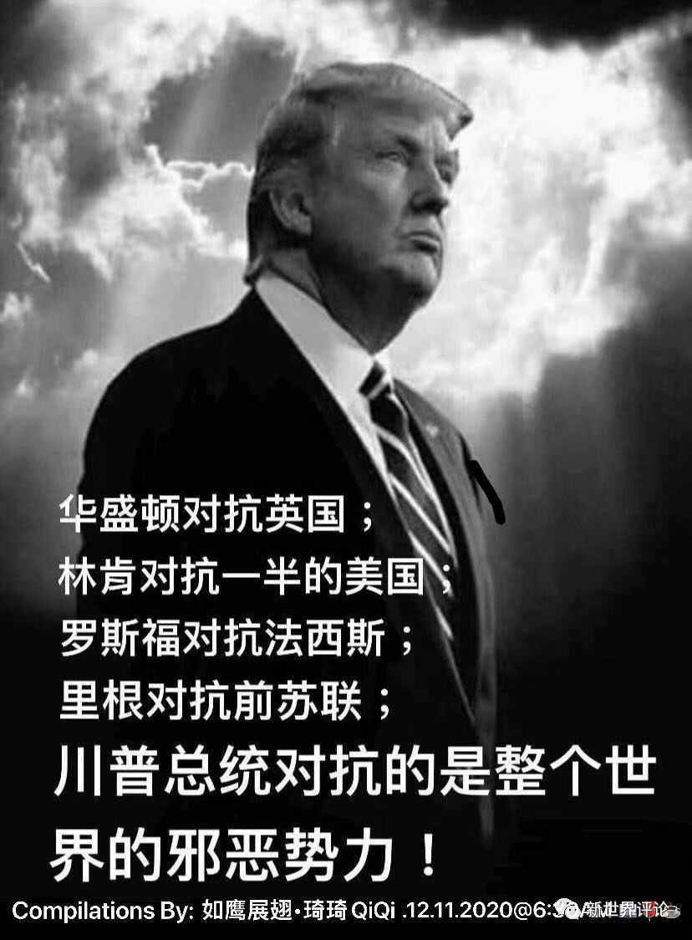

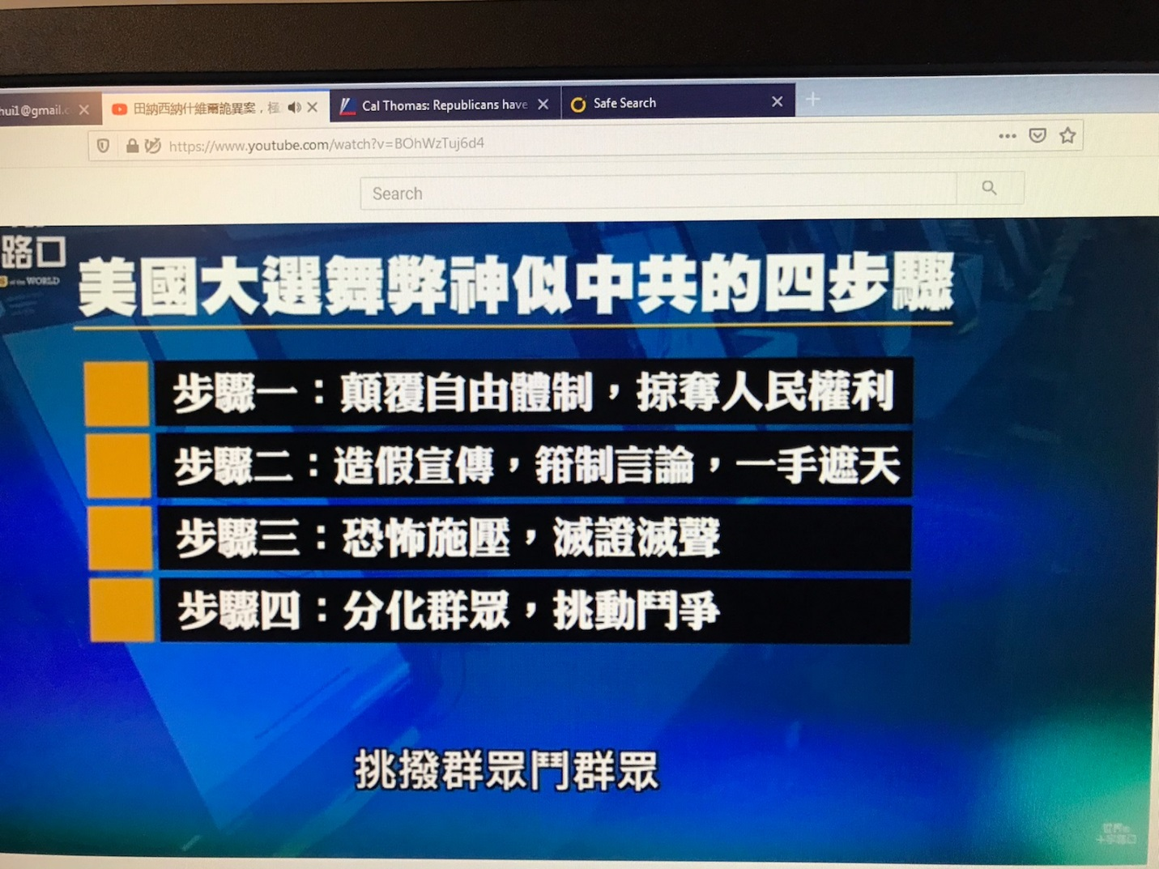

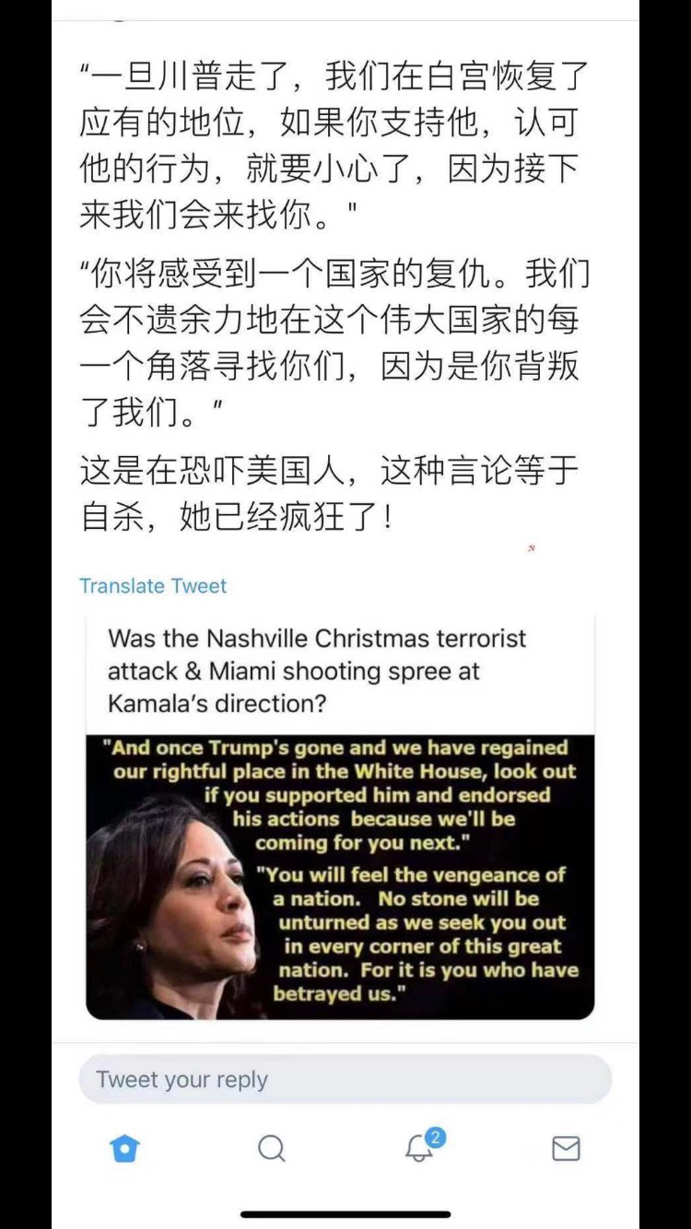
From:
Date: January 23, 2021 at 8:01:47 PM PST
To:
Subject: China's 2020 Election Interference

China’s 2020 Election Interference
How the Chinese Communist Party sought to interfere with the US presidential election

January 6, 2021 Updated: January 7, 2021
biggersmaller
For the Chinese Communist Party (CCP), the 2020 presidential election in the United States was always a life and death struggle.
For the first time in decades, a U.S. administration had confronted the CCP’s subversion and infiltration of the United States, curtailing its expanding global influence.
The CCP made clear through its state-run media that it favored a presidency under Democratic Party candidate Joe Biden, because he would be “smoother” to deal with than President Donald Trump.
Beijing interfered in the 2020 election in multiple ways, and the regime was able to do this because it has, for decades, studied our society and form of government. It has systematically exploited all weaknesses in our system.

Using the Virus to Weaken America
The CCP covered up the spread of the CCP virus in Wuhan, allowing it to spread throughout China and the rest of the world. Trump defied early WHO recommendations and, on Jan. 31 last year, banned all travel from China. Chinese state media, as well as U.S. media and politicians, portrayed Trump’s move as “racist” and “xenophobic.” State-media Xinhua wrote on Twitter on March 16, “Racism is not the right tool to cover your own incompetence.” As the pandemic progressed, both Chinese state media and U.S. media continuously attacked Trump and his administration, accusing them of being incapable. Meanwhile, left-leaning politicians and governors in the United States adopted Chinese-style lockdowns of cities, which brought local economies to a halt.

Mail-In Ballots as a Result of CCP Virus
As a result of the CCP covering up the initial outbreak, the virus spread around the world and sparked a global pandemic. Due to pandemic-related precautions, many states expanded the use of mail-in ballots. This type of voting, which is prone to fraud, would become the focal point of voter fraud allegations in the fallout of the 2020 election.

Voter Registration Drives
The Chinese Progressive Association has close ties to the Chinese Consulate in San Francisco. Many of its former executives, as well as other pro-Beijing leftists, are now involved with the “Seed the Vote” initiative. The goal of the group was to defeat Trump and win more Democratic seats in the U.S. Senate. Their activities specifically targeted seven swing states: Arizona, Georgia, North Carolina, Florida, Michigan, Wisconsin, and Pennsylvania.

Pro-Beijing Groups Involved in Riots
Pro-CCP group Chinese Progressive Association funds the Black Futures Lab, which shares a principal organizer with the Black Lives Matter movement. Many of the protests and riots that swept across U.S. cities in 2020 had the involvement of pro-CCP groups, such as the Freedom Road Socialist Organization and Liberation Road, as well as Antifa and the BLM movement. One of the effects of the riots was a weakening of the president’s authority in the country as well as intimidation of his supporters. After the Nov. 3 election, amid challenges raised to the election results, the threat of similar riots resulted in the intimidation of state legislatures, lawmakers, and judges. After Sen. Josh Hawley (R-Mo.) announced that he would oppose the Electoral College vote in Congress, Antifa members threatened his family at their Washington home.

Chinese Influence Over US Politicians
For decades, the CCP has sought to subvert and control politicians, policymakers, and influencers in academia. One such case came to the surface when it was revealed that Rep. Eric Swalwell (D-Calif.) had close ties to an alleged Chinese spy. The CCP uses a wide variety of incentives and disincentives to persuade U.S. policymakers to do its bidding, and it ranks all U.S. governors according to how friendly or hostile they are to the CCP. In Georgia, a key battleground state, the governor has maintained friendly ties with Chinese dignitaries. In April last year, Li Qiangmin, then Chinese consul general in Houston, was invited to an event hosted by the governor, where Li praised him for “proactively pushing for cooperation with China,” according to a press release by China’s Ministry of Foreign Affairs. China has been Georgia’s largest trading partner for the past five years.

CCP Virus Propaganda Campaign
In February 2020, as the CCP virus spread around the world, Beijing started a large-scale propaganda campaign that sought to portray the CCP as a global leader in fighting the pandemic. Authorities simultaneously bought up protective equipment from the United States and other countries, and halted exports of Chinese-manufactured medical goods. As COVID-19 cases increased in the United States, the CCP actively portrayed the United States as a disaster zone with large numbers of deaths, while simultaneously covering up China’s own death toll. Beijing’s propaganda sought to portray the CCP as a savior of humanity, while casting doubt on Americans’ confidence in Trump’s leadership. This narrative was amplified by Chinese state media, as well as paid articles in U.S. media.

Chinese Parts in US Voting Machines
Voting system manufacturers use Chinese-manufactured parts. Using Chinese parts makes the machines vulnerable to hacking, exemplified by past examples of Chinese-made electronics containing backdoors in either the hardware or firmware. Due to a lack of forensic audits of voting systems, it remains unclear at this point whether any potential backdoors were used by China to access U.S. voting machines. Voting machine companies have denied that their systems are vulnerable to hacking. Also, any device connected to the internet on the same WiFi system as voting equipment poses a hacking risk. In Georgia, Jovan Hutton Pulitzer, an inventor and IT expert, raised concerns about devices such as a “cheap Chinese smart TV with WiFi” or a thermostat connected to the internet that creates vulnerabilities in the entire system.

Use of Social Media to Influence Election
Facebook in September shut down more than 180 fake Facebook accounts, groups, and pages, and Instagram accounts, that the company determined to be run in China. These accounts had posted content on the U.S. presidential election and spread Beijing’s talking points on a range of topics, from the South China Sea to the Hong Kong democracy protests. The U.S. social media giant announced the takedown in a blog post published on Sept. 22, saying that these accounts were in violation of its rule against “coordinated inauthentic behavior on behalf of a foreign or government entity.”

Use of Political Warfare
The CCP has deployed political warfare to covertly influence free societies around the world, as a top U.S. State Department official warned less than a week before the Nov. 3 election. The regime “wants control, or at least veto power, over public discourse and political decisions the world over,” David Stilwell, assistant secretary of state for East Asian and Pacific affairs, said. The CCP accomplishes this through a wide array of malign activities that are “covert, coercive, and corrupting.” These activities are dubbed by the CCP as “United Front work” but better understood in the West as political warfare, Stilwell said.

Spread of Propaganda
Chinese state-controlled media, including those operating in the United States, spread the regime’s propaganda on its behalf. These media made it explicit that they supported a Biden presidency over Trump. State-run outlet Global Times, for example, published an article on Aug. 19 that suggested that Biden would be “smoother” for the regime to deal with than Trump. And when the U.S. vice presidential debate was broadcast in China on Oct. 7, state-run media censored the discussion of sensitive topics related to China, in an effort to manipulate public opinion and push Beijing’s narrative. Meanwhile, China Daily, in many English-language articles, such as one headlined “Virus Surge Sharpens Choice for US Voters,” sought to amplify Biden’s platform on containing the pandemic, while portraying Trump’s CCP virus policies as incompetent.

Fake IDs
During the first six months of 2020, Customs and Border Protection agents seized nearly 20,000 fake driver’s licenses, most of them from China. It is unclear how many fake IDs may have been sent to the United States from China and gone undetected. Fake IDs can be used for a wide variety of purposes, including voter fraud.

Influencing the Vote of Chinese-Americans
Part of the focus of China’s United Front Work Department is on developing ties with Chinese fraternal organizations, which work as unofficial representative bodies of overseas Chinese communities. The CCP maintains close relations or direct control over many such groups. These groups influence who their members, which in some cases amount to tens of thousands, vote for.

Influence Over US Media
The CCP has worked for years to increase its influence over U.S. media organizations. Each year, Chinese state-owned media spend millions of dollars to insert their propaganda into publications such as The New York Times, The Wall Street Journal, and The Washington Post. A recent list published by the National Pulse based on FARA filings shows most major U.S. media organizations received “familiarization trips” and “private dinners” from a group that is part of the CCP’s United Work Front.

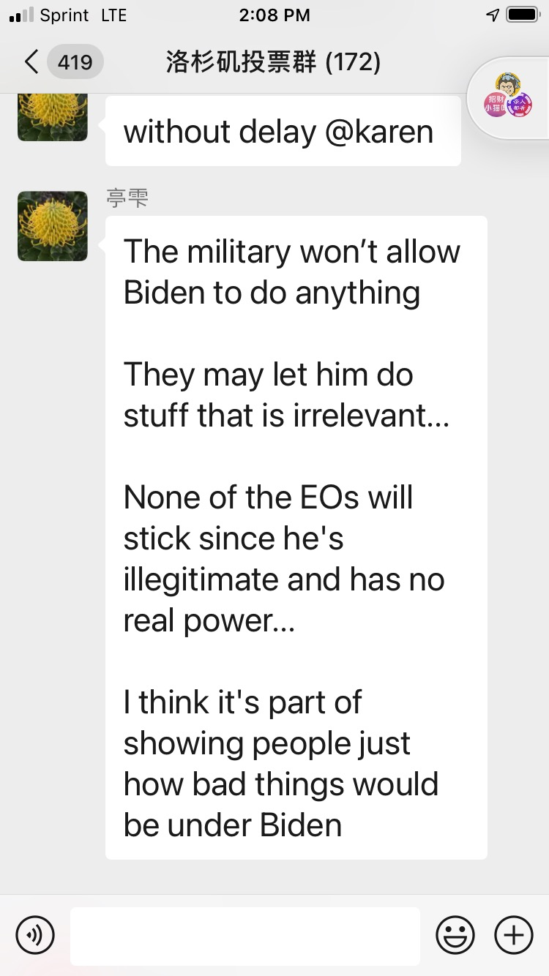

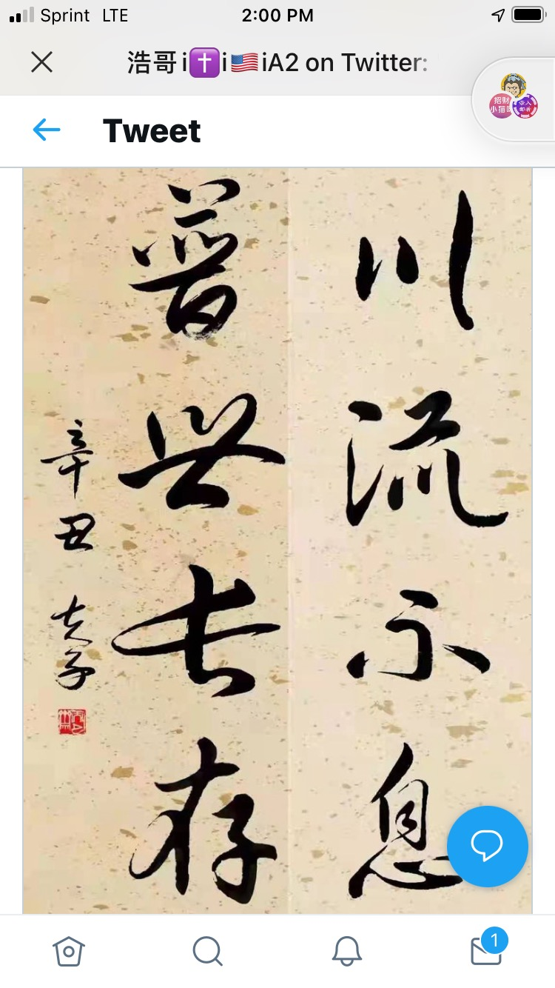

分享我的禱告 Day 3

 | 5:39 PM (4 hours ago)
  Will Shao
1-21-2021

親愛主：

昨天褻慢人偽總統坐上了寶座，今天你的僕人川普渡過了離任後的第一天。近處遠處愛你的人們痛心萬狀，眼睜睜看著魔鬼勢力在你建立的美國正式掌權作王！主啊，這一切你看到了，你也讓它發生了，究竟為了什麼？我們雖然知道黑暗勝過光明是暫時的，但褻瀆你名的現在反而得意狂歡，你任憑它要到幾時呢？今天世界能有這位一心努力想做對的事的川普已經難得，何況他一反其他總統當了一國之君反而放下世界好處，力輓狂瀾努力把美國奪回歸向你幾乎殉道。現在他滿身箭傷、心力交瘁，你就讓他揣了四年的四塊美金解甲歸田嗎？

然而，孩子雖然不解，但還是知道你是遍察全地、全知全能的主。你也告訴我們，你讓萬事互相効力，是讓愛你的人得益處。那麼，孩子甘願停住抱怨，轉向感恩，感謝你為了我們的好處，沒有照我們這些日子所求的，而是照你自己意思，讓一個個事件發生，阿們！

主啊，孩子雖然不過是人，對你的智慧無從確知，但還願意求你幫助讓我揣摸你這次要我們學什麼功課？你告訴我們魔鬼爭奪人類從伊甸園起初就已開始，美國墮落到今天應該也非一日之寒。莫非在建國之初，魔鬼已經埋下了定時炸彈？你是否要借我们今天所見痛定思痛，回想如何一步步入了魔鬼圈套？

美國社會的確問題深重，今天黑白種族衝突是否因當初先父們「好意」而擅改上帝對各族計劃和主僕關係而今天自食其果？今天女權運動是否始於當初歐洲式尊重女性但漸漸越過上帝所設界限反使女性受害而不自知？今天性混亂是否也因當初不顧上帝所惡，因自義而寬容，終達眼下不可收拾地步？面對這些和其他更多問題，人自以為聰敏的方法可謂用盡，非但未見好轉，反而越理越亂。謝謝你提醒，除非今天重回聖經，請教造我們的上帝才能找到我們病因。主啊，求你讓更多人放下自義回轉向你！

社會出了毛病，教會也許病得更重，因為我們失了鹽味，不再照亮世界。二百多年前先父們從歐洲把信仰帶到美洲並以此立為建國之本，並得到你大大祝福。教會也大大興旺，不但造亮美國更把福音帶到全球。但曾幾何時我們漸離了你，我們開始把你當各種學問中一個研究並發明人意解經。我們不理會你的生命冊，擅自宣告人的得救。我們許多的禱告成了向你開單索取，好象你倒是僕人。我們熱衷各種節目，坐下吃喝起來玩耍，建築越來越大，十架卻越縮越小。更糟糕的是我們向世界妥協，我們遵守世界對種族、女權、亂性等等規則，卻羞於傳講你是怎麼說的……感謝你今天向我們吹角，教會若不悔改，等火滅了這地，你卻要向我們問責！

主啊，感謝你借著讓我們走到美國眼下的絕路，好讓我們不得不呼求你。你借所多瑪日子的逼近，讓我們教會、社會痛心悔改。求你照著你應許決不輕看痛悔的心，再給我們一次機會，好讓你多留存幾個不向巴力屈膝的人，以至美國這地能逃脫你的烈火。求你聽我們同心禱告，阿們！

~ Will ~
William E. Shao

sharing with you my day 4 fasting prayer

Will Shao |  |  | Jan 7, 2021, 10:03 PM (21 hours ago)
親愛天父：

今天這個美國歷史上最黑暗的日子真的來臨了，魔鬼幾十年、可能幾百年摧毀這個以祢的名撐起的國家終於坍塌了，我們此刻看到大魔鬼和它的小魔鬼們正在放肆狂笑，而祢的兒女心裡滴血如注！

這個世界里我們無法訢說我們的痛苦。謝謝天父，祢永遠樂意我們到祢面前，今天孩子們就俯伏向祢，說說我們心裡話：

我們雖然不好，但必竟還是願從魔鬼手裡逃脫投靠了你，我們中就有這樣一位弟兄。他和我們一樣只是祢的嬰孩，信仰道路也跌跌撞撞，但和我們不一樣的是四年前祢立他成了我們總統。當時很多人不明白為什麼祢選了這個毫無從政經驗且言語粗俗的人成了一國之君，後來慢慢知道因為這個國家越來越離棄祢，祢用祂扭轉局面。

這位兄弟果然是個勇士，一上台就挺身而出剎住了這個即將一頭墜入懸崖的龐然大車，坐在車上的我們感謝他為他拍手叫好，想不到許多人為他的仗義勇為咬牙切齒，他們那時起就謀劃了一個最最陰險、最最狼毒的計劃要把他推下駕駛座。四年來他們聯合起來各就各位萬箭一起射向這位勇士，今天這個日子就是他們狂歡勇士終於渾身是血垂下了手，他們急不可待奪過方向盤，重新衝向懸崖！

雖說這一切祢看得比我們更清楚，我們還是要說，因我們實在不明白為什麼會有這樣的事發生？這位弟兄雖然我們不敢說是個義人，因為祢說沒有一個義人，但他必竟有意做一個義人，並且非常努力。他為了讓這國掉頭以至重回立國初的樣子，一上任就把白宮前任留下的、祢憎惡的異教偶像除出白宮。他愛祢所愛把使館遷到耶路撒冷這個祢眼中的瞳仁，一舉完成好幾任總統不敢做的。他體恤勞工們的苦楚，把工作從那些肥胖的貪婪人手中奪回還給祢教導我們給一杯涼水的「小子們」，而他們也正是當今美國僅存的「聖經帶」里僅存的清教徒後人並以勤勞工作為榮。我們的弟兄在那些靠不勞而獲且褻瀆祢名的人欲燒毀祢殿時又一次站出來力輓狂瀾，在眾人順服政治正確向歹徒下跪時，他站起來高舉聖經勇敢認祢的名……

他做的還有很多很多，祢都看到。而他今天遭遇的不公祢也知道，而且還是祢允許的。我們不能說他做得完美，但比我們中許多人好許多，必竟他盡了努力來實踐祢的教導，難到會不討你喜悅嗎？

要緊的是：今天在這個國家發生的標誌著她已被惡者劫持，正式踏入世界最邪惡的共產主義，好不容易四年的起色竟毀於一旦！最最要緊的是祢的名將遭更大褻瀆，這個當初的山巔之城將成眾國的嗤笑。雖然我們明知祢讓這些發生定有自己美意，因我們不過是人不明靈界的究里，還是要從我們卑微的地位求祢在此危急時刻讓奇跡發生局面得翻轉，讓我們這位弟兄再任四年，因為祢說在祢沒有難成的事！以至讓愛祢的人得安慰，讓褻慢人羞愧，把大小魔鬼捆綁，讓美國重回祢的笑臉！不過雖然我們如此求，還是願祢自己旨意成就！阿們！

~ Will ~
William E. Shao

【新聞大家談】極左組織頭目承認 闖國會 他在場
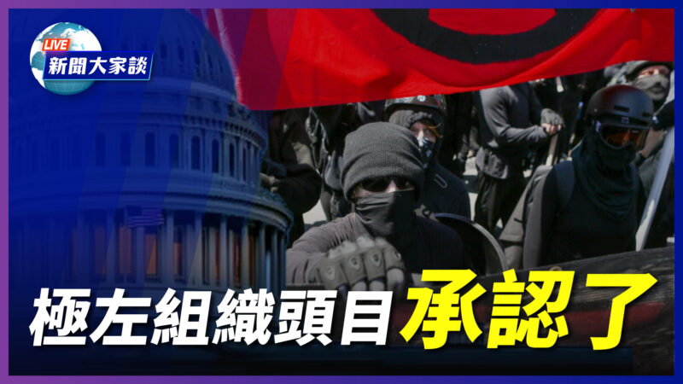極左組織頭目承認了，他在第一現場。（新聞大家談）
北京時間：2021-01-08 10:58
FacebookTwitterEmailPrintFont Size簡體
【新唐人北京時間2021年01月08日訊】 大家好，欢迎收看周五（1月8日）的《新闻大家谈》。今天焦点：极左组织头目承认了闯国会，他在第一现场；终局之牌意味深远，白宫正式表态，严厉谴责暴力冲击；美国驻联合国大使将访问台湾……
1、【极左组织头目承认了 闯国会 他在场】
犹他州KUTV2台，1月6号晚上采访了一名当天闯入国会的犹他州居民，是一名叫约翰·沙利文的26岁男青年。值得注意的是，沙利文不是川普（特朗普）的支持者，而是一名反川普者。他创立了一个名叫“美国叛乱（Insurgence USA）”的组织，该组织主张“种族争议”和“警察改革”，是去年BLM运动期间成立的一个团体。
沙利文的社交媒体Instagram显示，他常用的标签包括：BLM、Antifa、砸烧、解散警察、还有侮辱川普的词。现在，沙利文的Instagram账号已被删除。
我们查询沙利文的推特发现，他1月2号还在推特呼吁，所谓反法西斯者们6号到DC去。这被怀疑是向反川普的Antifa成员发出动员令。他的推特上一则视频，是一名蒙面者点火焚烧美国国旗。
6号，沙利文在接受KUTV2台采访时说，他周三从打破的窗户进入国会。当那名女抗议者被警察开枪打死时，沙利文就在她的旁边。他说：他看到她的眼睛没有了生机，知道她已经死了。
不过罕见的是，这个左翼成员为6号的抗议者辩护说：“抗议者并不是真的想烧掉任何东西，他们并不是真的想破坏任何东西，他们的主要动机是想进入会议厅。”
秦鹏、晓旭：有两个关注点，第一，这名反川普者为抗议者辩护？第二，冲击国会的时候他们为什么在现场？
2、【白宫正式表态 严厉谴责暴力冲击】
周四，白宫新闻发言人麦肯纳尼在记者会上，对冲击国会的行动进行谴责。
她说，周三发生的“暴力事件令人震惊，总统和本届政府给予最强烈的谴责”。“那些暴力围攻我们的国会大厦的人，是本届政府所代表的一切相反。本届政府的核心价值观是，所有公民都有权利在安全、和平和自由中生活。”
在这次声明中，白宫明确把冲击行动定义为暴力围攻。这和川普周三的表态有所不同。川普周三发布视频声明向支持者喊话说：“我知道你们很痛苦、很受伤……但你们现在该回家了。我们必须保持和平、维护法律与秩序，我们必须尊重执法人员，我们不希望任何人受伤。”
秦鹏、晓旭：怎么看这种变化？
3、【严峻现实 民主信心受损 美国何去何从】
我们不能否认，昨天进入国会的人群中有川普支持者。其中一些人对记者说，他们觉得，过去几年，保守派的声音一直被主流媒体和社交媒体压制；司法、行政、立法部门也受到左翼的影响或控制；左翼违法受到的惩戒特别轻微；奉行传统价值观的人觉得受到逆向歧视；尤其是大选期间，“主流群体”对选举舞弊的漠视，使这部分选民觉得自己的民意完全被漠视；所以他们想进入国会，告诉国会议员：请重视这一部分人的意见。
这种行为非常有争议，但不可忽视的是，它背后有一个严重的问题：一部分美国人可能对美国的民主制度失去了信心。
秦鹏、晓旭：现在主流媒体把这归罪到川普身上。你们怎么看？
周四，麦肯纳尼在记者会上说，川普团队正在努力确保有序的权力过渡，“现在是美国人团结起来，并肩而行，拒绝我们所看到的暴力的时候了。”
但是，谈到团结，现在美国政治极化非常严重，能找到共同点来弥合分裂吗？还有可能恢复对民主和选举的信心吗？
4、【参众两院民主党人 拟弹劾川普总统】
周四，国会两院的民主党领袖，包括众议院议长裴洛西和参议院民主党领袖舒默，都敦促副总统彭斯立刻援引第25修正案罢免川普总统，如果副总统和内阁不采取行动，国会可能准备推进弹劾。
现在距离1月20日权力交接只剩下12天，有必要现在采取这么大的动作吗？
5、【中共讥笑美式民主 美国国运会否就此衰落？】
中共现在抓紧时机，攻击美国的制度，说“自诩民主灯塔的国家，在宪法危机和对民主制度日益加剧的不信任中，举步维艰，美式民主正在全世界面前丢丑、破产，美国政客还有什么颜面吹嘘他们那套骗人的把戏！”怎么回应？（恰恰是共产主义对美国的渗透，破坏了美国民主的根基：道德和信仰）
很多人也关心，接下来到底会怎么样？在左翼政府的领导下，美国的国力会不会被全球主义掏空？美国还有没有意愿和强大的价值观感召力去联合盟友抵抗中共扩张？甚至有人问得更严肃：美国的国运会就此衰落吗？
6、【密集出牌 美驻联合国大使将访台湾】
这两天，中共在香港展开大抓捕，53名去年参与了民主派初选的人士，被指涉嫌违反“颠覆国家政权罪”全部抓捕。英国人权组织“香港监察”创办人罗杰斯说，被捕人士“只是和平参选、守护被承诺赋予的民主权利”，他质疑“胜出选举便等于颠覆国家？”
拜登的国务卿人选布林肯，在社交网发文，批评港府的做法“侵犯勇于提倡普世权利的人士”，他宣称拜登会站在香港人的一方，反对北京打压民主。
美国国务卿蓬佩奥7日凌晨发表声明，谴责香港大抓捕，表示考虑制裁参与抓捕行动的个人和机构；他同时宣布，美国驻联合国大使克拉夫特近日将访问台湾，他说，台湾展现的是一个“自由中国”所能达到的成就。
晓旭：过去几年，川普政府似乎展示出一个战略，就是中共越不把自由法治、国际秩序放在眼里，美国就和台湾走得越近，是不是这样？这背后的考量是什么？有可能承认中华民国而否定中共的合法性吗？
秦鹏：拜登在大选前曾投书媒体，说他如果当上总统，会深化与台湾的关系。你对美国继续维护台湾的国际空间和安全利益乐观吗？美国还会力挺香港吗？
7、【至少37国出现变异病毒 世卫调查团签证受阻】
周二，世界卫生组织总干事谭德赛透露，一个准备前往中国调查疫情起源的世卫调查组，多名成员无法获得中国签证，导致无法成行。他表示非常失望。
世卫组织也表示，已向中方提出交涉，“希望只是行政手续问题，希望能尽快解决问题。”
在世卫调查团准备出发前，中共外交部发言人华春莹再次暗示疫情起源可能不在中国，而是在全球多点爆发。
但据英国《每日邮报》报导，美国前副国家安全顾问博明1月3日说，关于病毒来源，最可信的理论是，病毒是从武汉一个实验室泄漏出去的。
秦鹏：在这些争议下，你觉得世卫调查团签证受阻是行政手续问题吗？
再来看到疫情的最新消息。
现在，全球至少37个国家出现了传染性更强的变种病毒，在美国，疫情重灾区纽约州也宣告发现第一例变种病毒感染病例。
爱尔兰卫生官员报告，爱尔兰的疫情水平，已经超过了今年4、5月份的第一波疫情。
英国疫情持续上升，首相下令全国封锁，民众只有在必要情况下才能出门。
中国疫情严峻，河北石家庄一天就出现确诊病例50例、无症状感染者67例，而且至今无法锁定传播源头。当地已经禁止车辆出城市。据称这次疫情有传播速度快、传播力强、潜伏期长、情况复杂等特点。
这个病毒还在不断变异，很多人担心它会不会正在往“疫苗逃逸”的路上前进，也就是病毒变异到能绕开疫苗，继续传染人。现在有这个迹象吗？
訂閱 + 按小鈴鐺 訂閱 新唐人 讓全世界看到真實新聞：http://985.so/hGAQ
（責任編輯：劉明湘）

【西岸觀察】川普：旅程剛剛開始
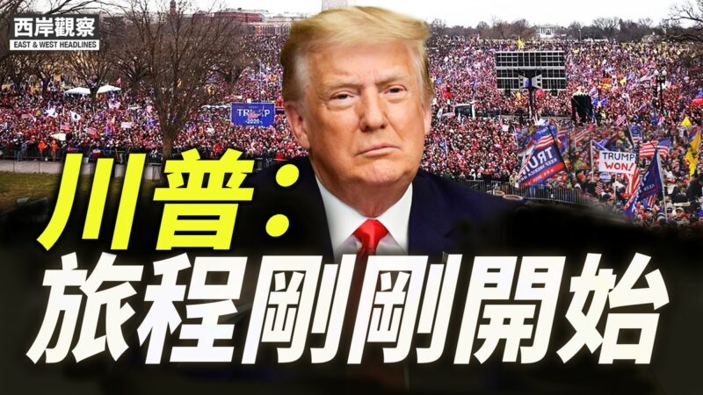1月7日，川普總統發推譴責暴力，保證平穩過渡。（西岸觀察）
北京時間：2021-01-08 01:25
FacebookTwitterEmailPrintFont Size簡體
【新唐人北京時間2021年01月08日訊】大家好！歡迎收看西岸觀察，我是林驍然。今天是1月7日，星期四。今天凌晨，美國國會通過了各州選舉人投票認證，承認民主黨總統候選人拜登當選總統。由於遭遇社交平台禁言，白宮副幕僚長斯卡維諾（Dan Scavino）在推特上代表川普總統發表聲明，並呼籲保持冷靜。
川普說：「即使我完全不同意大選的結果，事實也證明了我的觀點，但1月20日仍將有序進行過渡。我一直說過，我們將繼續努力，確保只統計合法選票。雖然這代表著總統歷史上最偉大的第一任期的結束，但這只是我們使美國再次變得偉大的鬥爭的開始！」
不過，昨天下午衝擊國會事件不斷發酵，一夜之間川普支持者從「愛國者」成為變成了左媒口中的「暴徒」。民主黨人更揚言要川普對暴力事件負責，甚至呼籲啟動憲法25號修正案，要求副總統彭斯解除川普的總統職務，甚至醞釀在1月20日前再度彈劾他。
壓力之下，川普今天下午在推特上發布了新的視頻聲明，主要有這麼幾個要點：首先，譴責昨天的暴力。他說，我一直尋求在法律範圍內行事，並立即下令國民警衛隊和聯邦執法人員，保衛國會大樓，驅趕入侵者。其次，保證平穩的政權過渡。他說，這是他下階段工作的重點。第三，疫情當前，要所有人共同努力，才能戰勝疫情，重建經濟。最後，川普說美國社會需要康復與和解，他知道自己的支持者很失望，但是「精采的旅程才剛剛開始。」
最後一句，和斯卡維諾的推文頗為一致，意味著川普不接受敗選，也不會就此沈默，他將繼續為「美國再次變得偉大」而奮鬥。
（責任編輯：曹靜）

男子承認受僱衝擊國會 議員提前兩天獲安全警告
1月6日，有人衝入國會。此次衝擊被質疑是由極左翼組織安提法（Antifa）組織的。（Win McNamee/Getty Images）
北京時間：2021-01-08 05:27
FacebookTwitterEmailPrintFont Size簡體
【新唐人北京時間2021年01月08日訊】美國國會週三（1月6日）下午認證選舉人團投票時，有抗議者衝入國會大廈，導致聯席會議一度中斷。次日，有網友曝光一段視頻顯示，一名男子坦言自己就是收錢假扮成「愛國示威者」衝入國會的滋事者之一。國會共和黨眾議員莫•布魯克斯（Mo Brooks）也發推稱，自己兩天前就收到了安提法（Antifa）會衝擊國會的警告。
週三，美國國會聯席會議認證2020年總統大選結果期間，很多人衝擊國會大樓，造成國會一度休會。事件引起全球關注。
網友週四凌晨在推特上曝光一段視頻，一名男子在視頻中承認，自己不是真正的川普（特朗普）支持者，是有人花錢雇他衝進國會滋事的。
他說：「我剛剛離開國會大廈，我的腿受了傷（我很沮喪）。我要承認，我很辛苦的完成了有人付錢讓我做的事情。我錄製這段視頻是想坦白，我是受僱來假扮成愛國示威者。我現在不能說他們是誰，總之他們是一個組織。」
另外，阿拉巴馬州共和黨眾議員布魯克斯週四早間也連發推文指出，越來越多的證據表明，是安提法暴徒精心策劃了這起襲擊。
他說，請大家不要跟假媒體一樣急於對國會大廈遭襲做出判斷，請等待調查，「越來越多的證據表明，是安提法（ANTIFA）通過巧妙的暴徒控制手段，策劃了國會大廈的襲擊。」
接著，布魯克斯列舉出如下4條證據：
「1、週一，一名國會議員警告我，安提法的威脅在增加，並建議我睡在辦公室，而不是離開國會大廈到公寓去睡。我聽取了這個建議，連續四個晚上在辦公室睡覺。
「2、國會議員告訴我，週二國會警察警告他，情報表明，具有法西斯主義性質的安提法人員，將穿上跟川普支持者一樣的服裝，混進支持川普的集會中。」
「3、就在週二，國會大廈警察建議，最好不要離開國會大廈。」
「4. 大量公開證據表明，許多襲擊國會大廈的人是安提法暴徒，而不是川普的支持者。」
布魯克斯同時強調：「時間將揭示真相，不要急著判斷，不要被假媒體愚弄，它們在政治傾向的驅動下進行報導。」
他還重申了自己的觀點，即「全面起訴（參與的）所有人！」
也有分析指出，這場衝擊事件發生的時間點也很可疑。事發時，共和黨參議員特德•克魯茲（Ted Cruz）剛在國會聯席會議上提出挑戰，反對亞利桑那州的選舉人團投票結果，並將要呈交大選舞弊證據。此前的報導也指出，有超過100位議員將挑戰拜登勝選這一結果。
此外還有一段視頻曝出，正是國會的執法人員，為這群人打開了擋在路中間的鐵欄杆，放他們衝進國會。
很多華人網友質疑，這次衝擊國會的行動背後有中共的黑手：「共產黨的慣用招術」，「從8964到香港到美國……全部同一只手同一套路」，「去年香港立法會已經上演過一次了」，「一樣的配方，一樣的手法，將無恥進行到底」，「熟悉吧，中共的那套手法！」
（記者蕭靜綜合報導／責任編輯：梅蘭）

视频：彭斯主持联席会议不许辩论 把议员赶到国会走廊 关起门给拜登站台
本文网址：https://www.aboluowang.com/2021/0108/1543031.html

星期二, 05 1月 2021 02:20

艾玛·沃尔弗顿惨遭禁闭的一生
原文章名：Life imprisonment for ‘feeble-mindedness’?
这一学说认为，就像农民控制牲畜受孕来提升牲畜质量一样，促进“优秀”人群生孩子，抑制“不良”人群的孩子出生，同样可以提高人种质量。
1世纪早期流传着许多倡导优生学（EUGENICS又译为人种改良学）的“道德故事”。优生学运动由查尔斯•达尔文的表弟弗朗西斯•高尔顿(FRANCIS GALTON)开创，完全以进化论中“适者生存”的理念为基础。¹

优生学是西方世界的科学共识，被该领域所有杰出的研究人员所接受，并得到美国最高法院的批准


艾玛15岁
一个最为著名的倡导优生的例子就是 “ 黛博拉 • 卡利卡克 ”（“Deborah Kallikak”，化名）的故事。
“ 卡利卡克 ” 家族的祖先代号叫 “ 马 丁 • 卡利卡克 ”（“Martin Kallikak”），他与一名 “ 智力低下 ”的酒吧女服务员发生了性关系，生下了男孩小马丁（Martin Jr）。之后，马丁娶了一名 “ 门当户对的清教徒女子 ”，他们的后代人才辈出。
但不幸的是，小马丁嗜酒成性、不学无术，他的众多孩子也都心智不健全、道德低下。据说，黛博拉就是小马丁的直系后代，而且她经检测被确认 “ 智力低下 ”，因此被关在一家收容所里以防止做出什么不端行为。²
葡萄园训练馆
“ 黛博拉 • 卡利卡克 ” 是艾玛 •沃尔弗顿（Emma Wolverton）的化名。真正的问题在于，这个说法从头至尾都是错的。家族关系一开始就弄错了。“ 马丁 ” 和 “ 小马丁 ” 是远房亲戚，并非父子，他俩都是名门望族之后。³
之前对艾玛 “ 智力低下 ” 的检测结果站不住脚，因为艾玛在进收容所之前根本没有受过教育，但检测并没有考虑这点。之后人们对她的各种评价也故意淡化了她在学习技能方面所取得的成就。事实上，拜访收容所的人经常对艾玛 “ 智力低下 ” 却能有如此优异的表现而感到惊讶。然而不幸的是，没有人对她是否真的智力低下提出过质疑。
艾玛在培训学校
艾玛 8 岁那年进入了位于新泽西州的瓦恩兰培训学校（Vineland Training School），之后被转到了一街之隔的女子学院。她从没有机会过上属于自己的生活 —— 艾玛直至晚年才获得自由，而那时的她早已疾病缠身，无福消受这份迟到的自由。艾玛 • 沃尔弗顿于 1978 年去世，享年 89 岁，成为残忍伪科学的受害者。⁴

以史为鉴
有人可能会问，为什么艾玛 •沃尔弗顿的故事直到今天依然重要。这是一个悲惨的故事，但她已经去世近 40 年了。优生学在当今已经臭名昭著（译注：至少在西方如此），原因是纳粹曾经以优生学的名义，对犹太人和其他 “ 少数 ” 民族实施种族灭绝，这一理论为大肆屠杀身心缺陷者提供了理论支持，以防止他们传播 “ 劣等的基因 ”。
艾玛操作缝纫机
但在当黛博拉进入瓦恩兰培训学校的年代，优生学得到了当时西方科学界的普遍认同，该领域所有知名学者以及美国最高法院（巴克诉贝尔案，1927 年）都赞成这种做法。
对那些 “ 智力缺陷 ” 者进行终身监禁，并对更为广大的群体实施永久性绝育，似乎是不言自明、顺理成章的。⁵ 每每想起他们仅仅因为贫穷、未接受教育或是其它不利条件，便惨遭如此暴行的迫害，我们不禁为之骇然。被当年用于迫害他们并以此得以推进的学说，却成了当今最为著名的一批科学家赖以功成名就的理论。
基督教的世界观是唯一一种不分人类和人类的价值而维持其生命价值的世界观。

然而，人们很容易忽视一个现象，科学家今天依然在发布裁决生死的言论。一些 “ 伦理学家 ” 认为，比起出生之后的残疾，在子宫里结束一个婴儿的生命更为人道。还有，比起 “ 迫使 ” 一个不幸的人过着 “ 不值得过 ” 的生活，帮助他们实施自杀则更为可取。理查德 • 道金斯（Richard Dawkins）等名家学者认为，比较 “ 人道 ” 的做法是，父母应该打掉患有唐氏综合征的婴儿，然后“ 再生一个 ”。⁶ 彼得 • 辛格（Peter Singer，普林斯顿大学生物伦理学教授）甚至无耻地声称，有些动物比人类新生婴儿更具道德价值。⁷
世界上有一种世界观，不分才智高下、能力大小，维护每一个人价值，这就是基督教的世界观。因为《圣经》告诉我们，所有人都是按照上帝的形象创造的，虽然这形象因人犯罪而受损，但依然赋予人人与生俱来的价值。

参考文献和注释
1. 参见 Grigg, R., ‘Hooray for eugenics!’, Creation 30(3):50–52, 2008; creation.com/eugenics-church.
2. 黛博拉的故事最初记载于 Goddard, H., The Kallikak Family, New York, Macmillan and Company, 1912.
3. Smith, J.D. and Wehmeyer, M.L., Good Blood, Bad Blood: Science, Nature, and the Myth of the Kallikaks, pp. 200–201, Washington, D.C., AAIDD, 2012.
4. 艾玛的故事详载于Smith and Wehmeyer, ref. 3, and Smith and Wehmeyer, Who Was Deborah Kallikak? Intellectual and Developmental Disabilities 50(2):169–178 | doi:10.1352/1934-9556-50.2.169, April 2012.
5. Sarfati, J., America’s evolutionists: Hitler’s inspiration? Creation 27(2):49, 2005; creation.com/weak.
6. Cosner, L., Richard Dawkins: Dolphins worth more than babies with Down syndrome? creation.com/dawkins-ds-abortion, 24 August 2014.
7. Cosner, L., Blurring the line between abortion and infanticide? creation.com/infanticide, 2 July 2008.

本文原英文链接见：https://creation.com/wolverton-kallikak.

星期一, 28 12月 2020 06:10

硫细菌进化停滞：至今为止最大的进化缺口
原文章名：Sulfur bacteria stasis—“The greatest absence of evolution ever reported”.
在超过将近20亿年的所谓进化时间轴上，海底硫细菌竟然没有改变。有一篇报道中，证明进化过程不存在的证据被说成是证明进化的证据！
“ 一个国际科研团队发现了迄今为止最大的进化缺口 —— 缺口长达 20 亿年。这种深海微生物 20多亿年似乎没有进化，但是研究人员表示，这实际上支持达尔文的进化论。” ²
他们通过采用进化时间表而陷入困境
研究小组的领导是加州大学洛杉矶分校（UCLA）³ 进化和生命起源研究中心主任斯科夫（J. William Schopf），所以他们默认的起源理论框架当然就是进化论。
他们的科学论文中写道，他们观察到的西澳大利亚硫细菌化石与 2007 年在南美洲海岸附近发现的现代硫细菌 “ 没有区别 ”。⁴研究人员到此为止的言论都没有问题。但他们进一步采用进化时间框架作茧自缚。他们给化石定年为 18 亿年（同一地区更早发现的相同外观的硫细菌化石被定为23 亿年）。⁵ 如此，他们要面对硫细菌为什么 “ 呈现了持续时期极长的无可辨识变化的现象 ” 即 “ 极端进化停滞现象。”^{4、6}
深受进化预设影响的斯科夫教授也发现：“ 生命超过 20 亿年 —— 超过地球年龄的一半竟然没有进化，这实在令人震惊。鉴于进化是客观事实，这种进化缺口需要得到解释。”²
虽然进化绝非事实 ⁷，但是就连斯科夫也意识到，进化停滞的确是进化论者的一个问题。这是斯科夫和他的同事试图在论文中解决的问题。然而，请注意，他们给出的超过 20 亿年没有进化的“ 解释 ”，其主要假设前提是硫细菌生存的环境在此期间没有变化：
“ 如果一个被完好适应的生态系统的物理 - 生物环境没有改变，那么其中的生物成员就不应有物种分化，或产生形态、功能及代谢要求方面的进化。”⁴
换句话说，“ 生物学的原则就是：除非物理或生物环境发生变化，否则不会进化，这与达尔文的理论一致。这些微生物很好地适应了它们非常稳定的简单环境。如果所处的环境没有改变，但生物却还是进化了，那就说明我们对达尔文进化论的理解存在严重缺陷。”²
乔治·奥威尔（George Orwell）虚构的《十九四十八》中新闻和教育负责人的“双重讲话”在这里看起来真是真实。

但就算真到那一步，历史也表明，无论哪个进化 “ 教条 ” 被推翻，进化本身的“宏观理论”——微粒以某种方式转变为人和所有其他生物 —— 永远不会遭到质疑。⁹ 这就像是永远不会输的抛硬币游戏：正面 —— 进化论是事实；反面 —— 创造论是错的。因此，硫细菌的破纪录停滞被称为 “ 对达尔文理论的确认 ”⁴, 并且 “ 完全符合他的思想。”² 简而言之，没有进化=进化论。活现了奥威尔《1984》虚构小说中的新闻和教育控制者的 “ 双言巧语 ”。¹
然而，称环境没有改变的主张违背了地球进化史。地球进化史中还有 “ 雪球地球 ” 时期，这一时期据称与这些细菌是在同一个时间范围内。¹¹
这与奥威尔式反乌托邦小说中的如出一辙，小说中的 “ 真理部门 ” 以斯大林时期的苏俄为原型，按政府需要负责伪造历史事件。同样，那些支持进化论的人实际上所鼓吹的是以伪造历史代替创世记记载的历史事件（大约6000年前）和全球大洪水（大约 4500 年前）。
他们否认了大洪水，然后将其在全球留下来的大量含有化石的地层说成是数十亿年沉积的证据。否认创造，按照他们的思维模式，既然不存在创造主，也就不需要为造假而向创造主交代。或许这样看来，也就能理解他们为什么会提出一个看似完全不合理的观点，即这些硫细菌的泥土环境（记住 ‘ 环境 ' 还包括无数其他生物的存在和活动，而这些据说在同一时间框架内的生物都进化了）在将近三十亿年毫无改变。

参考文献和注释
1. 来自奥威尔的著名小说《1984》（写于1948年），这本小说深刻地描绘了一个用权利为自己牟利的社会主义政权对公民的压迫。这个政府的“真理部”严格控制新闻、教育、娱乐和美术。它不断传播更广泛的政府口号“战争就是和平”，“自由是奴隶制”和“无知就是力量”。
2. Wolpert, S., Scientists discover organism that hasn’t evolved in more than 2 billion years, phys.org, 3 February 2015.
3. University of California—Los Angeles.
4. Schopf, J.W., and 9 others, Sulfur-cycling fossil bacteria from the 1.8-Ga Duck Creek Formation provide promising evidence of evolution’s null hypothesis, PNAS 112(7):2087–2092, 2015 | doi: 10.1073/pnas.1419241112.
5. Van Kranendonk, M., Schopf, J., Grice, K., and 7 others, A 2.3 Ga sulfuretum at the GOE: Microfossils and organic geochemistry evidence from the Turee Creek Group, Western Australia, Proceedings of the 34th International Geological Congress2012, Brisbane, Australia, Abstract P3M-259, p. 2422.
6. Cf. Bell, P., Evolutionary stasis: double-speak and propaganda, Creation 28(2):38–40, 2006; creation.com/stasis.
7. Catchpoole, D., Created or evolved?, creation.com/coe, 25 June 2013.
8. Batten, D., Evolutionists can’t dodge ‘Living Fossils’, Creation 33(4):42–43, 2011; creation.com/dodge.
9. E.g. see: Grass-eating dinos: a ‘time-travel’ problem for evolution, Creation 29(2):22–23, 2007; creation.com/dino-grass.
10. Statham, D., Heads I win, tails you lose—the power of the paradigm, creation.com/evo-coin-toss, 11 November 2010.
11. Oard, M., ‘Snowball Earth’—a problem for the supposed origin of multicellular animals, J. Creation 16(1):6-9, 2002, creation.com/snowball.

本文原英文链接见：https://creation.com/sulfur-bacteria-stasis.

逾百万爱国者聚集首都集会“拯救美国” 彭斯软弱退缩放弃拒绝战场州选举人


由义工
1月 6, 2021
作者：约瑟 / 发稿：2021.01.06
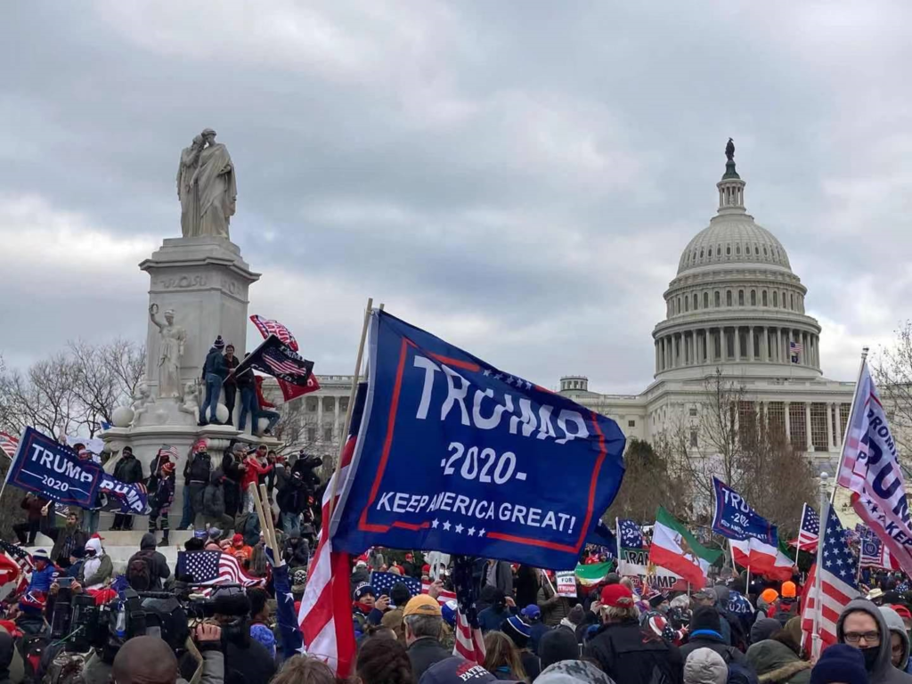
逾百万爱国者响应川普总统的号召，昨天开始就聚集到了首都华盛顿特区，参加“停止窃选，拯救美国”集会，向今天在国会大厦参加参众两院联席会议认证各州选举人票的全体议员们发出震天的怒吼，“停止窃取选举！”、“停止盗窃我们的选举权！”、“停止盗窃我们的自由！”、“停止盗窃我们的国家！”
昨天的集会中下起了大雨，然而没有一个爱国者离开会场。
在今天的集会上，带头提出要在国会联席会议反对战场州选举人的阿拉巴马州众议员莫布鲁克斯（Mo Brooks）首先发表了激情的演讲。他说：“我今天来给大家带来一条信息，请你们记在心里。70年来，美国都是在世界历史中最伟大的国家！我们的生活标准是世界历史上最好的！我们的武装力量无人匹敌！我们享有世界上无可比拟的自由！为什么？只是因为我们幸运吗？不！我们幸运是因为我们的先辈们做出了巨大的牺牲。他们流汗流血，甚至献上了生命。他们牺牲为了什么？是为了建立将美国建设成为世界历史上最伟大国家的基础！”
原民主党众议员弗农·琼斯在集会上宣布：“今天，我正式脱离民主党，登记加入共和党。”
川普总统的儿子埃里克·川普也发表了演讲。他表示：“战斗刚刚开始，我们绝不认输！”
中午11时许，川普总统也发表了讲话。他说：“在这之后，我们要走下去，我会和你们一起，我们要走下去 —— 到国会大厦，我们要为我们勇敢的参议员和国会议员们欢呼。我们可能不会为他们中的一些人如此欢呼–因为我们永远不会用弱小来夺回我们的国家。你必须展示力量，你必须坚强。”
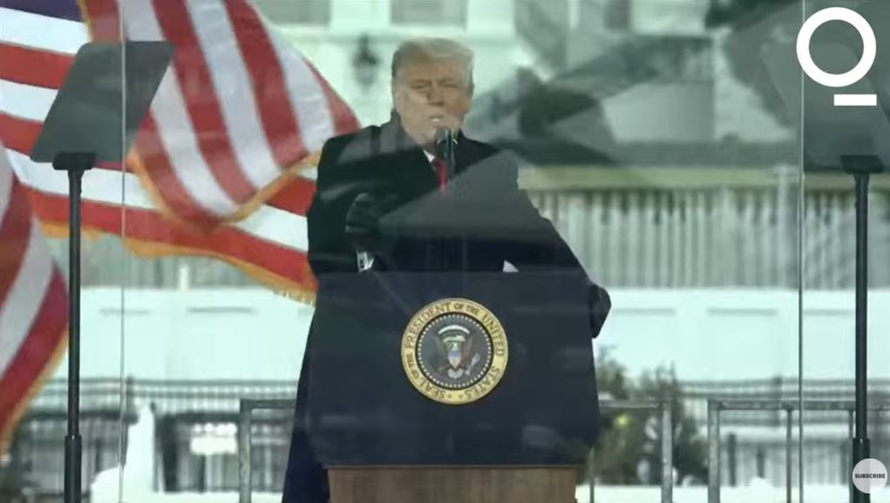
下午国会联席会议前，彭斯副总统发布了一封声明，称：“我经过深思熟虑的判断是，我的誓言支持和捍卫《宪法》，使我无法要求单方面的权力来决定应计算哪些选票，而哪些则不应该。” —— 他的意思十分明了，他将不会拒绝接受来自战场州的选举人。
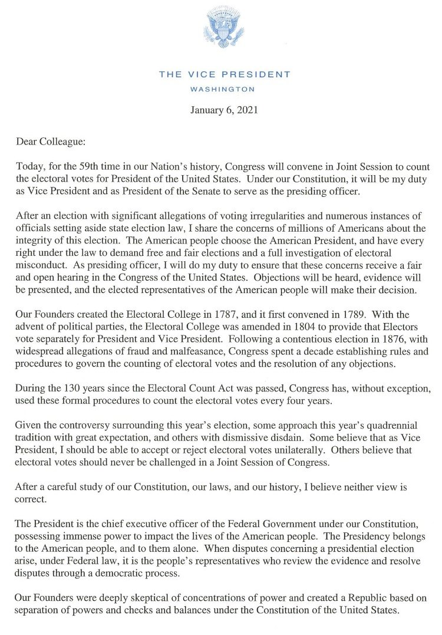
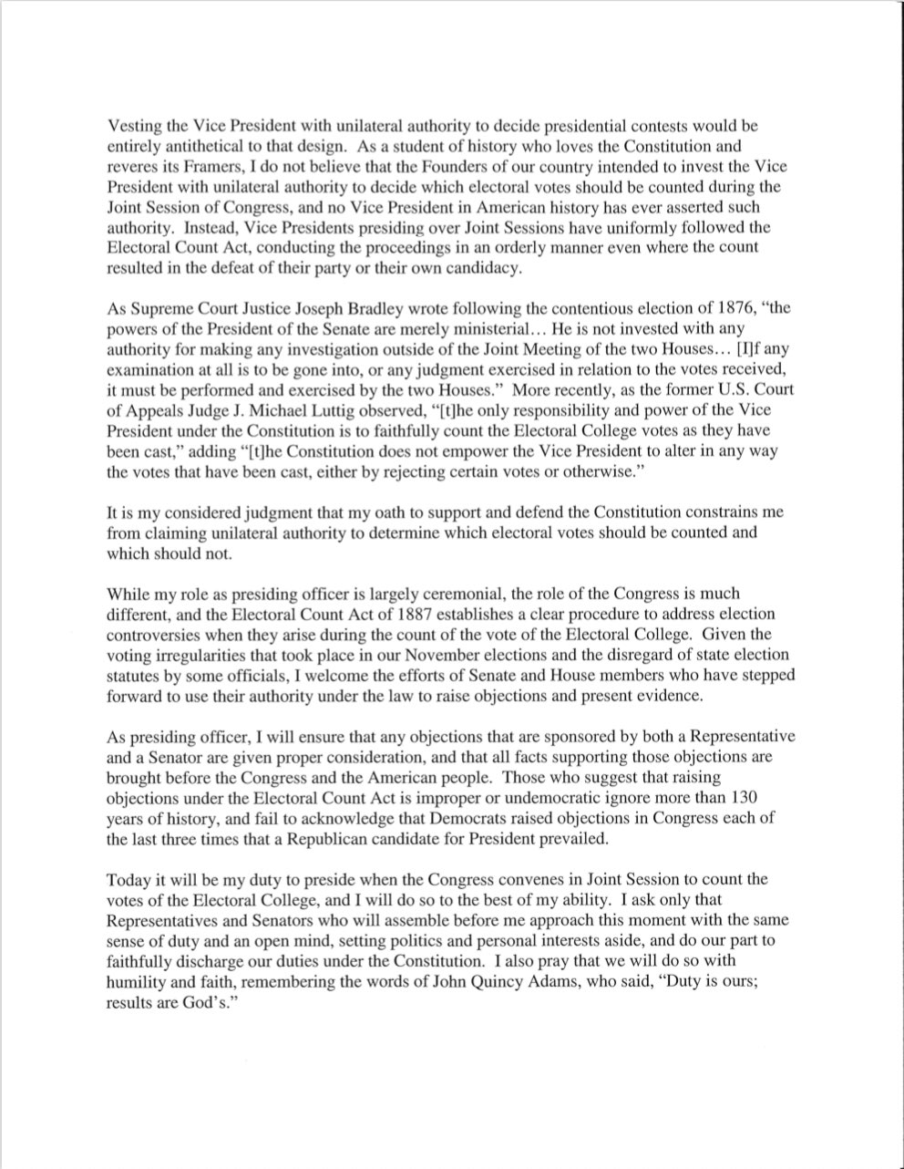
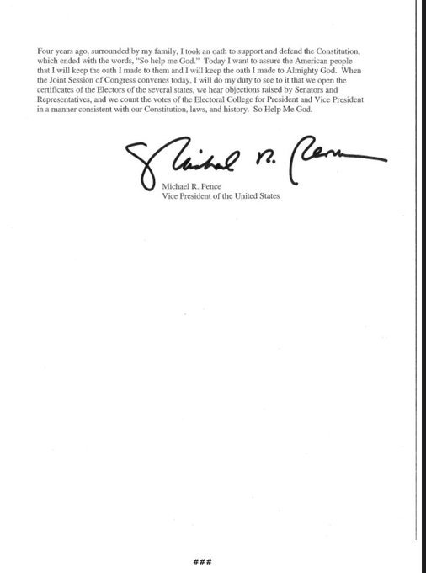

New York GOP congresswomen blast Nancy Pelosi’s new House gender rules
By Jon Levine
January 2, 2021 | 4:51pm | Updated
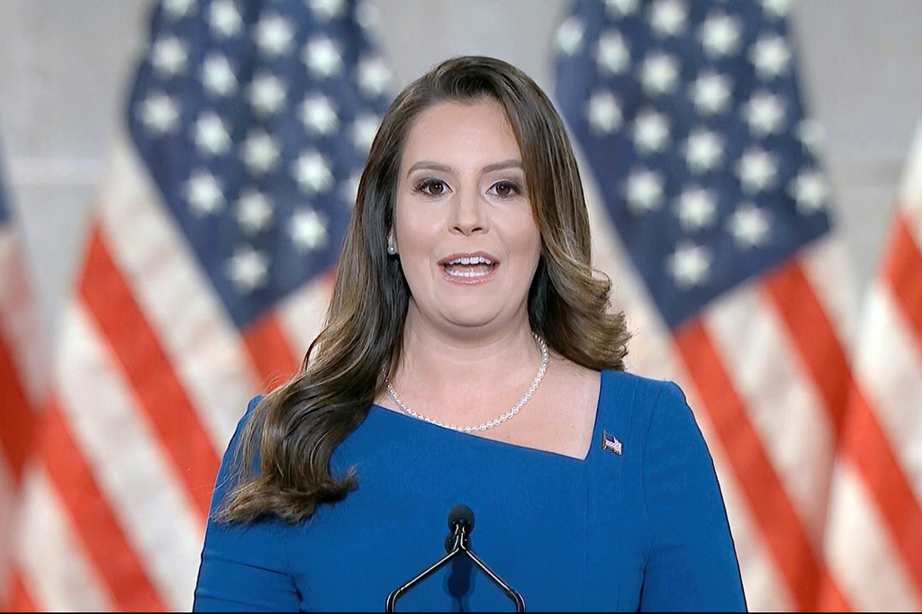
12
Rep. Elise Stefanik
AP

More On:

us house of representatives

Nancy Pelosi just showed why it’s vital to keep the Senate in GOP hands

Capitol Hill’s progressive ‘Squad’ is back with two new members

Nancy Pelosi re-elected Speaker of the House

Slim margins, COVID-19 absences threaten Nancy Pelosi’s Speaker election
Some of New York’s most prominent female Republicans derided and mocked Speaker Nancy Pelosi’s proposal to eliminate gendered language from the official House rules.
“Instead of reviving the economy, restoring our Constitutional freedoms and delivering results for the American people, Speaker Pelosi has chosen her debut legislation — which would ban words like mother, sister and daughter,” upstate Rep. Elise Stefanik told The Post. “Obviously she is triggered by the historic number of GOP women elected to Congress who will fire Nancy Pelosi once and for all in 2022.”
Staten Island’s Congresswoman-elect Nicole Malliotakis also had words for the new rules.
“There are millions of Americans suffering, our economy is hurting, vaccine distribution is lagging and Nancy Pelosi and the House Democrats are worried about this nonsense,” she said. “Here’s a gender neutral word to describe this legislation: ridiculous.”
Proposed changes to the rules of the House of Representatives would “honor all gender identities” by eliminating such specific terms as mother and father, son and daughter, and aunt and uncle.
Instead, only gender-neutral terms such as “parent,” “child,” “sibling” and “parent’s sibling” would be allowed in the text of the House rules.
House Speaker Nancy PelosiSHAWN THEW/EPA-EFE/Shutterstock
Outrage even made its way to the all-important Georgia Senate runoff, where Republican Kelly Loeffer warned it was reason enough to vote for her.
“The far-left’s priorities, everyone. If you’d like to still be able to call yourself a father, daughter, mother or son, vote for me and @Perduesenate on Tuesday,” she tweeted Saturday, adding, “Sincerely, A Proud Daughter.”
Meanwhile, top Dems in Congress took credit for the new regulations.
“I’m proud to start the 117th Congress by drafting these historic rules changes,” Rep. Jim McGovern said in a tweet.

see also

Pelosi may strip all gender references from House of Representatives rules

Pelosi touted the new rules, calling them “the most inclusive in history.”
However both Pelosi and McGovern continue to use gendered terms to describe themselves on their respective Twitter pages Saturday.
The new rules are expected to be voted on when the house reconvenes Sunday.
The rules also got a big boost from progressive Queens/Bronx Rep. Alexandria Ocasio-Cortez, who said she was “grateful for@RepMcGovern’s leadership” during the process.
One Capitol Hill insider told The Post the idea for nixing gender from the new rules package likely originated in the House’s Office of Diversity and Inclusion. The same rules also enshrined the office as a permanent new addition to the Capitol.
The agency was created by Democrats in one of their first acts at the start of the previous Congress.
“This office is charged with submitting to Congress a diversity plan to direct and guide House employing offices to recruit, hire, train, develop, advance, promote, and retain a diverse workforce,” reads its official about page.

大陆边缘于洪水后期迅速形成
原文章名：Continental margins
在挪亚洪水的后半期，大陆抬升，洪水流入下沉的海盆。^{1、2}

这些快速流动的大型水流侵蚀了大量洪水前期形成的沉积物，将它们冲走。水流如此快速，以至于没有在大陆上发生多少沉积作用，到达海洋时，才逐渐减慢并开始沉积。


尽管很少有科学家解决这个问题，但是在统一主义（缓慢而渐进的）范式中很难解释大陆架和坡度。

大陆边缘
所有的大陆（和大型岛屿）都由大陆边缘环绕，其构造是以一圈连续的沉积岩为主（图1），占海底面积的20% 左右，剩余的是深海盆地（深海平原）。
大陆边缘主要包括大陆架和大陆坡，其中包括多种不同类型（见下页方框）。

大陆架
大陆架相对平坦，向下倾斜角度缓和（不到0.1°），它由海岸线向外延伸，直到大陆架的边缘或陆架坡折，接下来就是大陆坡（图2、图3）。大陆架的宽度变化极大，有的仅有几公里（几英里）到超过400 公里(250 英里)；平均宽度是80 公里（50 英里）。超过1000 公里（600 英里）宽的大陆架至少有一个。3 极宽的大陆架一般位于北冰洋、白令海、大浅滩和纽芬兰（图1）

大陆坡

图1：浅蓝色为大陆边缘（NOAA美国国家海洋和大气管理局）海岸线大陆架

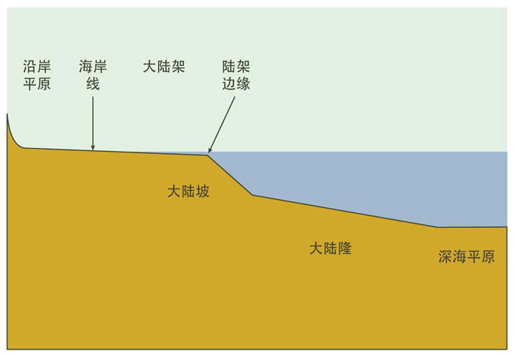
图2：大西洋型边缘图示
在大陆架的边缘，平均水深一贯保持在130 米（430 英尺）左右，海底的坡度从几乎平坦突然增加到4° 左右，直至1500 到3500 米的深度（4900 到11500 英尺）。这就是大陆坡，如果海洋中的水都被抽掉，这会成为地球上最显著的地貌边界。（图4）
大陆边缘上的几个地方，坡度也可能比平均值大得多，高达90°。

边缘沉积岩
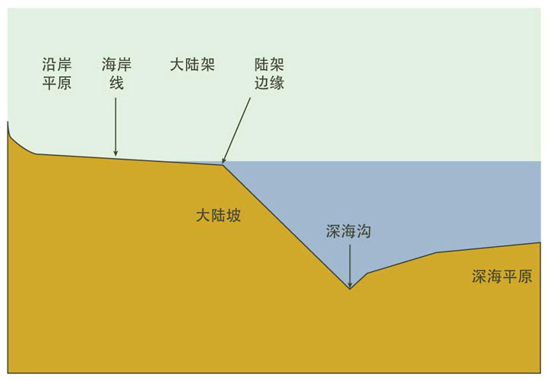
图3：太平洋型边缘图示
大陆边缘以内的沉积岩有些非常厚—— 有些地方深度超过20 公里（12 英里），特别是在被掩埋的盆地4。沉积单元一般都是片层状，随入海方向越来越厚，坡度缓增（图5）。这一剖面特征强有力地证明了以下地质活动：大陆边缘在沉积过程向下塌陷几千米的同时，附近的大陆发生大面积的抬升。
两种大陆边缘
（1）大西洋型边缘：这通常是不活跃的地震，即地震和火山很少（图2）。
（2）太平洋型边缘-地震活跃（图3）。¹
除了大陆架和大陆坡，大西洋边缘还有另一个地貌特征——大陆隆。
太平洋边缘取而代之的一般是深海沟。
南极大陆架的剖面与其它都不一样，因为冰层的重量不仅将陆地压下，
同时也压低了大陆架。

参考文献
- Kennett, J., Marine Geology, Prentice-Hall, Englewood Cliffs, NJ, pp. 23–30, 1982.
地貌学家莱斯特· 金（LesterKing）这样总结：
曾经发生了反复的地质构造场景：情景总是一样——陆地抬升，海底下沉（本文作者强调）。⁶
这符合诗篇104:8 对洪水减退时期的描述：“ 诸山升上，诸谷沉下，归你为它所安定之地。”

大陆边缘——一个神秘的地貌特征
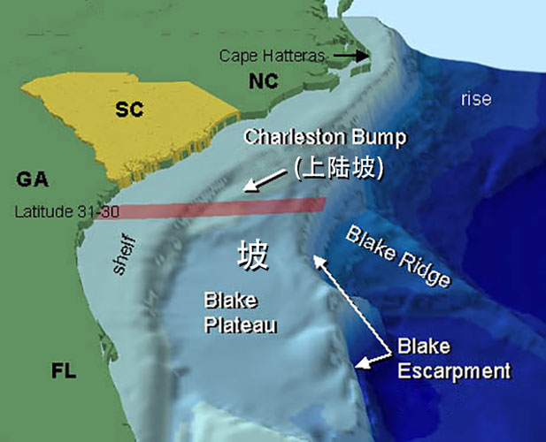
图4：美国东南岸的几乎平坦的大陆架以及大陆坡断层（NOAA）。北部的断层处非常陡，下延至大陆隆。
虽然，很少有科学家提到这一问题，但是大陆架和大陆坡非常难以均变论（缓慢渐进）的范式来解释。非灾变的过程应该会倾向于形成向海底深处的缓和沉积，而根本不应该存在大陆架或大陆坡（见图6的虚线）
地貌学家金是这样描述这个问题的：
“偶尔，大陆架一时太宽，发展到外部边缘，又太深，这不可能是由普通风力在海面带起的海浪所致。”（本文作者强调）⁷
目前观察到的过程不能形成这样的剖面。海德伯格（Hedberg）也说道：“……关于大陆坡的具体起源，存在很大争议。很明显，没有唯一的答案。” ⁸
人们预期看到的是一个延至深海的缓坡，原因是大多数洋流都是由风带动的。（在高纬度密度较高的海水沉降仅是一个次要因素，当然也有科学家不这么认为）⁹ 因为海风作用，洋流一般与海岸并行，如美国东岸的湾流。¹⁰ 一个均变论者期待看到的现象是：沉积物首先铺开，紧接着缓慢地滑入深海。
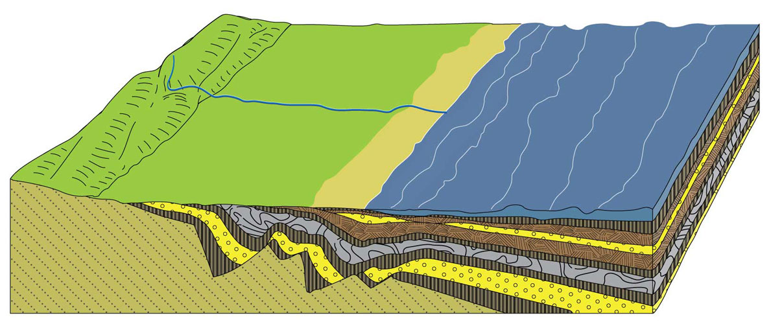
图5：入海方向逐渐增厚的楔型沉积岩。
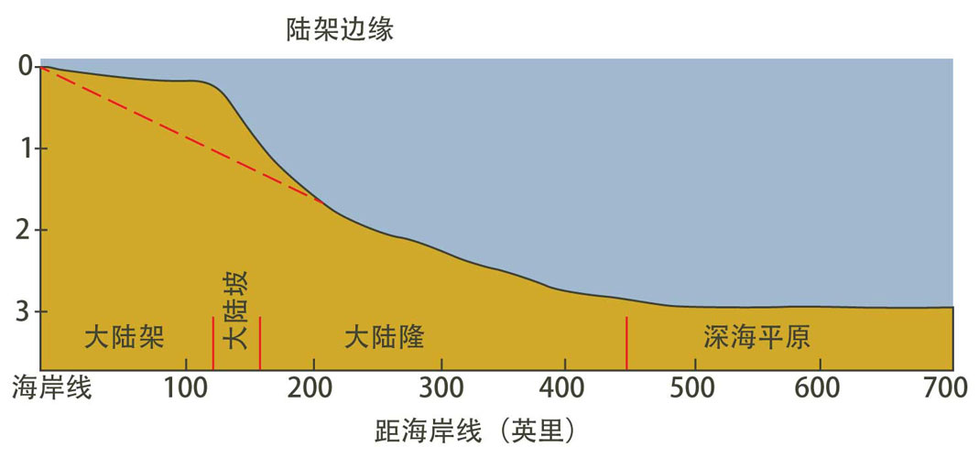
图6 大西洋型边缘的主要特征对比按照今天看到的普通风力洋流形成的应有结构（虚线）。垂直放大约1/50。

创世记大洪水是大陆边缘形成的原因
由于大陆架和斜坡遍布所有大陆，因此片层沉积（这意味着强烈的洋流）似乎是解释其存在的唯一合理方法。
大陆架和大陆坡环绕着所有的大陆，因此，片流沉积（意味着强大的水流）似乎是唯一一个合理解释。这也符合沃尔克的大洪水模型中，洪水消退期前半阶段的情况¹¹。在这个阶段中，洪流非常宽，可能几百甚至几千公里宽。
有时候，大陆边缘的沉积岩的倾斜度会随入海方向逐渐增大，形成三角洲一样的地貌。这意味着沉积流的流势是从大陆退向海洋的，而不是我们所预期的那样，会由风提供动力的洋流，且平行于海岸线的那种流势。
海德伯格说：“ 反射剖面显示，从很多斜坡的目前形态来看，它们是进积型沉积的产物。”⁸
进积的意思是，由向远离大陆、与海岸线垂直的水流形成的沉积作用，¹² 与我们今天看到的平行于海岸线的典型洋流不同。
今天，泛滥的河水涌入更大的水体时，会将其裹挟的泥沙沉积，形成三角洲。这个现象可以对大陆架和大陆坡的起源提供一些启示。三角洲的顶部代表着大陆架，外缘则对应着大陆坡。大陆边缘是一个全球化现象，是指向全球性洪水的有力证据。大陆边缘也有力地反驳了全球沉积层是经“ 亿万年” 缓慢形成的说法。

袋熊
原文章名：The wombat ‘Badger’ of the south
当欧洲人第一次看到我们称之为袋熊的这种澳洲动物时，他们竟然把它吃了¹。

一些人认为袋熊应该得到 “ 更高的保护地位 ”，以确保它们能继续繁衍。然而在 1797年，遭遇悉尼湾号（Sydney Cove）船难的水手为了确保自己能存活下来，于是在被困在巴斯海峡的保护区岛（Preservation Island）上的那年，他们靠吃袋熊为生。
随同前往救援的马修 · 弗林德斯（Matthew Flinders），后来成为了一位伟大的航海家和探险家。他把一只活袋熊带回了悉尼，把它赠送给了殖民地总督约翰 · 亨特（John Hunter）。这只袋熊六个星期后就死了，亨特把它保存起来，送到了伦敦著名的自然科学学家约瑟夫 ·班克斯爵士（Sir Joseph Banks）的手中。总督在随附的信中提到：
它的体型大小和獾相当，从它用前爪在地上挖洞的灵巧性来看，我们猜想它是一种獾；
但从它的一般活动来看，它似乎有很多熊的行为习性……¹
袋熊生有强壮的爪子和肩膀，有报告显示，它能在一小时内挖1.8 米深的硬土。² 它们用门牙来切断像树根这样的障碍物。
人们普遍认为袋熊危害农作物，这不仅仅是因为它的穴居习性而且极爱吃草（它有一些夜行动物的特性，主要在夜间觅食），还因为它能用粗壮的身体和宽大的骨盆强行挤过防兔栅栏，造成极大的破坏。1906年维多利亚州将袋熊列为有害动物—— 现今仍然如此，不过需要得到许可才能进行捕猎以控制它们的数量。³ 在澳大利亚的其他地方，袋熊受到法律保护。

揭示地下秘密
洞穴直径与袋熊的大小匹配得刚刚好，可达半米（20 英寸）宽，足够一个块头小的人爬进去。1960 年，一名学生， 彼得 · 尼科尔森（Peter Nicholson）就在他位于维多利亚州中心的学校周围，钻进了丛林里较大的洞穴，还做了测绘。他在探索袋熊时所写的研究报告，不仅使他获得了一项学生科学人才奖 ⁴，而且至今依然被视为一份颇有价值的袋熊深入研究资料。尼克尔森和后来其他人的研究显示，袋熊洞穴的可长达 30 米（100 英尺），深达 3.5 米（11 英尺），有多个卧房、侧道和入口。
当袋熊受到猎食者（如澳洲丁格犬 ⁵）的威胁时，袋熊会逃进最近的洞穴，身体堵住洞口，用它那厚皮的臀部把敌人挡在外面。有时，袋熊会让入侵者把头挤到袋熊的背上，此时，袋熊就会用它强壮的腿部肌肉猛然站起，这样来使猎食者窒息，或者甚至在洞顶上把它的头骨挤碎。人们曾在袋熊洞穴中发现狐狸和狗的碎头骨。
虽然袋熊的洞穴挖得刚好容得下它们的身躯，但是它们很灵活，可以在洞穴里转身。袋熊有个奇特的能力，可以在趴着的时候，将它那胖墩墩的身体放扁。人们曾看到一只肩高 24 厘米的袋熊毫不费力地挤进一个只有 10 厘米高的缝隙。

Garth Wilshire/123RF | Photo by animals.sandiegozoo.org/animals/wombat S | Susan Flashman/123RF
 | 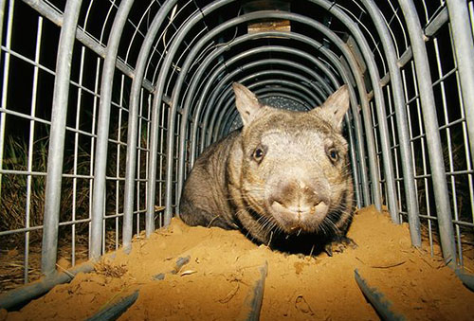 | 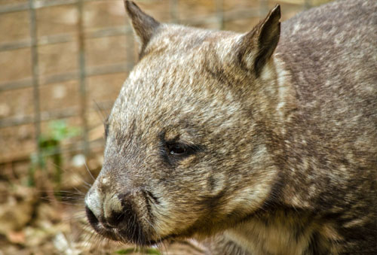
图 1：袋熊的三个种类。
左 —— 普通袋熊（Vombatus ursinus）。这种袋熊不像以前那么普遍了，现在通常被称为光鼻（barenosed）袋熊。 右下 —— 南方毛鼻袋熊（Lasiorhinus latifrons）。 右上 —— 罕见的北方毛鼻袋熊（Lasiorhinus krefftii），也被称为卷毛袋熊（yaminon）。一些分类学家认为这三种都是普通袋熊（Vombatus ursinus）的亚种。相信《圣经》的创造论者很可能会同意，这三个种类，连同 Phascolonus 属（希腊文 phaskolos = 育儿袋）的两只已灭绝的巨型袋熊都源自挪亚方舟上的一对袋熊先祖。这两只已灭绝的巨型袋熊是由澳洲更新世Pleistocene，即洪后）地层里的化石得知的。其中最大的是巨袋熊（Phascolonus gigas ；gigas = 巨大），重达 200 公斤（450 磅），约为当今最大袋熊重量的五倍。

曾经身份不清，现今起源不明
亨特州长在 1798 年给班克斯的信中，提到他们最初认为的这只保护区岛的动物是獾，并补充说：“ 我们最近发现这种动物也生活在这个国家的内陆 …… 当地的山民叫它 Wombach。” 他指的是前囚犯詹姆斯 · 威尔逊（James Wilson，他曾和当地土著居民一起生活过）和亨特的仆人约翰 · 普莱斯（John Price）那年1月在悉尼的蓝山的发现。在这份最早的对袋熊的书面描述中，普莱斯写道：
我们看到了几种不同动 物的 粪便， 其中一种被威尔逊称为 “Whom-batt”……看起来很像獾。
早期移民总是把这种动物误认为獾，因为它们有相似的体型和挖土习惯，由此产生了如獾溪和獾角这样的澳洲地名。但是袋熊绝对不是一种獾。
通过维基百科的'DiverDave'CC BY-SA 3.0 袋熊洞穴外的讲故事袋熊粪便。得益于高度保留水的消化系统，袋熊粪便比骆驼粪便干燥四倍。袋熊每个最多可能有12个洞穴，其中三个或四个是它们的主要居住地。当他们的夜间觅食使他们远离“家园”时，可能会与其他袋熊定期共享，使用它们进行白天中途停留
两者都是哺乳动物，但獾是胎盘类，袋熊是有袋类。胎盘类哺乳动物在子宫里孕育幼崽，子宫会长出一种精密的孕育结构，称为胎盘。这意味着胎盘类的幼崽出生时比有袋类动物发育得更成熟。有袋类动物生出的幼崽还很不成熟，需要在一个提供保护的育儿袋中哺乳发育。一只小袋熊在约 21 天的孕期后出生，体重只有 1 克（0.04 盎司），体长不到 3 厘米（约 1 英寸）。然后它爬进妈妈的育儿袋，在那里长到七个月。这一切都挑战着现代人对于万物皆进化的错误观点；袋熊和獾相似却不同，这个例子暴露了进化思维中的根本矛盾。

进化论理论变化无常
进化论的经典论说是，生物之间的相似性是因为它们有血缘关系或共同祖先。但是，正如进化论者自己所承认的那样，这种说法不能用来解释袋熊和獾的相似。无论是相信《圣经》的创造论者还是进化论者，都（正确地）使用相似性将不同的动物加以联系：獾、黄鼠狼、白鼬、雪貂、水貂、黑貂、水獭都可以关联到一个新近的共同祖先—— 对创造论者而言，它们的共同祖先是登上挪亚方舟的一对同类动物 ⁶。但是，胎盘类和有袋类动物的繁殖模式差异之大，是不能用共同祖先来解释袋熊和獾的相似性的。（进化论者声称袋熊和澳洲的其他有袋类动物是从一个共同祖先进化而来的，这个共同祖先刚好生活在这片大陆上，而胎盘类哺乳动物则是在其他大陆上进化的。⁷）
而且，袋熊并不是有袋类中唯一一个看起来像胎盘类哺乳动物的。有袋鼹 [yǎn] 鼠看起来像非洲的胎盘类金鼹鼠，袋猫看起来像猫，兔耳袋狸看起来像野兔，袋狼看起来像狼，袋貂看起来像胎盘类老鼠，羽尾袋鼯 [wú] 看起来像飞鼠，袋食蚁兽看起来像食蚁兽。这些相似的动物数量不胜枚举。若像进化论者认为的那样，是由偶然突变和自然选择引起的，那就更不可思议了。既然进化论者承认自然界中的这些相似性和许多其他自然界中的相似性显然不是源自共同祖先，那进化论者又怎么知道相似性就是进化而来的呢？
进化论者为了解释所有这些动物间的相似情况，会解释说这是因为这些动物刚好生活在相似的生态栖位（ecological niches）中，由此出现了相似的进化。他们使用的术语听起来很科学，即趋同进化（convergence），或平行进化（parallel evolution）。实际上，这只是给无法用（进化论的）共同祖先来解释的相似现象贴了一个方便的标签。另外，如果相似的生态栖位能自动产生相似的生物，为什么袋鼠没有更像它们在其他大陆的生态对应动物：马、牛或鹿 ? 同为一位设计师所创造，这才能更好地解释它们之间的相似和差异。

图片由Bjornfree.com的BjørnChristianTørrissen摄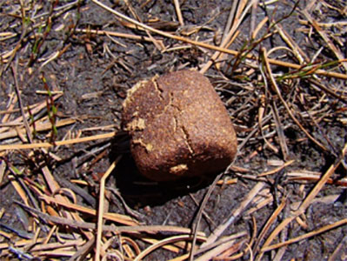 图 2：袋熊特有的方形粪便
（在袋熊的洞穴外）。由于消化系统持水性极高，袋熊的粪便比骆驼的要干燥四倍。每只袋熊可能有多达 12 个洞穴，其中 3-4 个洞穴是它们主要居住的地方。有时袋熊也会共用一些洞穴作为白天歇脚的地方，因为晚上觅食会让它们离 “ 家 ” 很远。
育儿袋的设计
即使是在有袋类动物中，证据也于进化论不利，反而指向一位造物主。例如，如果所有有袋类动物都源自一个进化出了育儿袋的共同祖先，正如进化论者所说，那么这个育儿袋最初是朝哪边开的呢？在不同的有袋类动物中，育儿袋有的是朝后开的，有的是朝前开的。袋熊和袋獾的育儿袋开口是朝后的—— 这对于挖土洞的动物来说是很好的设计。但对于袋鼠来说，若是育儿袋开口朝下，每次跳跃时，向下的力就会把小袋鼠从袋中甩出。小负鼠在树枝间跳跃时的情况也一样。所以，对这些有袋类动物来说，开口朝前的育儿袋才是更合理的设计。
如果一个共同的祖先首先进化出了育儿袋（不管开口是朝前还是朝后），那么在它不断进化的后代中，至少有一个支系的育儿袋的开口一定要转过来。人们认为进化是在漫长的时间内由许多小的偶然增量促成的，每一个增量都因其优越的生存价值而被选上。然而，为什么自然会 “ 选上 ” 一个仅转到一半（尚未完全转完）的育儿袋，使它的主人明显不适合生存？智慧设计的解释显然更好！ ⁹
似乎上帝在设计袋熊和其他有袋动物，以及和它们相似的胎盘类哺乳动物时，祂是有意地挫败自然主义（唯物论）对大自然的解释。正如《圣经》所说，祂的作品实在叫人无可推诿（罗马书 1:20）。

参考文献和注释
1. 除非另有说明，本篇文章的内容均出自Triggs, B., Wombats, 2nd Edn, CSIRO Publishing, Collingwood, Australia, 2009.
2. Wombania’s wombat information centre, wombania.com, acc. 29 June 2017.
3. Wombats, bushheritage.org.au, 22 May 2017.
4. The wombat boy, ABC Australian Story transcript, abc.net.au, 25 March 2002.
5. 澳洲野狗可能是东南亚土著人引入的家犬，现游荡在大陆的大部分地区——creation.com/dingo.
6. 参见 creation.com/badger.
7. 除了美洲负鼠，一种有袋动物，生活在北美。
8. Batten, D., Are look-alikes related? Creation 19(2):39–41, 1997, creation.com/lookalikes.
9. 无尾熊（考拉）的育儿袋更好地说明了智慧设计——参见： creation.com/practical-pouches.

原文章名：The wombat ‘Badger’ of the south
原文见：国际创造论事工https://creation.com/wombat

行走在水面上的蜥蜴
原文章名：The ‘water-walking’ lizard
走在水面上的蜥蜴？皇冠鬣（liè）蜥属（Basiliscus ）又常被不恰当地叫作‘ 耶稣蜥蜴’，这显然是借用主耶稣在水面上行走的神迹。
但更准确的说法是：蛇怪蜥蜴（basilisk，大家也这么叫）在水面上奔跑。

蛇怪蜥蜴有四种，分布在墨西哥南部至南美北部的多个地区和美国佛罗里达州。它们是游泳、攀爬的健将。受到猎食者威胁时，它们会在水面上疾跑，逃离危险。
与门徒目睹的神迹不同，蛇怪蜥蜴的这个能力是在神用以托住万有的自然法则下运作的。这类蜥蜴的巨大的后脚上有长长的脚趾，第三、四、五个脚趾两侧都生有鳞片。在地面上的时候鳞片会收起来；而在水面上，鳞片就会打开，使脚的接触面积变大。

单车踏板式运动
想一想单车的踏板和曲柄是如何转动的。蛇怪蜥蜴的后肢（曲柄）也是以同样的方式运动。一只脚（踏板）向下拍击水面。随着布有鳞片的脚的面积增大，这种拍击产生的气腔就像气垫一样，暂时支撑着蜥蜴的体重。
一开始拍击水面的那只脚会继续在水中向后蹬，从而产生前冲力；同时，水对脚产生相应的‘ 后’压力能（在短暂的瞬间）封闭气腔。此时，另一只脚也正在抡起，准备拍击水面，制造另一个气垫。
靠这种‘ 踩踏板’ 式的运动（运动轨迹更像椭圆形，而非圆形），任何一瞬间都有一只脚以水借力。水面上的每一步也会稍稍划向外侧，与毒蜴的长尾（起平衡作用）同步协调，这样蜥蜴就能保持直立的姿势。
所有这些动作都迅速进行。每只脚必须在气腔完全破碎前就从中跨出去，这个动作用时不到十分之一秒。这对蛇怪蜥蜴来说并不是问题，最轻巧的蜥蜴每秒能走20 步，¹
蛇怪蜥蜴在水上的速度可接近10 千米/ 小时，它们的奔跑距离可达20 米，然后它们会因疲劳开始下沉。虽然大型成年蜥蜴也能施展这项惊人的本领，但是未成年的小型蜥蜴却能跑得最快和最远，因为按比例来算，它们能获取的支撑力比其体重要大得多。重两克的蜥蜴能获取它体重的225% 的支撑力，而重200 克的蜥蜴能获取的支撑力固然更大，却也只有体重的111%。2 蛇怪蜥蜴一下沉就会进入慢速的游泳模式。
哈佛大学应用力学教授托马斯· 麦莫汉（Thomas McMahon）论到蛇怪蜥蜴，这样说：“ 我们用蛇怪蜥蜴身上学到的力学原理，就能设计出能在水面上疾行的机器。”¹人不断从自然界观察到的事物中获得设计和仿造的灵感，但他们很少承认原创的设计者和创造者。³ 蜥蜴在水上奔跑并不是超自然现象，但神的创造之工却一定是超自然的。两千年前在水面上行走的那一位正是创造了蜥蜴类动物的造物主。

参考文献和注释
1. Cromie, W.J., Biologists discover how to walk on water, news.harvard.edu/gazette, 4 April 1996.
2. Glasheen, J.W. and McMahon, T.A., Sizedependence of water-running ability in basilisk lizards (Basiliscus basiliscus), J.Experimental Biology 199:2611–2618,1996; life.illinois.edu.
3. For more examples of such biomimetics or biomimicry, 更多仿生学例子，请参考：creation.com/biomimetics.

原文章名：The ‘water-walking’ lizard
原文见：国际创造论事工https://creation.com/water-walking-lizard

了不起的罗伯特·菲兹罗船长：气象学的先驱
原文章名：The remarkable Captain Robert FitzRoy.
罗伯特 · 菲兹罗（Robert Fitz-roy 1805-1865）正是那艘载着达尔文环游世界的小猎犬号的船长。
wikipedia.org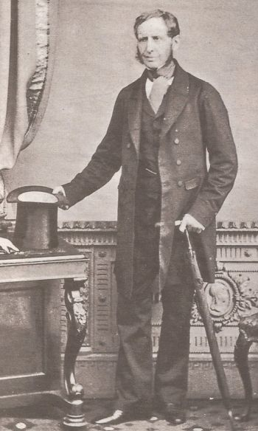
菲兹罗留给人们的印象是一位严肃好辩，易受情绪和抑郁影响的人，甚至最终因此丧命（见 13 页）。不过，达尔文在《自传》中对这位船长有着如下评论：“ 恪尽职守、宽以待人、勇猛果敢、精力充沛、坚强不屈，对谁都是一位热心肠的朋友 ”。¹
成就突出
根据 2004 年出的已补资料翔实的传记 ²，有充分证据表明菲兹罗船长还是一位好丈夫、好父亲。最近，很多人因菲兹罗的成果将他评为一流勘测员和气象学的先驱。他也是为土著谋求利益的维权人士。
小猎犬号上那些人的任务是完成对南美南部海岸的调查。

菲兹罗出生贵族，虽无头衔，却是查理二世国王的曾孙。“ 他坚持要在姓氏中用大写的 R 以象征皇家（非官方）血统。” ³
菲兹罗 13 岁那年加入了皇家海军，之后被派往位于朴茨茅斯的皇家海军院校，接受更为全面的教育 ⁴。教育体系除了经典学科（包括拉丁文和希腊文），还有地理、历史、几何、法语、剑术、绘画、舞蹈以及航海、静水力学、力学、天文学和 “ 天体运动 ”（这包括诸如牛顿的微积分一类的著作）⁵ 1828 年，年仅 23 岁的菲兹罗第一次受任，当小猎犬号的船长。⁶他用实际行动证明了自己出色的航海能力。
当年的船长凡事必须亲力亲为。要驾驭一艘 28 米长、214 吨位的双桅杆横向舵艇帆船 —— 小猎犬号并非易事。这艘船原本是双桅杆横帆船，后来被改造成三桅杆帆船。这类船在当时被称为棺船（coffin ship），因经常在暴风巨浪中倾覆而臭名昭著。⁷ 相比之下，1770 年到达澳大利亚波特尼港湾，由库克船长掌舵的著名的奋进号则更坚固，也更安全，那是一艘 32 米长、335 吨位的三桅帆船。⁸
小猎犬号船员的任务是完成对南美洲南海岸的勘察，这项任务是在另一位船长带领的首次航行中启动的。与此同时，这次任务还包括天文观测，使用 22 个精密的天文台计时器进行一个完整的经线测量循环。这些计时器是菲兹罗购买的，收藏在他的小船舱中。⁹
科学荣誉
费茨罗伊（FitzRoy）将创世记1（Genesis 1）中创世的日子理解为原本的24小时工作日，他将自然与圣经视为一体。

1830 年，菲茨罗伊船长驾着小猎犬号驶过当时还没有进入地图的好望角。他勘察了该地区，绘制了第一批测绘图。这些水域航行的船舶直到二战后期仍然在使用。¹⁰ 1837 年，皇家地理学会授予菲兹罗协会金质奖章，这是对他成就的认可。
1831 年 12 月，菲兹罗带上了年仅 22 岁的查尔斯 · 达尔文，开启了今天广为人知的旅行。长年在海上航行的船长通常过着孤独和封闭的生活。虽然菲兹罗着重于测量和水文学，但他想要有一位旅途的伙伴，能对航行地点的动植物进行科学观察。达尔文喜欢打猎（大家都说他喜欢射猎一切会动的东西），也是一名出众的自然学家、甲虫专家，并曾在著名地质学家亚当 · 赛治威克（Adam Sedgwick）的门下学习地质学。
剑桥大学植物学教授约翰 · 亨斯洛把达尔文引荐给了菲兹罗船长 ¹¹，随后没多久两人就见了面。菲兹罗十分欣赏这位年轻人，便决定在接下来超过五年的时间中一起乘着小猎犬号环球旅行。
菲兹罗的圣经观
菲兹罗是一位虔诚的基督徒。从他的文字中可以看到，航行刚开始时，他对创世记也心存疑惑，不能肯定大洪水是否是全球灾难。经航行期间的观察，尤其是地质方面的观察，他的疑惑一扫而光，荡然无存。¹² 他对圣经的研读以及对人类迁徙和天文学的观察，使他更加确信创世记是一卷完全值得信赖的准确史实。^{13、14} 菲兹罗把创世记第一章中 “ 日 ” 按字面理解为 24 小时的 “ 日 ”，在他看来，自然和圣经同源共流。他不认同培根的观点，认为自然和圣经好比两卷不相干的 ‘ 书 ’，这个观点盛行于当时的大学界。菲兹罗接受圣经字面意义，这一做法后来得到了妻子玛丽的鼓励，玛丽也是一位虔诚的信徒。

达尔文的惊世海行记
说来很具讽刺意味，菲兹罗亲自送给了达尔文一本查尔斯·莱尔撰写的《地质学原理》, 为此他十分懊悔。书中对大洪水的否定、对现被称为 “ 深时 ” 论的倡导刚好为达尔文提供了一个他建构反圣经的假说所需要的平台。
在 2009 年 —— 达尔文 200 周年纪念，国际创造事工通过全球筹资，制作了一部关于小猎犬号旅程的高质量纪录片 ——《达尔文惊世海行记》。
Movieguide.org 称之为 “ 一部有史以来制作最佳的纪录片之一 ”。除了戏剧性重构了达尔文的一生和他的著名旅行之外，现场采用的精湛录制拍摄技术，在现代知识的聚光灯下，让科学家们重新审视了那些能帮助说服达尔文的地质构造和动物。这部纪录片能够温和且有力地打开进化论的禁锢思想。纪录片有 DVD、蓝光和视频格式，可以输入《达尔文惊世海行记》在国内网络上搜寻并购买，批量购买赠送亲友可享优惠。
更多荣誉
1851 年，菲兹罗在达尔文的支持下成为了久负盛名的皇家协会的成员。菲兹罗在旅行记录的《自白》论说，从观察巴格达尼亚的地壳压紧的特征，他认为海水“ 一定非常深，巨大的水压将地球和地壳压得如此严实 ”，而这个造成沉积物“聚合”的移山造海之力，正是源自 “ 全球大洪灾 ”。¹⁵
观察南美“土著”的外貌特征，他下了一个正确的结论：“ 不同的发色和肤色可能仅来源于两个先祖 ”。¹⁶ 菲兹罗把人的起源于原始状态、源自动物祖先的观点视为“ 荒诞 ”。
二十年后的 1859 年，达尔文发表了《物种起源》，遭到菲兹罗的竭力反对，因他否定创世记，取而代之用自然选择解释生命的多样性和设计特征。
1860 年那场韦伯福斯主教和赫胥黎的著名（但被严重歪曲报道的）¹⁷ 辩论，菲兹罗也在场，据称他反复 “ 举着 ” 圣经，称自己 “ 对达尔文先生一书的出版深感懊悔，并认为赫胥黎教授的言
论不是对事实的逻辑阐述。”¹⁸
抑郁、自杀和饶恕

抑郁症困扰了菲兹罗一生，最后在 59 岁夺去了他的生命。虽然人们从来不能确切知道心理疾病的真正原因，人已离世，更无从得知。但是今天我们知道，遗传 ¹、环境因素和生活方式都有一定影响。
有些人对此可能感到疑惑，真正的信徒也会自杀吗。菲兹罗自杀是否意味着他其实没有跟随基督？虽然自杀是严重的罪，但并不是一个不能被赦免的罪。菲兹罗符合圣经标准的信心有目共睹，这让我们信徒可以盼望再次见到他。到那日，不再有“悲哀、哭号和疼痛，因为以前的事都过去了。”（启示录 21:4).

- 即躁郁症，许多学者都认为菲兹罗患躁郁症（参见 Jones, S., View from the lab: journeys of the mind, telegraph.co.uk, 17 August 2005）。他的叔叔也死于自杀。对双胞胎的研究表明这是医学上认为遗传性最大的一种情况。而且他经常复发的抑郁症史（伟大布道家司布真也有雷同经历）都说明这至少是实际存在的一种可能性。.
推行正义
遗憾的一个主要根源似乎是他的小猎犬号首领为达尔文意识形态发展做出了无意的贡献。

1843 年菲兹罗告别航海生涯，担任新西兰的总督。他以公义维护毛利人的权益闻名，包括使得毛利人自愿出售土地后能得到最大收益，自然也因此四面树敌。^{19、20、21}
他挂冠还乡后，又担任了气象部部长。曾为水手的他，深知天气预报在海上的救命作用。菲兹罗综合自己对好望角狂风的观测和经验，设计了一个可靠的晴雨表，撰写了《气象书》（1858年出版）—— 一本预测天气变化的手册。²²
走出阴霾
菲兹罗一生中经历不少遗憾。其中一个最为主要的就是，他从未想到自己担任小猎犬号船长一事竟然无意间辅佐了达尔文发展其学说 —— 这明显会夺走（后来的确也夺走了）人们对上帝和圣经的信心。
虽然在达尔文著名旅行中担任船长是他留给今人的主要印象，但他高尚的品格以及所取得的许多重大的成就也不应该被遗忘。
导航系统
菲兹罗记录了北大西洋的天气规律后，开发了一个风暴预警系统，使用沿岸桅杆上的视觉信号，让远处船只也能看到。他的系统用三角形或正方形、圆锥形和圆柱形内的灯来警示船只有大风或狂风的危险。不久之后，这个新系统就被法国采用，紧接着又传到其他国家。
罗伯特 · 菲兹罗的仁爱豁达为众人所知，许多生命因此获救一定是他的一大欣慰。²³

 | Sun, Dec 27, 5:19 PM (2 days ago)
  Song Huang

This US Presidential election offers a great lesson for me. As we know, most of the so-called main-stream media block any election protest information. However, many Chinese language individual media hosts did report greatly what are going on. Outfits such as e-poch, 阿波羅網,希望之聲 and a few others are much cautious in their effort to validate the news. But a large portion of the chinese self/individual hosts are not. They try hard to sensationalize the news/opinion to attract their audience.It seems to me that apparently they can attract on-line donations and receive reasonable revenue from their effort. Most of their sources come from the English original source and translate and add-on their speculations to their Chinese language based audients. Even a few individual hosts use prophecies to placate their audiences to get revenue.
Because of main stream media's anti conservative, anti Trump and anti Bible bias, these Chinese outlets provide valuable real or fake-news reporting and commentary. I learned to limit my time with them as I can get the English version as well.
I would also venture to say that spending more time to be in God's word shall be a better way of dealing with the current crisis. Multitudes of the human voices do not necessarily make them true. Attached is an article I posted in the www.reminderfromapastor.org on "Reflection on Year 2020". Your comments are solicited.
Song
反思2020
我們正在快速接近2021新年。 在反思2020年，大多數人會同意，對人類來說2020並不是一個好年頭。 記得2020年是Covid-19引起大流行的一年，這一流行病影響了全球數百萬人。 最近新聞又報導了該病毒的新變種，在世界範圍內，這種流行病的影響仍在不斷增長。 造成這種可怕疾病的嚴重後果包括：
1. 全球死亡人數接近200萬人，並且還在繼續增長，其中Covid 19病例超過8200萬人，並且在世界範圍內還在增長。
2. 所有人類活動，包括教堂禮拜，學校，社交聚會，節日慶祝活動和工作都受到影響。 減少了所有面對面的個人互動。 所有個人的人際關係也會受到影響。
3. 商業受到影響。 餐館，公共交通，旅行和娛樂等大小企業受到嚴重影響。 許多人失去了工作和收入。
4. 所有的教育也受到影響，特別是小學生。
5. 由於Covid-19的旅行限制，國家之間的關係也很緊張。 同樣，由於政府留在家裡和停業的命令，使居民和政府領導人之間的關係也很緊張。
6. 在情感上，由於恐懼與焦慮以及失去親朋好友之間的私人聯繫，人們失去了安寧和對生活的信心。
7. 缺乏應對Covid案件的醫院急診床，使人們感到恐懼。

此外，總統選舉和隨後的選舉結果爭奪導致大眾進一步分裂，一些城市的抗議活動和違法行為造成進一步的焦慮。

從積極的方面來說，我們有以下幾點：
1. 已開發出Covid疫苗，其中兩種正在大眾注射中。 我們開始看到Covid 19隧道的盡頭。
2. 我們比一年前知道很多這種病毒的特殊性質。 並有多種治療選擇。 居民越來越廣泛使用面罩和社交距離。
3. 經濟正在復蘇，充滿希望。
4. 世界上有小戰爭，但沒有大規模戰爭。
5. 在Covid 19的新限制下，大多數人仍會盡其所能應付焦慮。
6. 選舉混亂也將很快結束。
7. 上帝仍然掌控一切。 人們仍有基本是非的念頭。

可以公平地說，我們比過去幾年現在更需要平安。 有人會問你在說什麼樣的平安？ 讓我們看看聖經告訴我們的。
A. 什麼樣的平安
約翰福音14:27，27 「我留下平安給你們，我將我的平安賜給你們。我所賜的不像世人所賜的，你們心裡不要憂愁，也不要膽怯」。這節經文的上下文背景是：主耶穌在被釘十字架之前的晚上在頂樓傳道中安慰了他的門徒。 因此，我們所有人需要的和平是耶穌的平安，而不是世界的和平。 世界的和平來自地上，我們的主給予的平安來自天上。
B. 如何獲得這種平安
世界和平基於力量，賄賂，威脅和欺騙的談判。 世界的和平充其量只是暫時的，而不是真正的和平。 證明：只要看看人類的歷史就會知道。
然而，我們主的平安是在他裡面。 主耶穌要把他的平安給他喜悅的人。 就像天使向牧羊人宣告他的出生的好消息一樣，路加福音2:14，14「在至高之處榮耀歸於神！在地上平安歸於他所喜悅的人！」。對於基督徒來說，我們的主在他頂樓傳道的話語安慰了我們：約翰福音16:33，33「我將這些事告訴你們，是要叫你們在我裡面有平安。在世上你們有苦難，但你們可以放心，我已經勝了世界」。要獲得他的平安，就必須在他裡面。
C. 不要被欺騙
除非我們與上帝和好，否則我們將永遠不會有和平。 耶穌基督在十字架上的犧牲使上帝與那些相信的人和解。 因此，不要相信精英可以為這個世界上的任何事物帶來任何和平解決方案。 證明：只看世界歷史上所有國王，州長，哲學家，革命主義者和所謂的精英們的徹底失敗。
因此，只有相信耶穌基督，我們才能擁有真正的平安!


Jack Jiang |  |  | Dec 25, 2020, 11:07 PM (9 hours ago)
转载一个网友聊一聊美国大选争议的话题。非常有料也很有道理
自上周五白宫会议以来，大家都在谈话戒严的话题。在信息有限的情况下我也被林伍德律师骗了，因此也谈了。根据当时的情况，我分析依赖1月6日众参两院认证选举人票时通过众议员与参议员挑战选举人票达到翻盘的目的有一定的风险，所以认为戒严是最有把握的手段。
在鲍威尔律师发推澄清没有把戒严作为选项之后（她很少发推，她发推说的话具有相当的可信度），我开始相信川普总统确确实实是没有把戒严当作一个选项。再回推来考虑川普似乎也不是一个喜欢使用武力解决问题的人，使用武力解决问题不符合川普总统160智商的头脑。他在解决中东问题时，是所有总统当中运用武力最少但解决问题最多的总统。他处理问题，往往让人无法预料。
我一直在说他的目标不是总统连任而是抽干沼泽，朋友们在交流时的观点是总统不连任如何抽干沼泽。实际上，在选举之前之后这段时间里，他所干的事就是在抽干沼泽，他一直在抽，但我们不知道，以为他象祥林嫂或者秋菊一样喊冤叫屈打官司，要争取总统连任。实际上大错特错了。他是借着打官司之名，在干着抽干沼泽之实。直到他把大小牛鬼蛇神都抽到露出沼泽的烂泥，我们才慢慢发现川普总统好象在努力加大他的抽水机的马力，而不是在争取连任（因为他老神在在，一点都不担心连任问题）。川普把乔治亚州的州长与州务卿抽出来了，他把高院首席大法官约翰罗伯兹抽出来了，他把参议院议长麦康奈尔以及他太太赵小兰的家族生意抽出来了，他把佩洛西及其家族生意也抽出来了，他把中共武汉档案抽出来了，他把败灯儿子腐败案抽出来摊在阳光下让美国人民知道，他把中共翟东升如何渗透颠覆美国政商的鱼也给抽出来，他把中共女间谍渗透民主党的情况以及民主党内陷入中间谍报的人都抽出来了，他把陆军总司令与陆军参谋长也抽出来了，他把美国的媒体与媒体平台的恶劣表现展现给美国人民看，他让美国人民对高院产生怀疑了，他让美国人民看到立法机构里一张张丑恶的脸，让人民知道自己投票都选了什么样的人来服务国家。一条一条的大鱼甚至大鳄鱼都抽出了烂泥。
你可能会说，so what?把这些沼泽里的鱼都抽出来，若川普连任不了不也是白搭吗？
若你要是这样想的话，你就真的大错特错了。我说过多次，美国这个西瓜虽然受到中共的毒农药所侵蚀有点坏了，但本质没有烂掉。美国的宪法精神没有死，美国的民主价值没有死，在美国人民知道真相之后，美国人民生气了愤怒了，美国人民站出来维护宪法了。
我多次说过，川普总统的团队，大家在任何时候都看不到他们象是马上要离开白宫或是行政团队的样子，每个人都信心满满，相信川普总统必胜，干自己该干的事。必胜靠的是什么？靠的是宪法，靠的是人民。
怎么说呢？美国有反叛乱法与戒严法。大家可能因为这两个法都要动用到军队而把它们混为一谈，以为反叛乱法就是戒严法，实际上这两个法完全不同。戒严法是暂时冻结现有的一些法律的适用、让司法机关立法机关暂时失去功能，针对的范围是全民，这会影响到民众的利益。而反叛乱法是现在已有的法律，即叛乱情况出现，只要动用现有的法律就行，对叛乱者叛国者进行正常的执法，所以动用反叛乱法要比动用戒严法要容易一些也不会对民众有更多的伤害。从川普总统一向对人民的爱与重视来看，他内心是不会愿意动用戒严法的，当然如果需要动用到戒严的情况出现时，我相信他也不会犹豫对这个法律的使用。实际上，民主党也害怕川普总统动用反叛乱法，所以才在疏困法案里偷偷夹带上禁止总统使用反叛乱这一条跟疏困毫不相干的东西，以期废掉川普总统的武功。左媒疯狂炒作戒严法也是给民众一个反感川普总统的印象。实际上，我认为，目前情况，美国民众对总统使用任何手段维护宪法恢复选举诚信都是支持的。
这个时候，大家也许有一个疑问，既然不想动用那为什么福林将军与林伍德律师一整天大喊大叫动用戒严法？这个大家要非常的明白，川普总统团队的人分工是非常有策略与艺术的（川普总统身边的人似乎不多，但每一个人都是有顶尖脑袋瓜的人）。林伍德律师就是个大型抽水机，他的大喊大叫把沼泽里的鱼儿吓得乱跑乱跳，包括乔治亚州的州长马上向川普总统投诚然后乖乖核对签名重新点票，总统也邀请他与女儿参加白宫18日的圣诞晚会。今天朱利安尼说乔治亚州一两天之内会有重大突破，可能要召开特别会议重新任命选举人。林伍德还把高院首席大法官约翰罗伯兹吓得可能也要在宾州的案子上表态。林伍德叫民众准备生活用品等，把左媒引导到戒严问题上去，给川普总统打了最好的掩护，让川普总统在其他方面着手解决问题，包括使用个小把戏通过国防部交接个所谓的机密情报给败灯，结果败灯团队马上传给的中共，半个小时之后中共就知道了这个情报，这样就证实了败灯团队里通中共的事实。川普总统如果想动用反叛乱法的话，实际上马上就可以抓捕败灯了，但川普总统象吃饱的猫玩弄一只老鼠一样把败灯玩弄于股掌，让它跑掉再把它按住。林伍德大叫戒严，也让白宫幕僚长梅多斯露出了马脚，当然白宫法律顾问西波龙也露出头来并且被川普总统立马直接开掉，最重要的是把陆军总司令与陆军总参谋长都钓出来了。
大家可能比较着急，你说不使用戒严法也不使用反叛乱法，那川普总统怎么赢呢？
实际上，这里有个问题必须澄清一下，川普并没有完全否认不使用戒严法与反叛乱法，而只是说到目前为止，没有把它们当作解决选举纠纷的选项，但并不表明未来不会。
大家都看到了川普总统号召民众1月6日去华盛顿，表面上看是去抗议选举不公，实际上是去观看川普总统如何在议会获得胜利。
前面说了通过议员提出挑战选举人票然后辩论以获得权变选举的机会，即一州一票选总统与副总统。实际上，根据宪法第12修正案，当天副总统彭斯有非常大的权力，可以说关键在彭斯，即他可以根据当时的情况与宪法的规定作废六个摇摆州甚至外加新墨西哥州的选举人票，即79张或84张选举人票，然后根据简单多数确定获胜者，即川普将以232：227或者237：222战胜败灯。
你可能会怀疑，你想得倒是很美，彭斯当天权力再大也不可能随便宣布79张选举人选作废呀。没有错。不过，我要提醒大家一点，你们是不是忘记了大海怪Kraken呢？牺牲了五个三角洲特种部队士兵抢到的服务器里头的东西是不是会在当天放出来呢？不能排除这个可能性吧？因为川普总统老早就知道高院不可靠，所以他一直都没有把这个关键的证据交给高院。通过意外插曲德州诉四个摇摆州案也更加证实了高院的不可靠。假如这个大海怪不是在法院放出来而是在议会两院放出来，直接证明选举违宪，宣布这六个州或七个州的选票作废，民主党的国会议员（说不定都有人卷入其中）还怎么反驳呢？也就是说根本不需要戒严，也不需要外国情报监控法院，宣布了川普总统当选，然后根据反叛乱法抓捕败灯以及参与选举舞弊的相关人员，这也是林伍德所一直大喊大叫的东西，他所喊叫的东西都是有根据有证据的，先给你机会，让你自己主动投诚，做污点证人，死不悔改的，到那一天就不会客气了，抓捕进监狱去牢饭去。
据小道消息，川普总统已经获得梁家河大力士亲自指挥亲自部署做掉川普总统的录音，说务必在1月6日之前消灭川普总统的肉身（这也证实了我前面所怀疑的10月初老川中毒事件是一起政治谋杀）。败灯的老板这样给他下指导棋太TM坑死他了。这样的东西假如弄到议会殿堂上去，是不是许多国会议员都要晕过去了？
所以，川普总统未来的胜选之路还有几条：第一条，彭副1月6日当天废掉79张选举人票，用简单多数解决选举纠纷。第二条，触发权变选举，一州一票。第三条，大海怪在外国情报监控法院放出来，启动叛乱法抓捕败灯等沼泽里的牛鬼蛇神。
大家要非常清楚一点，为何贺锦丽一直到现在还迟迟不敢辞掉参议员职务，这是个指标，她心里太清楚了。
另外再加一条新闻，那就川普总统昨天签署行政命令，做了41项任命。挺好玩，你觉得一个马上要离任的人就剩下不到一个月的时间做任何任命有意义吗？这样的动作象是一个马上要离任的总统吗？不得不提，这41项作保当中的一项任命特别引人关注，那就是任命沃特尼克担任国防部负责情报与安全的代理副部长，这个家伙1986年出生，才34岁。如果你对他没有印象，我告诉你，他就是上一个月指挥突袭德国法兰克福CIA数据中心的指挥官，当时他是DIA的头。他也是最早向川普总统通报CIA正在监视他的人，这一通报导致奥巴马行动的破产，以及后来川普布置抽干华盛顿沼泽的计划
，然后CIA就被DIA反监控了。看了这个，你是不是感觉很崩溃？一个国家的中央情报局居然监控总统，然后国防情报中心反监控中央情报局。本来两个情报机构都应该是为国家服务的，怎么会变成这样呢？当奥黑被审判的那一天，美国人民会知道这个所谓的“万人迷”笑面虎是如何背叛美国人民与美国国家利益的。

2020 Election Fraud Is CCP ‘Assassin’s Mace’: Patrick Byrne
BY SIMON VEAZEY AND JAN JEKIELEK

December 16, 2020 Updated: December 18, 2020
biggersmaller
Print
Election fraud is the secret “assassin’s mace” of the Chinese Communist Party (CCP) that has long confounded security hawks, according to tech billionaire and entrepreneur Patrick Byrne, who back in August assembled a cyber intelligence team to analyze the U.S. voting system.
“For 10 years or more, there have been references to a coming ‘assassin’s mace’ in the Chinese literature—where they take out the United States with one stroke,” Byrne told The Epoch Times’ “American Thought Leaders” program. “The national security community in the United States has been trying to figure this out: Is it their new aircraft carrier? Is that the hypersonic missile? Is it this, that, is it an EMP?”
“I don’t think so, ” he told host Jan Jekielek. “The one stroke that takes the United States out is what we’re experiencing right now.”
The 2020 vote involved “massive election fraud,” he says. “Not voter fraud, but election fraud.”
Byrne has been a driving force in the research for lawsuits filed by attorneys Lin Wood and Sidney Powell. He has also been working together with ASOG, the company that recently carried out the forensic audit on voting machines in Antrim County, Michigan.
Byrne said he started investigations back in August, and that as a result, he anticipated the very irregularities which he later observed in the November election.
He says his team of online security experts now believes Chinese developers are “under the hood” of the software that has infiltrated at least two of the main voting systems in the United States.
Suppliers of such election software and systems involved in the U.S. election have responded to allegations of voting irregularities with consistent denial that their systems can be manipulated or that they have any such connection to foreign governments.

‘Reverse-engineering the Coup’
Byrne described the election as a soft coup.
“We are basically reverse-engineering this coup,” said Byrne, in reference to his team of 30-40 people.
Byrne says that he fell in with cyber experts who had been looking at election manipulation since 2018 when they were hired as part of a blue-ribbon commission set up to examine potential election fraud in Texas.
“That group has had two years to really reverse engineer what the rest of America has had a couple of weeks to understand,” he said. “They had already figured out really about a dozen different ways you could defeat an election or hack an election—in a broad sense of hack, not necessarily just electronic cyber guys hacking.”
According to Byrne, they found cheating was possible “at an industrial level, in terms of generating hundreds of thousands of fake votes.”
Byrne says the pattern of manipulation can be identified through examining three key points—what he calls “three buckets of facts.”
“One bucket is understanding the systems themselves and how they were built: the functionality that was built into them and the vulnerabilities that exist.”
The second bucket, he says, relates to how the election process played out. “[In the event of fraud] you would expect people to have certain experiences when they either go in and vote or if they volunteer and work in the precincts.”
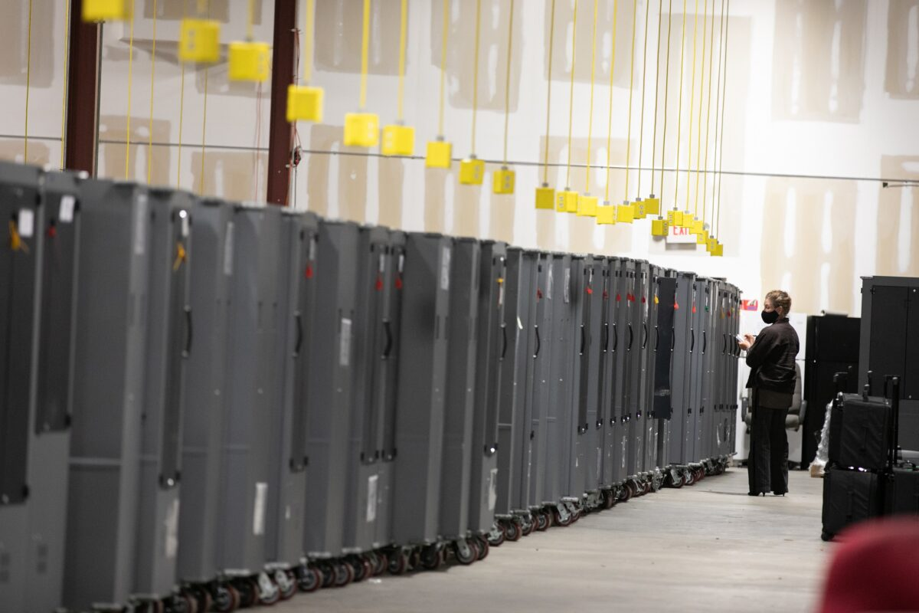A Georgia Republican Party poll watcher looks over voting machine transporters being stored at the Fulton County Election Preparation Center in Atlanta, Ga., on Nov. 4, 2020. (Jessica McGowan/Getty Images)
He gives the examples of vote tabulating being shut down, of poll watchers being denied entry, and of the video of election workers pulling out cases of ballots from under a table after observers had gone home and then scanning them.
The third bucket, he says, is the extreme statistical outliers that would be thrown up by such a manipulation process.
“Things like that happened—these statistical outliers: Having 123,000 votes in a row going to one candidate; or in Pennsylvania, I believe it was 580,000 votes got processed that were 99.4 percent for Biden… and they came through exactly when all the Republicans had been told they had to leave.”
“They’re on the order of you winning the Powerball lottery this week, and next week and the week after—and that happening in dozens of places around America at the same time.”
“When you put those three different narratives together, they also just come together perfectly. They all reinforce each other.”

Traced to China
Byrne says that the manipulation of the voting systems can be traced back to China.
“There’s a chain of command basically from China through Iran to Cuba and Venezuela,” he said. “The Chinese are funding Smartmatic through the Panamanian division of Smartmatic, but it bounces through Venezuela.”
“There is code buried within the Dominion machines that has been turned up that seems to show Chinese provenance.”
“There are Chinese developers under the hood of this stuff back in China who are actually getting their software into the Smartmatic systems which have infiltrated at least two of the main voting systems used domestically.”
Smartmatic’s headquarters located in Boca Rotan, Fla., on Dec. 2, 2020. (The Epoch Times)
“I say this as a guy who loves China,” he adds. “I speak Chinese, I have a great affection for China and the Chinese people—but I’m not such a big fan of the CCP.”
Smartmatic says its products were used only in one LA county in the U.S. 2020 election and has consistently denied any claims of wrongdoing or involvement in voter or election fraud past or present. It says it has no involvement with any governments or political parties or with Dominion.
Dominion Voting Systems has also consistently denied any wrongdoing or vulnerabilities in its systems and said that it does not use software owned by Smartmatic and that it has no ownership ties to the governments of China, Cuba, or Venezuela. Dominion products are used in 28 states.
Byrne, however, says that software created by Smartmatic went through a series of corporate mergers, acquisitions, divestments, and licensing agreements before ending up in at least two of the main commercial voting systems being used in the United States, including Dominion. “Its genetic lineage [goes] back to the software,” he says.
A number of other analysts have signed affidavits to the same effect.
Dominion has also come under scrutiny for its ownership structure after its parent company raised funds with the help of a Swiss bank before the 2020 U.S. presidential election. The transaction, peculiar in several ways, has led some to speculate that a Chinese entity could be an indirect investor in the company.
Byrne says that stealing the national election doesn’t require cheating across the board. “There are six counties that you need to steal. If you steal these six counties around the country, that flips the six states they’re in, which flips the electoral college votes that come with them, which flips the nation, ” he said. “You’ve got to take six places and cheat like crazy there.”
He says that some online security experts, who he describes as white hat hackers, say that they would give the election systems a rating of just one or two out of 10 for security.
Follow Simon on Twitter: @SPVeazey
Follow Jan on Twitter: @JanJekielek

Former Wisconsin Judge: ‘Our Court System Has Been Deeply Intimidated by the Left’
By Janita Kan
December 20, 2020 Updated: December 20, 2020
biggersmaller
Print
A former judge from Wisconsin, who is now representing the Trump campaign in the state, told lawmakers this week that he believes intimidation by the left has prevented lawyers and judges from accepting and hearing election fraud cases.
“We have to acknowledge that the court system has been deeply intimidated by the left, just as the lawyers have been intimidated,” James Troupis told the Senate Homeland Security and Governmental Affairs Committee on Wednesday. “And that’s a sad, sad state of affairs.”
The committee was conducting a hearing that explored voting “irregularities” from the 2020 general election. During the hearing, witnesses testified about a litany of alleged instances of election fraud occurring in multiple contested states.
Their claims are backed up by mounting evidence from witnesses, whistleblowers, and data experts that have emerged in recent weeks alleging that a proportion of ballots cast and counted in these battleground states were done so under irregular and fraudulent circumstances. Much of the evidence was presented through affidavits in the lawsuits filed by the Trump campaign or third parties, and through state legislature hearings hosted by Republicans.
During the Senate hearing, Troupis, one of the witnesses, explained why he decided to represent the campaign in their effort to challenge election results when many lawyers refused. He said that he believes many prominent law firms did not want to participate in the election lawsuits due to a fear of retaliation by the left.
“One of the reasons I was called because virtually every major law firm in this country and in this city refused to represent the president. Not because of the lack of merit in his claims—we’ve certainly demonstrated that there’s merit—but because of the cancel culture,” Troupis said.
“Because of the environment that has been created by the left that has intimidated lawyers so that they can’t be here. They’re not here, from the giant law firms, precisely because they were ordered by their management committees and others that, ‘You cannot take those cases. The reasons you cannot take those cases is because our clients, or the Democrat party, or the incoming administration will remember that and they will hold it against you.'”
He added, “As a former judge, I was so incensed by that.”
This comes as other lawyers representing the president and his campaign have revealed that they have been harassed or threatened following their decision to take up election cases.
One of the lawyers, Linda Kern, who has since withdrawn from a Pennsylvania case, had to be placed under official protection after receiving “threats of harm.” Kern revealed in November that she had “been subjected to continuous harassment in the form of abusive emails, phone calls, physical and economic threats, and even accusations of treason—all for representing the President of the United States’ campaign in this litigation.”
Kern said that some of the harassment came from a lawyer from an opposing firm—Kirkland & Ellis, which is representing defendants in the election case—who left a minute-long voicemail that “falls afoul of the standards of professional conduct.” Another Kirkland lawyer defended his firm, saying that the call was “discourteous and not appropriate” but disagreed with Kern’s characterization. The firm eventually withdrew from the case.
Similarly, Trump campaign legal adviser Jenna Ellis said she’s received “hundreds” of threats, including anonymous phone calls, since taking up election cases.
Despite the difficulties, many Trump campaign lawyers and attorneys from third-party lawsuits are pushing forward with their legal challenges seeking to invalidate certain ballots until concerns over potential fraud are transparently and independently addressed.
However, many of these cases have been tossed out by judges for procedural reasons, such as lack of standing to bring a case; lack of jurisdiction to sue; mootness, where there is no longer a controversy between the parties; and laches, where a judge ruled there was a lack of diligence in bringing a claim. Other judges were not convinced by the allegations presented.
Ellis told The Epoch Times’ “American Thought Leaders” in a recent interview that the “fight is not over” and that the president has until January to continue with their legal efforts.
Jack Phillips contributed to this report.
Follow Janita on Twitter: @janitakan

Redacted Information in Dominion Audit Report Shows Races Were Flipped: Analyst
By Zachary Stieber
December 19, 2020 Updated: December 20, 2020
biggersmaller
Print
The analyst who led the forensic audit of Dominion Voting Systems in Michigan said on Friday the information state officials pushed to redact shows that the outcomes of races were changed.
“The original report had log evidence that we published in the report to show exactly what we did and exactly the findings. Now, those did ultimately get redacted. And so now, the complaint is ‘well, but there’s no real proof and Dominion says ‘no, these things can’t be done,'” Russell Ramsland Jr. said during a virtual appearance on Newsmax’s “Greg Kelly Reports.”
“But at that point, Dominion’s argument is no longer with us. Dominion’s argument is with their own user’s manual and their own logs, because the logs—had they been able to be published—show very clearly that the RCV [ranked-choice voting] algorithm was enacted. It shows very clearly that the error messages were massive. It was very clearly [sic] that races were flipped,” he added.
Michigan Secretary of State Jocelyn Benson’s office didn’t respond to a request for comment.
Ramsland and his team at Allied Security Operations Group earlier this month audited Dominion machines and software in Antrim County, where officials on election night reported a win for Democratic presidential candidate Joe Biden. The officials later said the results were skewed and that President Donald Trump actually received more votes in the county.
The audit was the first conducted post-election of Dominion products. It was part of a court case.
Lawyers for Benson, a Democrat, asked 13th Circuit Judge Kevin Elsenheimer in court last week to order the redaction of code before allowing the release of the report, arguing publishing the the code could be a security issue. Matthew DePerno, the lawyer for the plaintiff in the case, said the information in question was just setting errors that Ramsland’s team found.
Elsenheimer ultimately sided with the state, saying he didn’t want to allow the release of potentially propriety information. The judge said he might allow an unredacted version of the report to be released in the future.
In the audit, Ramsland said his team concluded Dominion’s voting system “is intentionally and purposefully designed with inherent errors to create systemic fraud and influence election results.”
“The system intentionally generates an enormously high number of ballot errors. The electronic ballots are then transferred for adjudication. The intentional errors lead to bulk adjudication of ballots with no oversight, no transparency, and no audit trail. This leads to voter or election fraud. Based on our study, we conclude that the Dominion Voting System should not be used in Michigan. We further conclude that the results of Antrim County should not have been certified,” he added in the report.
Officials disputed the findings in a court filing, alleging the report “makes a series of unsupported conclusions, ascribes motives of fraud and obfuscation to processes that are easily explained as routine election procedures or error corrections, and suggests without explanation that elements of election software not used in Michigan are somehow responsible for tabulation or reporting errors that are either nonexistent or easily explained.”
Before the report was released, Benson’s office noted the audit had happened, while urging voters to “be wary of false claims.”
Benson said after the report was made public that the Nov. 3 election in the state and across the country “was the most secure in the nation’s history” and alleged “there continues to be no evidence of widespread fraud.”
Dominion’s CEO John Poulos in a state Senate hearing this week disputed the report’s conclusions, and the company said in a statement that “the claims made in the report are technologically impossible,” adding, “Dominion machines did not—and could not have—’switched’ or enabled the ‘switching’ of any votes.”
Perno on Friday said on Twitter he was looking forward to Benson’s deposition.
Ramsland on Newsmax predicted the emergence of more explosive information soon.
“I think that there’s going to be some information [to] come forth in the next few days, that is going to drastically change the playing field,” he said.
“And the real question is, will people report on it? We’ll see.”
Correction: A previous version of this article included an inaccurately transcribed quote. The Epoch Times regrets the error.
Follow Zachary on Twitter: @zackstieber

Trump Says Voting Machines May Have Been Breached by SolarWinds Hack During Election
By Allen Zhong
December 19, 2020 Updated: December 19, 2020
biggersmaller
Print
President Donald Trump said on Saturday that voting machines may have been hacked during the November election.
“There could also have been a hit on our ridiculous voting machines during the election,” he wrote in a Twitter post.
The president apparently was referring to the SolarWinds hack which caused a number of government agencies to be compromised.
He said the hack is not as big as it’s reported.
“The Cyber Hack is far greater in the Fake News Media than in actuality,” he wrote. “I have been fully briefed and everything is well under control.”
He also criticized the media for ignoring China as a possible origin of the hack.
CISA and Dominion Voting System didn’t respond immediately to requests for comments from The Epoch Times.
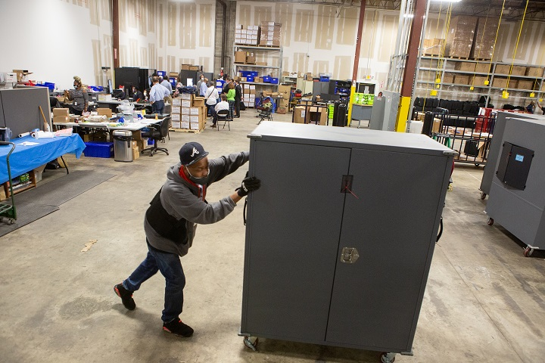A Fulton County employee moves voting machine transporters to be stored at the Fulton County Election Preparation Center in Atlanta, Ga., on Nov. 4, 2020. (Jessica McGowan/Getty Images)
The Cybersecurity and Infrastructure Security Agency (CISA) issued an emergency directive on Dec. 13 announcing that a known compromise involving SolarWinds Orion products are being exploited by malicious actors.
“The compromise of SolarWinds’ Orion Network Management Products poses unacceptable risks to the security of federal networks,” CISA Acting Director Brandon Wales said in a statement.
SolarWinds said in a recent filing that up to 18,000 customers may have had the tainted software. The company ignored warnings that its software could be accessed using a simple password.
Non-Orion products don’t appear to have been compromised, SolarWinds said.
SolarWinds’s approximately 300,000 customers include government agencies and all five branches of the U.S. military, according to a partial customer listing it has since taken offline. The Energy Department, Department of Commerce, Microsoft, Pima County government in Arizona, Cox Communications among other institutions have confirmed their systems were influenced by the recent safety breach.
The CEO of Dominion Voting Systems, the company under controversy after the November election, said on Tuesday that the company has never used the SolarWinds Orion platform which experts believe was breached by hackers as far back as last year.
“We don’t use the SolarWinds Orion package that was the subject of the DHS report from the 13th,” CEO John Poulos told legislators in Michigan via video link.
A screenshot of Dominion Voting Systems’ website shows the use of SolarWinds software. A spokesperson from the company said they don’t use SolarWinds Orion Platform. (Screenshot/Dominion Voting Systems)
However, a screenshot of a Dominion webpage that The Epoch Times captured shows that Dominion does use SolarWinds technology. Dominion later altered the page to remove any reference to SolarWinds, but the SolarWinds website is still in the page’s source code.
Poulos said Dominion hasn’t ever used the Orion platform.
“Dominion Voting Systems does not now—nor has it ever—used the SolarWinds Orion Platform, which was subject of the DHS emergency directive dated December 13, 2020 (Emergency Directive 21-01),” a Dominion Voting System spokesperson said in a statement to The Epoch Times.
Zachary Stieber contributed to the report.
Follow Allen on Twitter: @AllenZM

老公刚祝贺拜登当选，赵小兰就被曝遭众议院调查
@jenreport 发表时间：2020年12月15日(星期二)美西17:43
据《华尔街日报》周二报道，众议院监督和改革委员会正在对赵小兰是否利用她作为交通部长的身份为其家人谋取利益展开道德调查。
在周一发出的一封信中，该委员会要求赵小兰交出与她家族的航运公司沟通的相关文件，以及她的部门与一家建筑公司的互动，直到最近她还在该公司拥有股票。作为交通部长，赵小兰也负责监督国家的航运业。
监督委员会主席Elijah Cumming和众议员Raja Krishnamoorthi在信中写道：“委员会正在审查你对事实的错误陈述，你的行动可能使你继续持有股票的公司受益，以及你对道德和财务披露要求的遵守情况。”
监督委员会的信中说：“有几份报告显示，你利用你的公职为Foremost集团谋取利益，这家航运公司由你的父亲和姐妹拥有，总部设在纽约，经营着一支运输物资进出中国的船队。”信中提到了今年早些时候《纽约时报》和《政治家》的报道：“这些报道表明，你利用你的官职提升了Foremost集团在中国政府中的影响力和地位，中国政府向该公司提供了数亿美元的低息贷款，用于购买悬挂外国国旗的船舶。”
交通部发言人证实收到了这封信，并表示该部门期待着对委员会的要求作出回应。
该发言人说：“媒体针对部长家人的攻击是陈旧的，只是试图破坏她长期的公共服务生涯。”
《华尔街日报》今年早些时候报道称，赵小兰仍然拥有美国最大的碎石、沙子和砾石供应商Vulcan Materials Co. 材料公司的股份，该公司用于道路铺设和建筑，尽管赵小兰承诺放弃这些股份。
她在今年6月份出售了Vulcan股票。市场数据显示，从2018年4月赵小兰曾表示将套现股票，到6月3日卖出股票，Vulcan股价上涨超过16%，她净赚超过5万美元。
赵小兰与参议院共和党领袖麦康纳尔（Mitch McConnell）结婚多年。麦康纳尔在各州选举人投票后，于周二在参议院发言说：“选举人团已经说话（投票）了，”所以“我要祝贺当选总统拜登”。

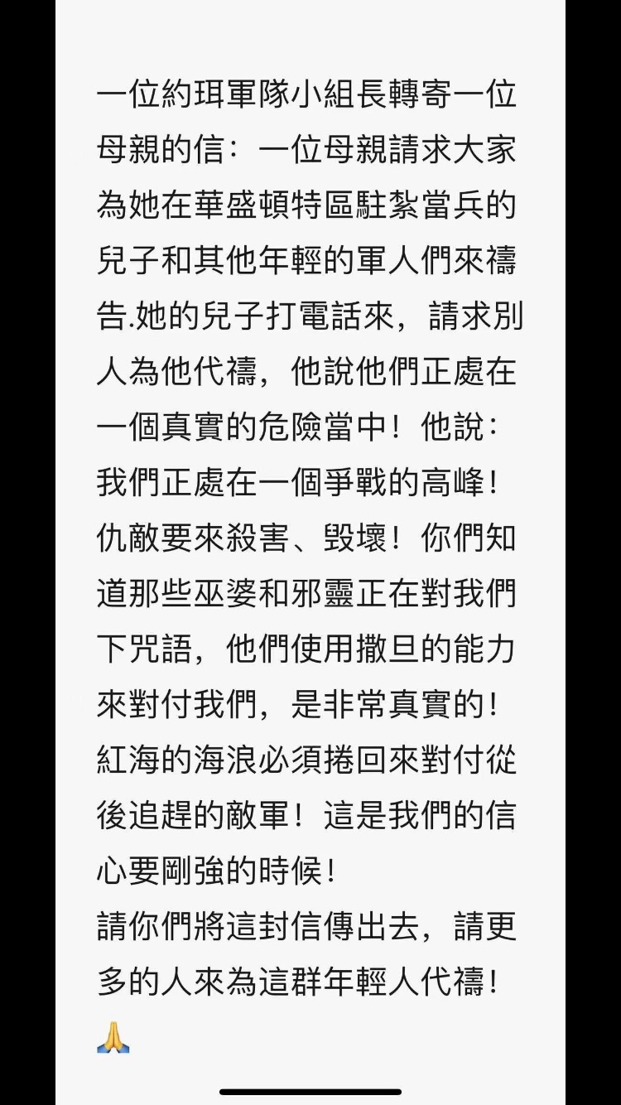
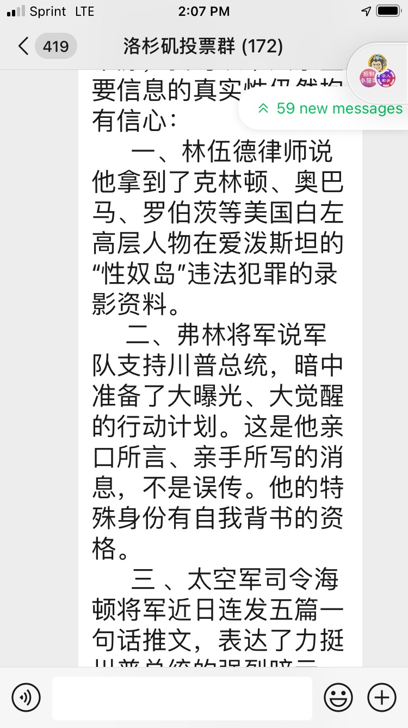
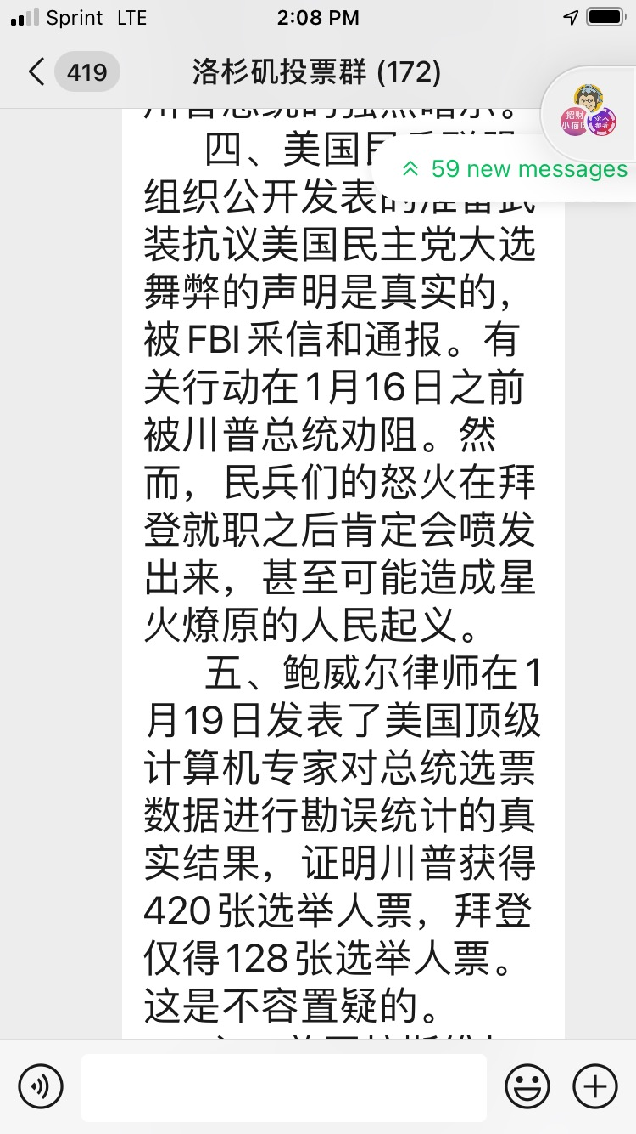
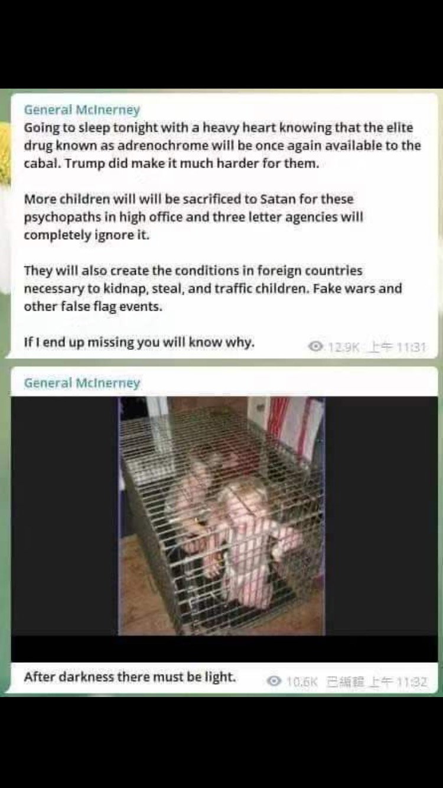

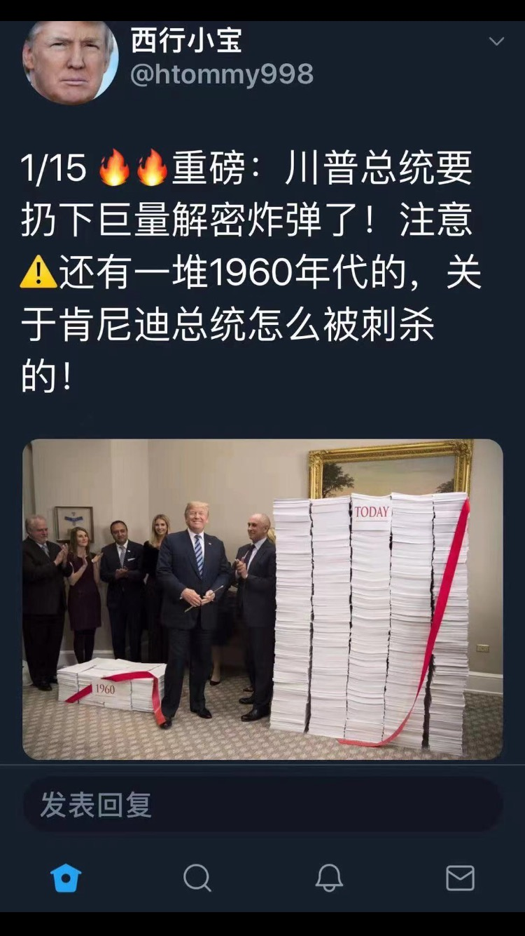

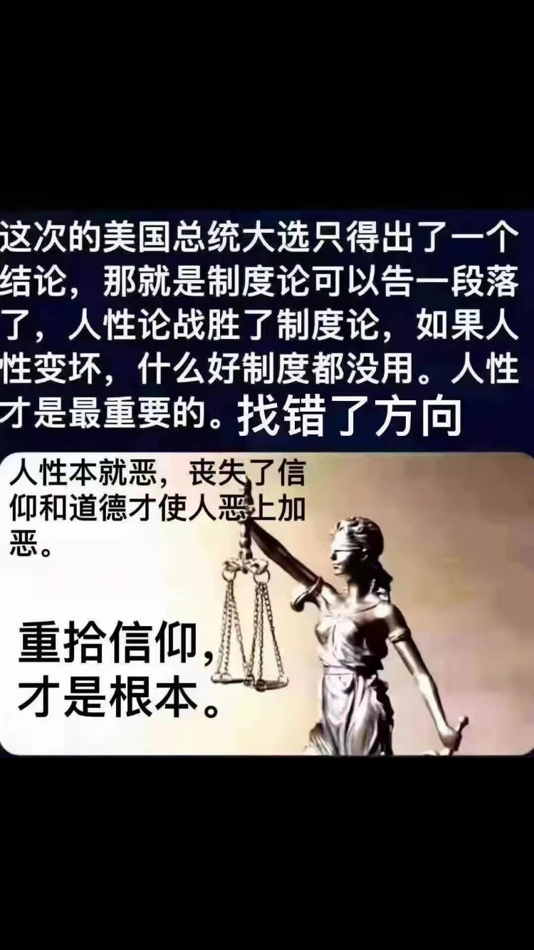

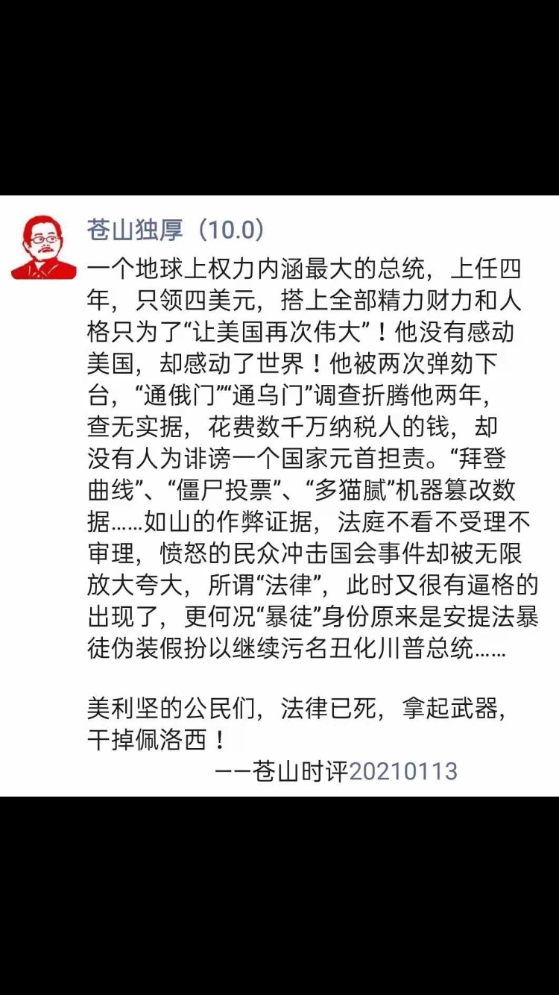

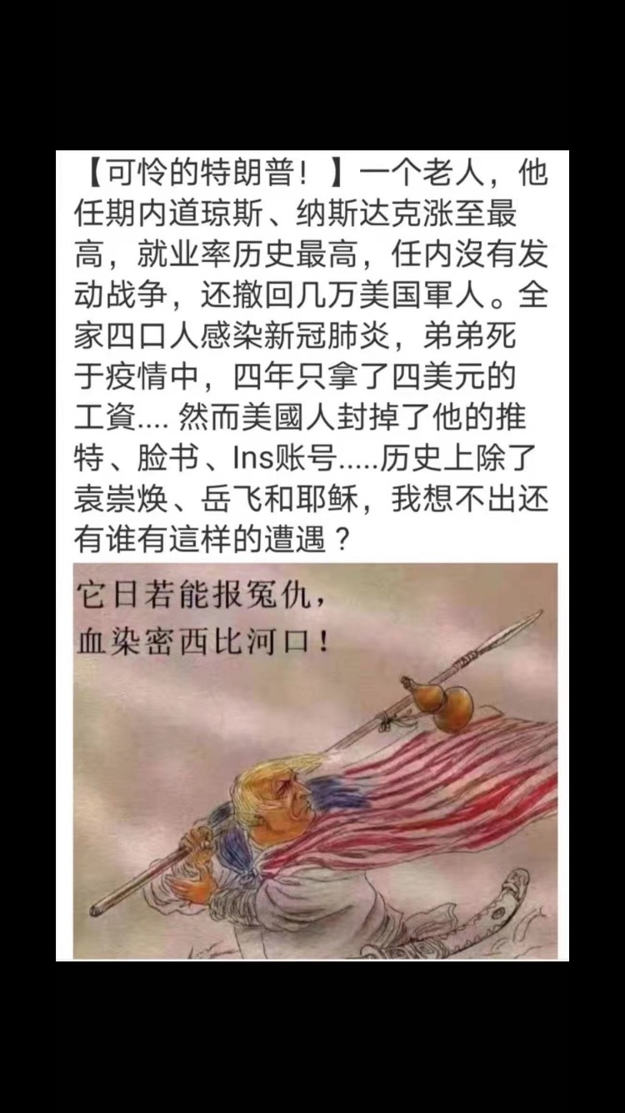


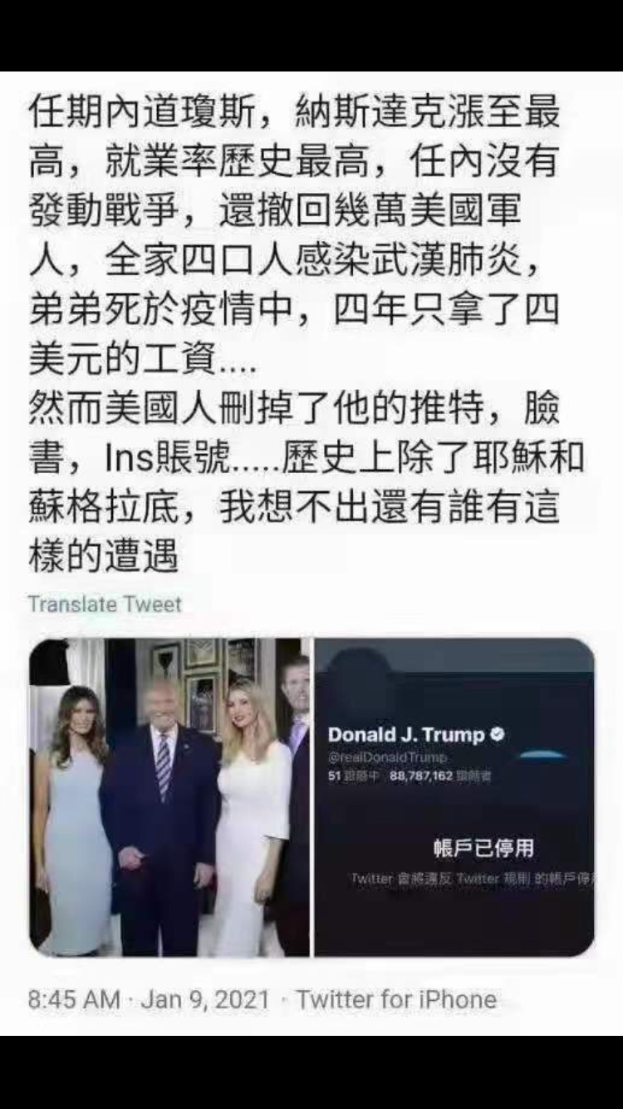

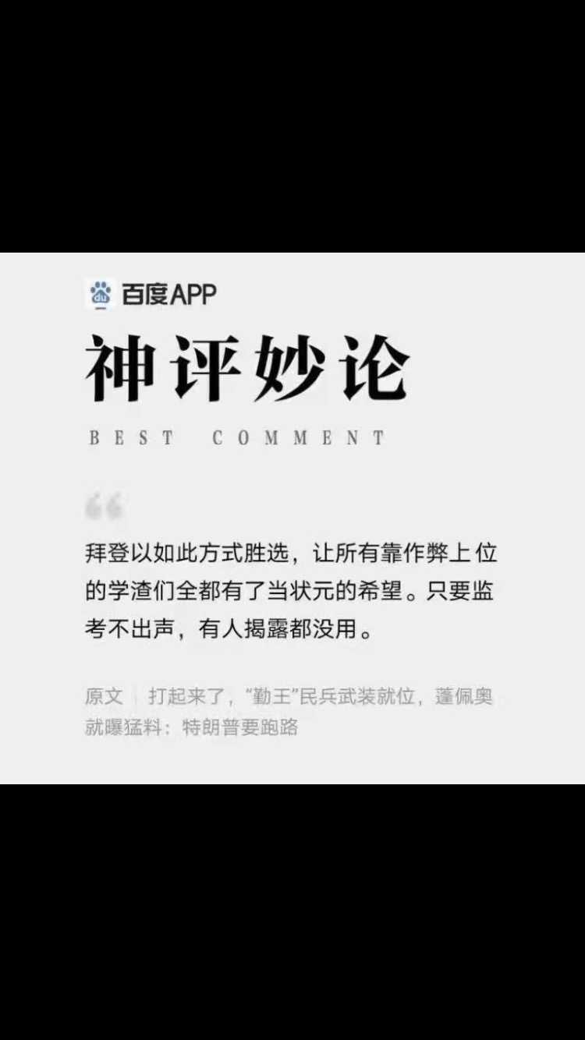
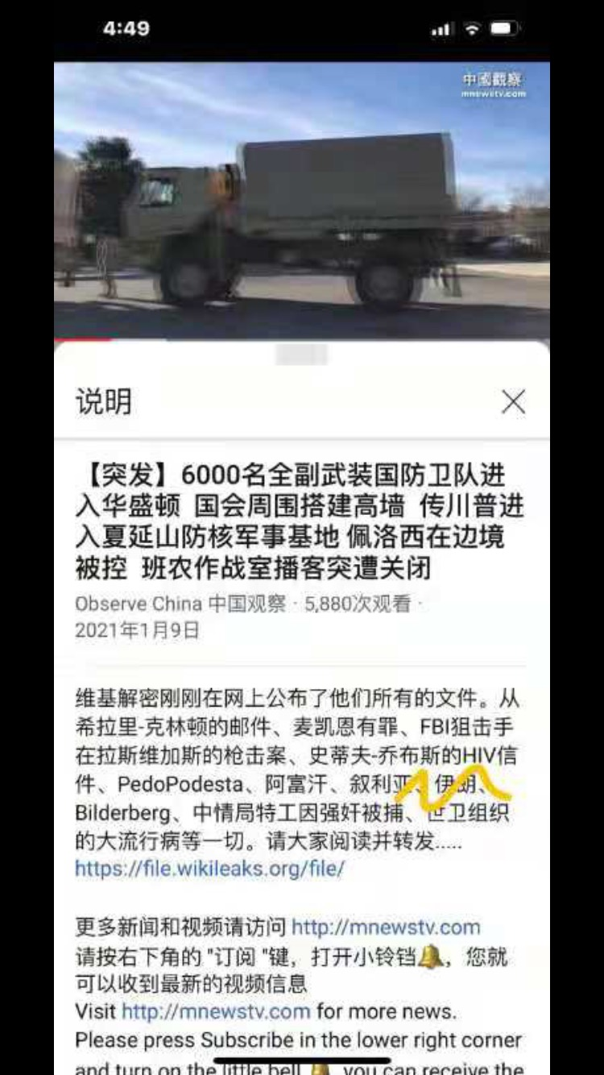
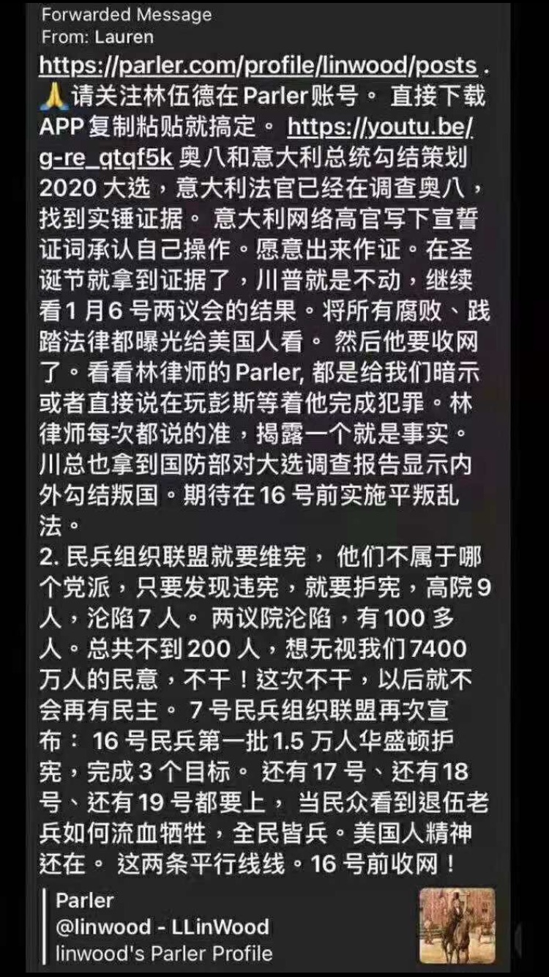

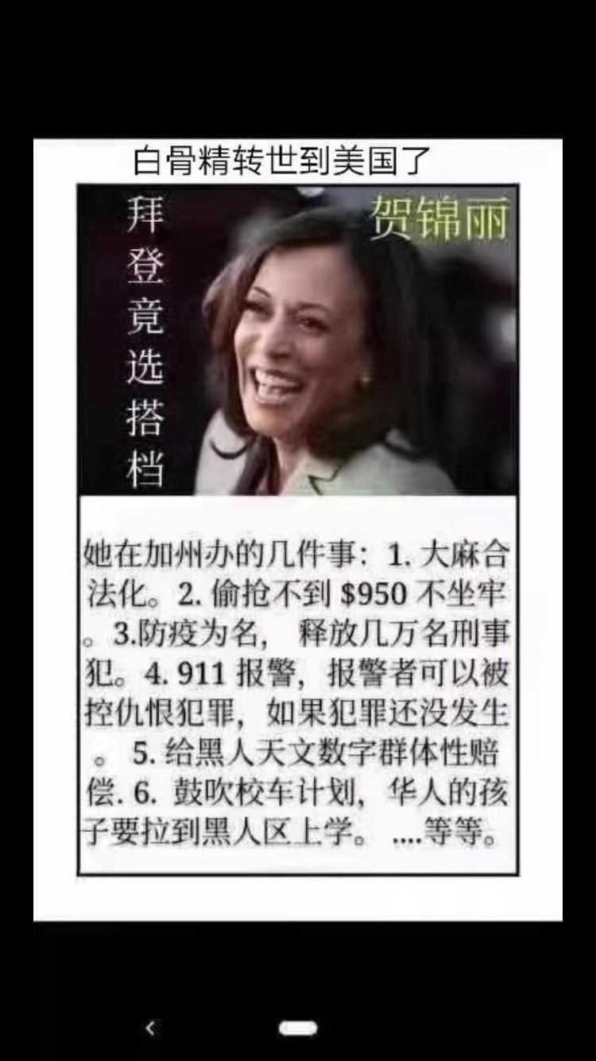

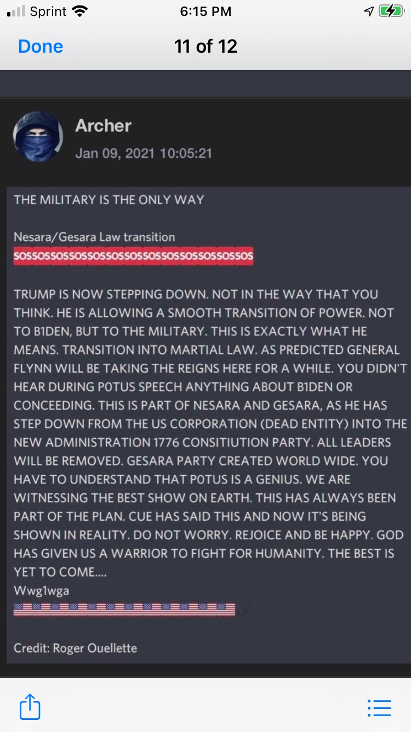



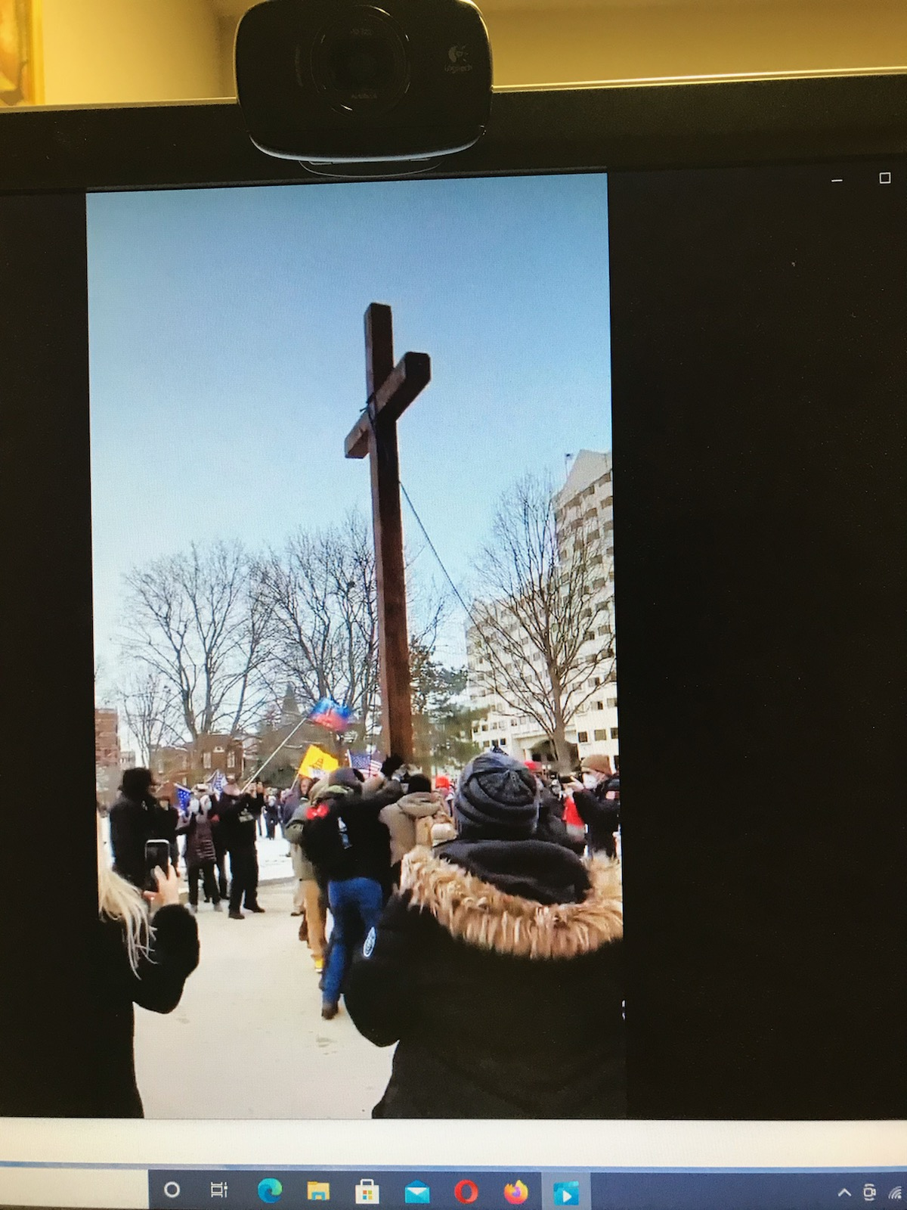

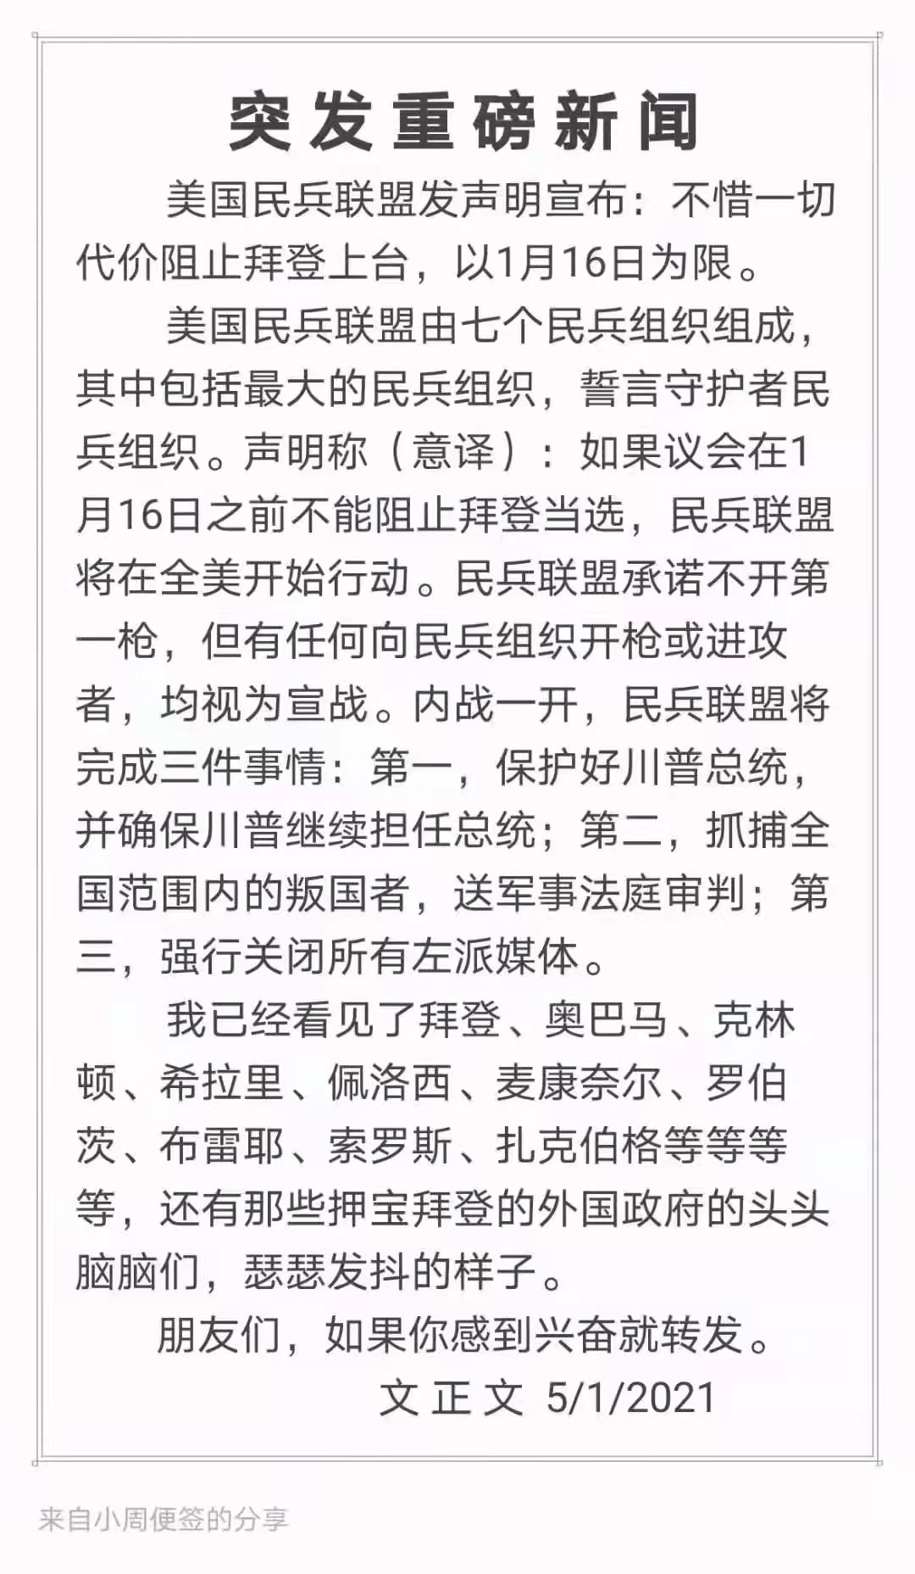



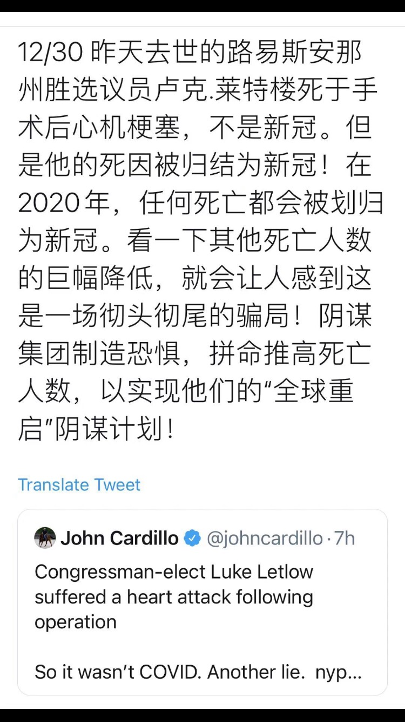

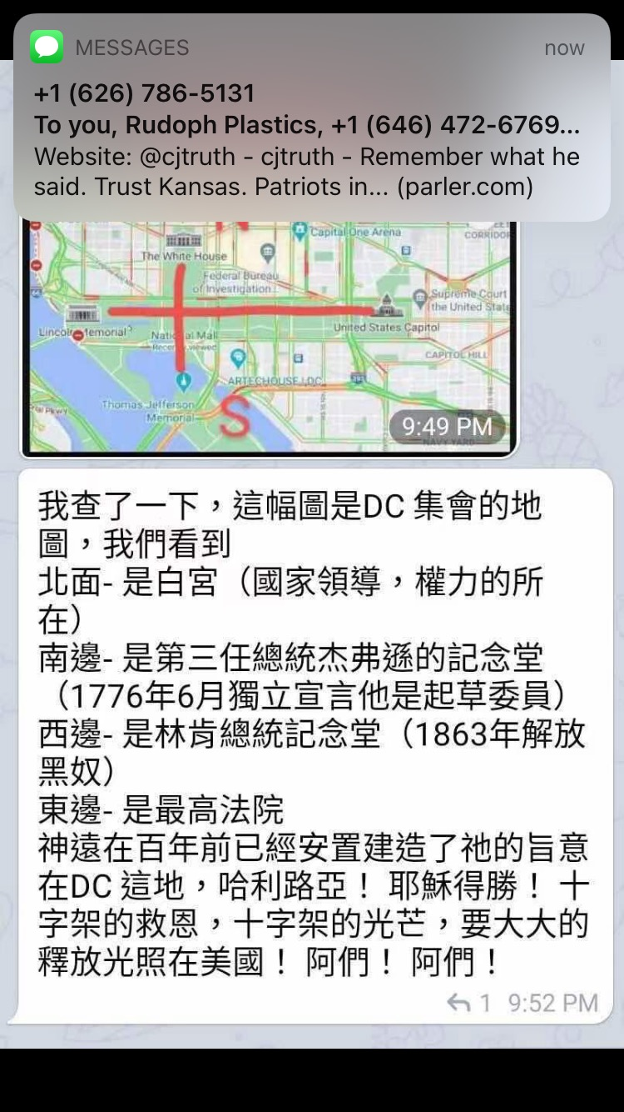

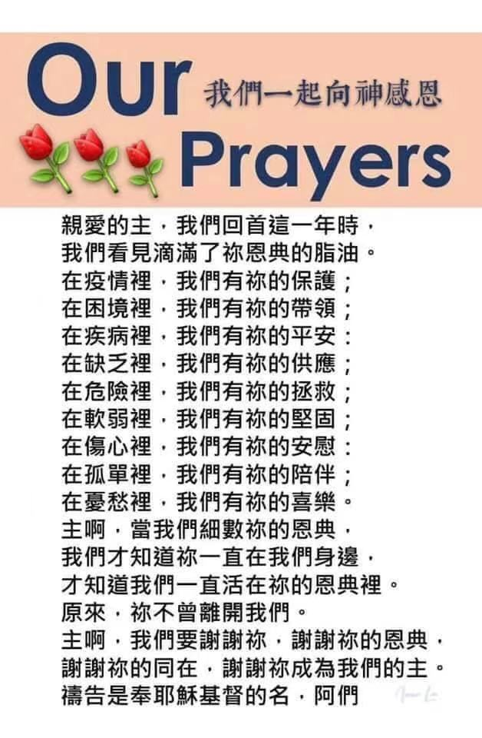

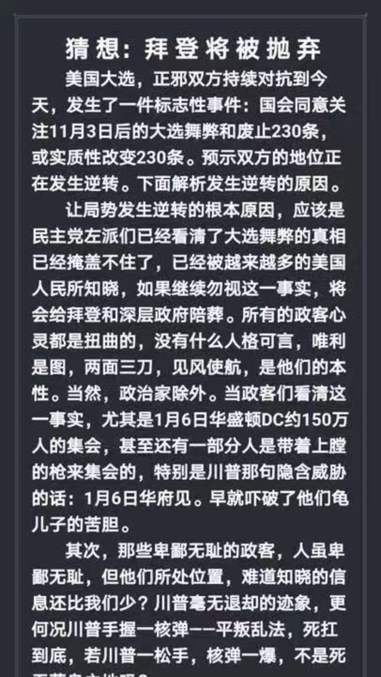

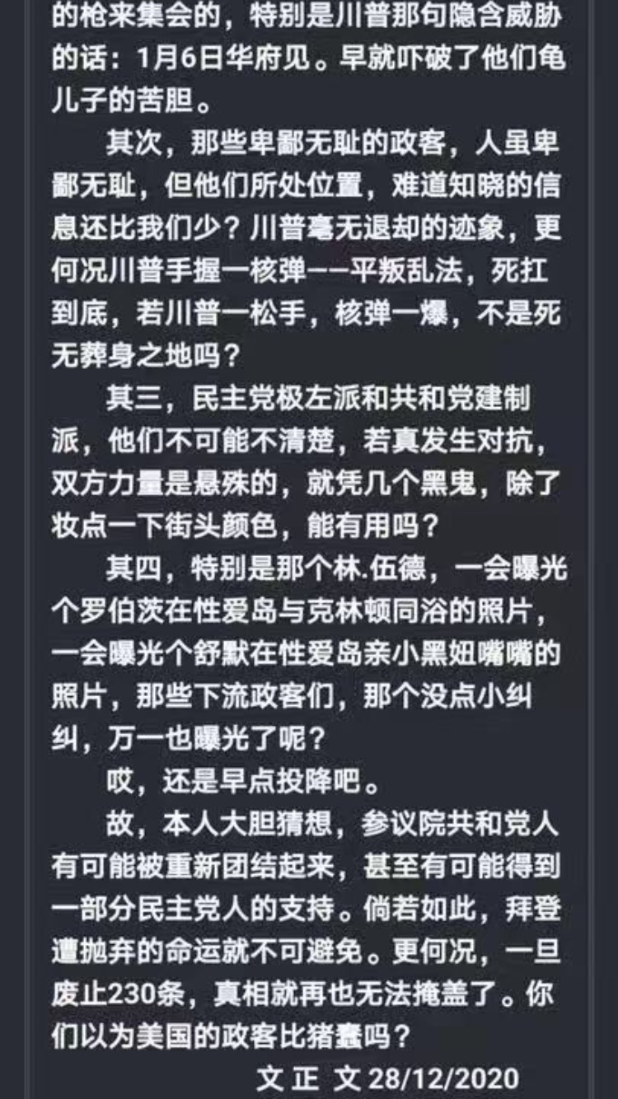

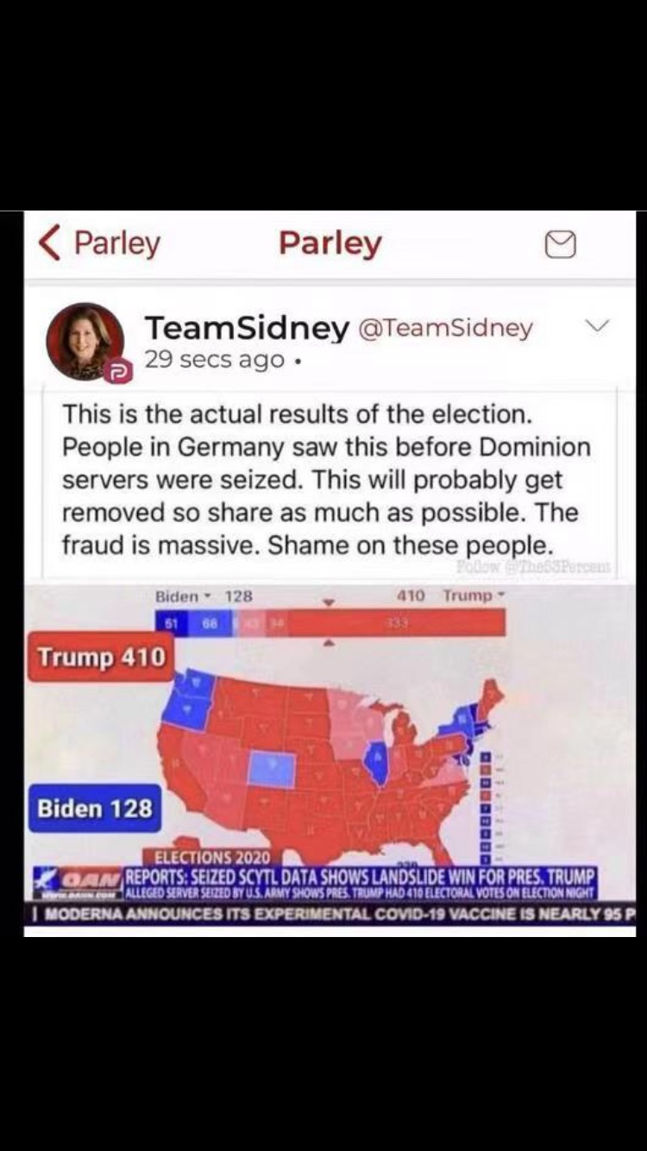

此地无银三百两 | 连浓眉大眼的司法部长巴尔也这么说？
Jerry Zhao 萧笙客 Today 12/6/2020
先是主流媒体众口一词说这次大选是有史以来最安全的大选，任何大选舞弊的指控都是捕风捉影。

再是劈柴哥的公司，Fakebook 和Twister 公司在网上提到大选舞弊的地方都要加上说明说拜登已经赢了大选，任何关于大选舞弊的提法都是有争议的。

最后是浓眉大眼的司法部长 Bill Bar “巴尔” 说他没发现有“可以改变大选结果”的舞弊行为。

这不是三人成虎吗？

最让人崩溃的是教会里有人在群里说川普律师团队的指控是莫须有！我怎么也无法把拜登和岳飞的形象放在一起，倒是想起了通俄和通乌门的闹剧中民主党的做法和秦桧的整岳飞的操作很像。

说起证据，不外乎两种。一种是间接证据（线索），一种是直接证据（实锤）。

比如说县上小张几次下班时，都发现自己太太从隔壁老王家里出来，神情慌张，衣冠不整。

老王理直气壮地说他只是给小张太太补习俄语。小张打听了一下，老王根本没学过俄语，而小张的太太对俄语从来没兴趣。

小张怀疑太太和老王有染，他有没有实锤证据？没有，因为没有抓奸在床。可小张有间接的证据（线索），所以他到派出所报案。

派出所的毕所长对小张的处境比较同情，可人家老王是县人大代表啊，毕所长抬头不见低头见。所以毕所长连走廊上的监控也懒得看，就放话给小区的街坊邻居说没有发现老王和小张老婆通奸的证据。

小张要上法院，他得有有实锤证据。他找私家侦探帮忙，可私家侦探还没来得及在老王家的卧室安装针孔摄像头，小张老婆就抢先一步在老王的陪同下到法院要求离婚，说和小张没感情了。

小张此时的心情大约等于川普在大选后的心情。

但这次大选舞弊案，川普团队不仅有间接证据（线索），更有很多实锤。

由于主流媒体包括狐狸台都选择 忽视任何川普律师团队的诉讼，而各州的法院都像躲瘟神一样躲着，川普的律师团队改变策略，开始带着证人向各州的议会做公开的听证会。

美国的选举是民主集中制，由选民投票，但538张选举人票是由各州的议会来定的。一般议会是会随从民意，但如果议会认为选票有诈，可以自行决定把选举人票给川普。

听证会一方面可以争取议会的支持，也可以造势对法院尤其是最高法院造成舆论上的压力。但我认为听证会最大的作用是让美国人民了解了第一手的选举舞弊证据。
Rudy Guiliani 和 Jenna Ellis 马不停蹄在关键的几个州穿梭，迄今为止已经在宾州（1场），亚利桑那州（1场），乔治亚州（1场），密西根州（2场）举行了听证会。

这是了解大选舞弊的最佳途径，强烈建议观看至少一场。油管上都有，我把链接附在文章的最后。

Rudy 和 Jenna 在密西根的议员前作听证会。一共5 个证人，前后5个小时。因为这次证人较少，每个证人都有充足的时间（不像上次听证会每个人只限3分钟）。油管上这个听证会已经有一百万万的观看量。

第一个证人叫Jessy Jacobs. 她是来自印度的移民在底特律政府某个部门作首席工程师。可以算上是人生赢家， 三个孩子都上医学院。这是她第一次公开作见证。可以看出来，她是挣扎很久才决定出来的。她是一个虔诚的天主教徒，见证过程中她一直握着天主教徒用的念珠。

她心情沉重地告诉大家这次民主党在选举的每个环节全方位作弊。

她和其他几十个人一起被民主党安排在邮寄选票的申请日期上作假，数量高达十几万张。

后面她在投票站工作时发现民主党的志愿者明目张旦诱导选民填拜登，来投票的人没有任何证件而且在签名与花名册上的签名差十万八千里的情况下也可以填选票。
邮寄选票必须在11月三号晚上八点前寄到否则作废，但她发现连四号收到的票都被改为收件日期为二号。

验票时每张桌子上要求有一个民主党和一个共和党监督，可她发现很多桌子上两个人都是民主党人。

她做完见证后，每个议员都可以提问。有个奇葩民主党议员CA Johnson, 对选举的事一个问题都不提，却盘问Jessy 的 名字，Jessy Jacobs 是不是她的真名，有没有中间名，分明是用来人肉的。议会主席赶快提醒不可威胁证人，Jessy 看起来身体很虚弱，但她这时分明把个人安危置之度外，不卑不亢地把她长长的印度中间名报了出来，没有一丝的惧怕！

第二个见证人叫Mellissa Carone, 她是有两个孩子的妈妈，在大名鼎鼎的Dominion 投票机公司的合同工。她在底特律TFC 中心计票站工作，看到计票员把同样的票扫很多遍。她听说有一个地方叫芝加哥仓库，假票都从那里出来。
11月4日凌晨川普领先时，她的主管说有数据丢失，所以要去芝加哥仓库，一去就是几个小时。

Mellissa 是个川粉，政治倾向比较明显，所以对她的见证不是很利。后来无数的左媒对她的人格进行疯狂攻击。

她的指控都是有名有姓，而且她是宣了誓的，也就是说如果和其他人对质证明她的指控有误，她会进监狱的。与其对她进行人格攻击，强大的左媒难道不该去找这些人对质，把她送入监狱吗？

接下来的证人是一男一女两个印度裔的年轻人。女的叫Hema, 男的叫Andrew. 他们看到共和党的监票员被歧视并被民主党人以各种借口赶出去。

他们看到邮寄选票有各种的猫腻，比如很多张连号（邮寄选票寄回来的时候不可能很多张连号，除非有人造假），信封上的号码和选票上的号码不同（应该是一个号码），很多的信封上签名一模一样。
很多邮寄选票上的日期有年份（2020），月份（11月），但日期却是一个空格。

Andrew的重磅证词是4日凌晨4点半时，民主党的主管Mr. Baxter 从后面的地下室拿出大量的选票。五点钟时前一班人下班后，后一半从5点推到6点，而且计票员绝大部分都是民主党人。
这个时候民主党的主管向大家宣告 “现在真正的民主开始了！”

这是四日凌晨最大两批邮寄选票计票结果。3:50AM 那一批计票结果，近六万张票，拜登占92%，6:31AM 那一批计票结果，近14万张票，拜登占96%！

拜登同学的支持率要赶上金正恩同学了。

一起禱告
Jack Jiang |  |  | 5:25 AM (2 hours ago)
11-24-2020
轉：
為美國大選訴訟案的突破與得勝宣告
http://www.kp24-newway.com/prayer/?recordId=20442
我們奉耶穌的名宣告：
˙神必保守法官的心，與神對齊，不受利誘、恐嚇或威脅， 在每起訴訟中，都能做出公正的裁決，並證明川普總統得勝。
˙神必賜給川普總統律師團隊智慧，能蒐集到所有制敵致勝的證據，將所有作奸犯科者繩之以法。
˙神必保守這些參與訴訟的律師或吹哨人免受邪靈或人身的攻擊，賜下平安、光明、真理和法治。
˙神必使搖擺州選票重新審核確實無誤，以主耶穌的寶血破除任何針對訴訟程序所施的巫術或咒語，所有操控電腦和選票的行為都必被揭露和糾正，使川普總統、共和黨參眾議員得到極大支持，並大獲全勝。
(部分改編自WFJM)
˙爭戰得勝在乎耶和華！神必為川普總統伸冤，取得突破性的進展，勝選臨到正義之方！
˙川普總統必要連任，他必作美國的父。神必將大衛家的鑰匙放在他的肩頭上，他開，無人能關；他關，無人能開。神必使川普總統安穩，像釘子釘在堅固處。(賽22:22-23)
˙神必以耶穌的寶血覆蓋川普總統、他的幕僚、律師團隊和他們的家人，破除所有攻擊他們的巫術和咒詛，拯救他們脫離任何暗殺計畫，保守他們出入平安。(賽54:17)
˙釋放混亂的靈進入反川普陣營，使他們彼此相攻，彼此爆料、速速滅亡！作惡之人，心必如蠟消化；使舞弊者大大驚恐、恐懼顫驚，及時悔改自首，並使其陰謀曝光，完全失敗。(詩55:5)
˙神的審判要臨到那些深層政府的首腦爪牙，將他們一網打盡！使他們所有的權勢要癱瘓瓦解，他們的財務也陷入癱瘓失敗， 惡人的財富要轉移到義人的手中！(箴13:22)
˙釋放更多真理的大光進入美國，聖靈澆灌在美國全地，屬靈的大覺醒臨到美國！使矇蔽的不再被矇蔽，瞎眼的不再眼瞎！

前英国大律师：军情六处情报证实 拜登窃取美国大选
温妮 | 美丽日报
8 hours ago
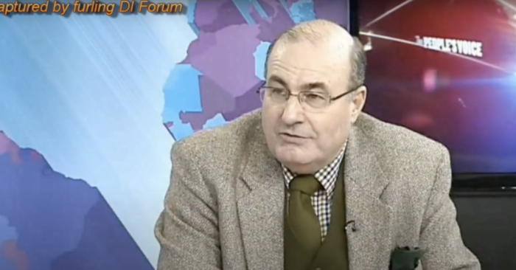
2013年11月27日，前英国大律师迈克尔·史林普顿接受电视专访。（视频截图）
【美丽日报2020年11月21日讯】美国民主党操控大选似乎已经是不争的事实，特别是Dominion服务器的被拿获，一切真相即将水落石出。而针对此次大选舞弊，前英国大律师迈克尔·史林普顿（Michael Shrimpton）披露，早在11月6日，英国军情六处（MI6）就已获得资料，证实本届美国大选确实是一场窃选，拜登不是当选总统，美国正在经历的是有史以来最腐败的总统选举。

Lin Wood tells Mark Levin he believes Trump won ’70 percent-plus landslide … over 400 electoral votes’
November 18, 2020 | Vivek Saxena | Print Article

Get the latest BPR news delivered free to your inbox daily. SIGN UP HERE

CHECK OUT WeThePeople.store for best SWAG!
Powerhouse attorney Lin Wood, the man responsible for Richard Jewell and Nick Sandmann’s successful lawsuits against the establishment media, believes President Donald Trump won the 2020 presidential election in a landslide.
Speaking on conservative commentator Mark Levin’s radio program Tuesday, Wood claimed that all the alleged voter fraud he’s uncovered has him convinced that the incumbent president won over 400 electoral votes in the race.
Enable
11 seconds...
“This election was a fraud. Donald Trump won, I believe, clearly a 70 percent-plus landslide election in the nation. He probably won over 400 electoral votes,” Wood said.
“So we’re uncovering step by step the layers of the onion. And we’re going to get to the truth. And the truth is, Donald Trump has been re-elected by this country to serve as president for four more years. The truth will come out.”
Listen from the 23:42 mark below:
<span data-mce-type="bookmark" style="display: inline-block; width: 0px; overflow: hidden; line-height: 0;" class="mce_SELRES_start">﻿</span>
That’s a bold statement to make, especially given the media’s disputed declaration that Democrat presidential nominee Joe Biden won the 2020 race with 306 electoral votes.
Wood remains confident nevertheless because he, a legendary attorney with decades of experience, genuinely believes the “election was stolen.”
“Donald Trump won by such a large margin that in the middle of the night they had to stop counting. And you’ll see in key states, they started bringing in ballots by the truckload, all of them for Biden, many of them in these mail-in ballots with little bubbles for you to circle over the person you selected all of them for bad[Biden] with perfect circles,” he continued.
“I believe upon examination you’re going to find those perfect circles were made by a computer. This election was stolen, but they got caught.”
But this isn’t some far-flung conspiracy theory to Wood — it’s the “truth.”

Trump Says 2020 Election Was Unconstitutional
BY ZACHARY STIEBER

November 16, 2020 Updated: November 16, 2020

Print
President Donald Trump asserted in a series of new tweets that the 2020 election violated the U.S. Constitution.
Trump, a Republican vying for a second term, started on Sunday, when he wrote: “Many of the court cases being filed all over the Country are not ours, but rather those of people that have seen horrible abuses. Our big cases showing the unconstitutionality of the 2020 Election, & the outrage of things that were done to change the outcome, will soon be filed!”
The president on Monday took aim at two battleground states and the way officials there ran the elections.
Trump repeated claims that Republican poll watchers were blocked from observing ballot counting in Pennsylvania, whose 20 electoral votes he won in 2016. Trump is trailing challenger Joe Biden in the Keystone State by about 69,000 votes, or 1 percent.
Trump then continued with criticism of Georgia’s recount.
“The Fake recount going on in Georgia means nothing because they are not allowing signatures to be looked at and verified. Break the unconstitutional Consent Decree!” he wrote.
Georgia entered a legal settlement after Democrats filed a lawsuit challenging the state’s mail-ballot procedures, accusing officials of not standardizing how they notified voters that their mail ballots were rejected.
The agreement saw Georgia’s secretary of state and Board of Elections agree to tell voters by email, phone, and mail within three days, or by the next business day during the eleven days before Election Day if their ballots get rejected. Voters then have an opportunity to “cure,” or fix, their ballots.
Democratic presidential candidate Joe Biden addresses the media at the Queen Theater in Wilmington, Del., on Nov. 10, 2020. (Joe Raedle/Getty Images)
“This settlement will give Georgians peace of mind that their votes will be counted and that they won’t lose their voices because of flawed state election laws,” Democratic Congressional Campaign Committee Cheri Bustos said in a statement at the time.
Georgia Secretary of State Brad Raffensperger, a Republican, said recently that Trump was misrepresenting the consent decree. Georgia election clerks must verify signatures under state law, he said.
Biden’s campaign didn’t respond to a request for comment.
Biden, the Democratic presidential nominee, declared victory in the election earlier this month after many news organizations projected he’d won over 270 electoral votes.
Trump and his campaign are challenging the results in battleground states like Pennsylvania and at least one state, Georgia, is conducting a recount.
The Epoch Times won’t call the race until the litigation plays out.
Follow Zachary on Twitter: @zackstieber

Harris Revealed Plan to Strip Free Will from America

Harris’ big mouth revealed the threat that Joe Biden and Kamala Harris are to the nation as she revealed what is obviously her plan for the country. She intends to force a liberal biased form of “equity” on people, so they have no choice but to accept the Democrat’s way of life. Biden and Harris plan on tightening and regulating freedoms so much that they virtually disappear. The socialist form of rule with a dictatorship flare is the only outcome of the new government.
Her plan to bring “equity” to America seeks to economically and socially put every person on the same level. Her plan is the basic definition of socialism. In order to bring people to the same level of equality, she states that people will be given the resources they need to be able to level the playing field.
Her plan takes what people have worked hard to earn and gives it to her lazy support base. She plans to strip away the strength of America and give it away. Biden and Harris will turn America into a socialist state within the first year of their reign if they win the White House.
Her plan clearly takes the ideas of Karl Marx and puts them into practice. Her plan is to take from the rich and give it to people as they have need. This means that the government takes over control of what people are allowed to have. So, the lying duo would essentially put themselves in power with the ability to control people through hunger and starvation.

Common ownership is what the lying duo seeks to make all people live under. When people dissect the government of Russia, they find the same thing. Communism will reign in America with a socialist dictator pair sitting in a place of authority.
Her message is that the government will take control of every sector of life. People will own nothing, and they will also lose their voice so they cannot complain about things. Anyone that complains under communist rule is killed or is forced into prison life.
Poisoned liberals believe that American life will be better in a socialist rule. Somehow they think that the failures of Venezuela, Russia, China, and other attempts will not happen in the United States. But failure never breeds success. There have to be changes made to the standard form to keep it from repeating the same end.
Biden and Harris hate the idea of free will. When people can decide what is best for themselves, socialists and communists lose their power. These two governmental ideas lose their power when people are in control. America was founded on the idea of people being in control. The right choice needs to be protected from people like Harris and Biden.
The end result of Biden and Harris’s plan is destruction. The leaders will do what is right in their own eyes, which leads to evil. People are killed and exploited for personal gain. And in the end, death levels the playing field as one evil ruler dies another takes what the former once had. The Democrats want power, and the only way they can get it is to take it away from the people.
Equity will only breed disaster. It robs people of their humanity and subjects them to slavery and destruction. When free is removed, there is no longer a choice for people to decide for themselves. The end result is a civil war that will either change things for the better or will return things to the way they were.
Socialism takes what does not belong to it and gives it to other people. It robs from the hard worker and seeks to destroy that freedom to work hard and prosper.
President Trump has stated all along that Biden and Harris are the enemies of freedom. They seek to strip it all away, so there is nothing left to look forward to. The Republicans and President Trump are the sole force that is keeping that form of dictatorship away. The people must decide what they want. And 2016 was a choice of freedom. That has not changed. President Trump will be victorious and will save the nation once again.

Election Fallout Reveals Battle Between Freedom and Communism
A choice that transcends the political Right and Left

Editorial Board

November 13, 2020 Updated: November 13, 2020

Print
When the founders of our newspaper fled a communist regime to come to America, they never expected that this great nation would one day become the focal point of the battle between communism and freedom.
Many Americans believe communism is an abstract concept, something that only affects faraway nations, without realizing that it has already arrived at our doorstep.
Communism has spread in America under names such as socialism, progressivism, liberalism, neo-Marxism, and so on, in a slow process over decades of systematic subversion by first the Soviet Union, and now the Chinese Communist Party (CCP).
This cumulative battle for the future of America—and with it, the rest of the world—is now coming to a head in the U.S. presidential election.
This is a conflict that transcends partisanship and party affiliation.
Belief in God has always been fundamental to America. The early colonists fled to the United States so that they could practice their religion freely. The United States was founded on the belief that we are all created equal by God and endowed by the Creator with our rights. The U.S. motto is “In God we trust.”
Belief in God and the principles derived from that belief are the fundamental reasons why the United States can enjoy freedom, democracy, and prosperity, and why the United States has become the nation it is today.
In this great tradition, voting is a sacred duty in which each citizen may take responsibility for who governs. This year, a record number of Americans voted to choose their next leader.
We have since learned that this process has been subverted. Numerous credible allegations of voter fraud have emerged, pointing to a systematic effort to change the outcome of the election.
The far-left and the communist devil behind it—the same force that Karl Marx once described as haunting Europe—are using lies, fraud, and manipulation in an attempt to deprive the people of their rights and freedoms.
One of the two major U.S. parties, the Democratic Party, is no longer the political party it used to be. Over the decades, it has gradually been infiltrated by the same Marxist ideology that has created the most brutal and repressive communist regimes in history.
Communist ideology, including socialism and its associated ideas, is not a normal ideology. It is the ideology that has caused the unnatural deaths of at least 100 million people.
The communist ideology uses seemingly righteous concepts, such as “equality” and “political correctness,” to confuse people. Its ideology has infiltrated all fields in our society, including education, media, and art. It unscrupulously destroys everything that is traditional, including faith, religion, morality, culture, family, art, education, law, and so on, and leads people to fall into moral depravity.
This is the ideology of totalitarianism, one that drives once thriving nations such as Venezuela into the abyss and that was able to destroy 5,000 years of culture in China, where people went from a belief in the divine to a devotion to the state.
It is the systematic undoing of all that is good that humankind stands for. It is diametrically opposed to goodness, fairness, truth, and compassion.
This has not only undermined people’s spirits and their righteous faith in God, but has dragged the American people and all of mankind to the brink of danger.

A Choice Between Good and Evil
This is a conflict that transcends party lines, a battle between whether we as Americans can stay true to our founding principles and follow God’s will, or whether we will be subjected to forces that seek to control and destroy our most fundamental rights.
This is not something we say lightly; because our founders lived through communist totalitarianism, they understand its destructive force.
As a media organization, we are independent and don’t take positions on political issues or candidates, but rather stand for truth and justice.
America has now come to the brink of falling into a communist abyss.
At the center of this battle is now President Donald Trump, who has clearly said no to socialism and communism and ended decades of appeasement of the Chinese regime by enacting a nation-wide effort to counter its influence and infiltration.
Trump has confronted the CCP at this critical moment in history.
To communist China, the trajectory has been clear: Trump is an American president who values tradition and opposes communism, and as long as he leads, the Chinese regime knows it won’t succeed in its decades-long objective to overthrow America and with it the rest of the free world.
We have communist China at our gates, ready to take over. The CCP has carefully studied the U.S. system over the decades and now has successfully taken advantage of our open society and infiltrated our country.
Internally, we have far-left groups such as Black Lives Matter and Antifa organizing protests and riots. The movement is similar to the CCP’s Cultural Revolution, which destroyed the cultural heritage and traditions of the nation. It is an anti-American movement, just like the Cultural Revolution was anti-Chinese. The core of the movement’s ideology is no different from that of the communist movement in China, and it goes hand in hand with the CCP, ready to subvert America.
The impact of this election is far reaching. It has made clear to people, governments, and organizations around the world that they must decide whether they stand with the communist devil or with tradition and universal values.
More and more people are realizing that the 2020 U.S. election is not a two-party fight, not a dispute between Trump and Joe Biden, but a battle between tradition ​​and socialism, a battle between good and evil, a battle between the divine and the communist devil.
To learn more, read the special editorial series “How the Specter of Communism Is Ruling Our World.”
Support an independent outlet at a time when it's hard to find factual news.
Share this article with your friends, and let more people know about The Epoch Times.

BREAKING EXCLUSIVE: Analysis of Election Night Data from All States Shows MILLIONS OF VOTES Either Switched from President Trump to Biden or Were Lost — Using Dominion and Other Systems
By Joe Hoft
Published November 10, 2020 at 6:32pm
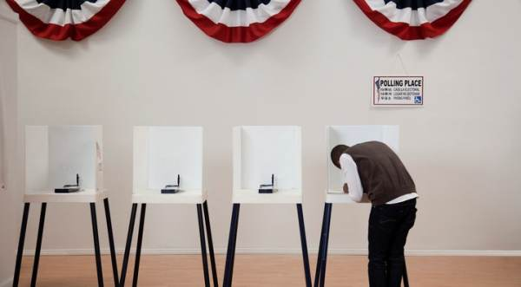

We’ve reported on numerous events in the 2020 election which are being referred to as system ‘glitches’ in the media.

Last night we provided another ‘glitch’, this time in Wisconsin, which if reversed would eliminate Biden’s reported vote lead in the state.
Advertisement - story continues below

Tonight we have obtained an unaudited analysis of data available for all the states looking for system glitches and other oddities in vote counts related to the Presidential race only.
Last night we reported on another so called system ‘glitch’, this time in a county in Wisconsin. Evidence was provided to us that showed that the vote totals for Rock County appeared to be switched between President Trump and Joe Biden. 9,516 votes were eliminated from President Trump and moved to Joe Biden. This 19,032 vote difference when corrected would eliminate Biden’s lead in Wisconsin.
01:20 01:30
TRENDING: EXCLUSIVE: Based on Reports By Auditors, IT Specialists, Data Analysts, and Statisticians - The Number of Illegitimate Votes Identified In Four Swing States Are Enough to Overturn Election
In the post last night we also identified issues we’ve reported on in Michigan, Pennsylvania and Georgia where similar ‘glitches’ occurred.
Advertisement - story continues below
We next attempted to obtain more data on this issue so we could determine how widespread this issue may be and/or if there are reasonable explanations for what is occurring.
Then tonight we were led to a site on the Internet thedonald.win where someone who had seen our posts decided to do an analysis himself.
Did the Democrats cheat?
In the piece the author claims his work is a full list of votes switched from Trump to Biden or votes erased by Dominion (the vote machines used in many states across the US).
(The author claims that his work has been verified but we have not verified the results so we currently are labeling his results “unaudited.”)
The author decided to obtain the data himself and perform an analysis of national votes switched from Trump to Biden and votes erased (the total amount of votes counted decreased by that amount throughout the counting).
Advertisement - story continues below
The author obtained data that has been passed around that was reportedly captured by the New York Times on election night.
By examining the data the author was able to locate an instance where votes were switched from Trump to Biden so he decided to perform an analysis on the entire data set, starting with the states where Dominion voting machines are used.
The author also claims that the data is from Edison Research and it is the same data that is used for election coverage by at least ABC News, CBS News, CNN and NBC News.
It is also used for the website of the NYT, and probably others as well.
Advertisement - story continues below
Here are the (unaudited) results by state:

The Chart Lists Votes Switched from Trump to Biden and Votes That Were Lost by Trump
 | Switched Votes | Lost Votes
Dominion Systems
Pennsylvania | 220,883 | 941,248
New Jersey | 80,242 | 20
Florida | 21,422 | 456
Michigan | 20,213 | 21,882
New York | 18,124 | 623,213
Georgia | 17,407 | 33,574
Ohio | 14,965 | 5,102
Virginia | 12,163 | 789,023
California | 7,701 | 10,989
Arizona | 4,492 | 0
Minnesota | 2,766 | 195,650
Tennessee | 2,330 | 0
Louisiana | 2,322 | 0
Illinois | 2,166 | 54,730
Wisconsin | 2,078 | 3,408
Colorado | 1,809 | 0
Utah | 1,627 | 0
New Hampshire | 973 | 116
Iowa | 938 | 477
New Mexico | 268 | 4,610
Missouri | 0 | 20,730
Nevada | 0 | 0
Alaska | 0 | 0
Washington | 0 | 0
Hawaii | 0 | 0
 | 434,889 | 2,705,228
Kansas and Texas use Premier Election Solutions, Owned by Dominion
Texas | 14,954 | 30,557
Kansas | 1,674 | 2,154
 | 16,628 | 32,711
Election Systems & Software
Nebraska | 30,086 | 50
Kentucky | 8,129 | 23,849
Arkansas | 3,664 | 20,748
South Carolina | 2,779 | 2,119
Montana | 2,330 | 1,276
South Dakota | 1,347 | 1
North Dakota | 234 | 681
Maryland | 203 | 0
North Carolina | 0 | 15
District of Columbia | 0 | 0
 | 48,772 | 48,739
Unknown Systems
Connecticut | 3,834 | 272
Massachusetts | 3,613 | 51
Oregon | 2,557 | 0
Alabama | 1,170 | 408
Mississippi | 355 | 0
Maine | 271 | 35
Rhode Island | 6 | 13
West Virginia | 0 | 78,300
Idaho | 0 | 0
Oklahoma | 0 | 0
Indiana | 0 | 0
Delaware | 0 | 0
Vermont | 0 | 0
 | 11,806 | 79,079
OVERALL TOTALS | 512,095 | 2,865,757
Based on this initial analysis over 500,000 votes were identified that were switched from President Trump to Joe Biden.
Advertisement - story continues below
In addition to this another 2,865,757 votes were deleted.
Note that these numbers have not yet been audited by us.
We also have not performed this exercise by county in these states which could impact the countrywide vote totals even more. More needs to be done. But what is clear, there are some very questionable transactions occurring within the voting machines and applications which need to be reviewed further because of apparent material issues in reporting.

We know there was a tremendous amount of fraud in the 2020 election.
Advertisement - story continues below

Nobody was following Joe Biden and he had zero support, and yet his vote count surpassed the greatest campaign in US history led by President Trump.

We are supposed to believe Joe Biden defeated President Trump and at the same time lost seats in the US House and state legislatures. This is highly improbable.

It looks like the Democrats did everything imaginable in their attempt to steal this election.

The problem was they never expected President Trump to lead a record breaking campaign and they got caught.
Advertisement - story continues below

More will be exposed.

Joe Hoft
Summary
Recent Posts Contact
Joe Hoft is the twin brother of TGP's founder, Jim Hoft. His posts have been retweeted by President Trump and have made the headlines at the Drudge Report. Joe worked as a corporate executive in Hong Kong and traveled the world for his work, which gives him a unique perspective of US and global current events. He has ten degrees or designations and is the author of three books. His new book: 'In God We Trust: Not in Lying Liberal Lunatics' is out now - please take a look and buy a copy.

Generous Man
In 1986 a farmer, Lenard Hill, took his own life on the morning his farm was to go to a courthouse auction, believing his life insurance would pay enough to save the cotton & soybean plantation in his family over 100 years. A complete stranger in Queens N.Y. read about this story & paid off the remaining $77,000.

A USMC Sergeant spent 7 months in a Mexican prison for accidentally crossing the border with a firearm. He was beaten & tortured in jail. Once he was released, the man from Queens sent him a check for $25,000 "To get you started."

In 2013 A black bus driver saves a suicidal girl from jumping off a bridge. Our Queens man sends him a check for $10,000.

A Rabbi's critically ill son needs to go from NYC to California for specialty care treatment in 1988. No airline will fly him.
A generous man in Queens pays for a private flight for the child.

In 2017 after Army Corporal Dillon Baldridge was killed in Afghanistan, a generous man in Queens sent his father a check for $25,000.

This kind-hearted man from Queens has committed many other "quiet acts of random kindness."

A wise man once said, "If a man's heart is good, Nothing else matters, & if a man's heart is bad, Nothing else matters."

Who is this kind man?...

President Donald J. Trump

- a man with a good heart.
Danielle 妲妮雅新品活动中 9:24 PM
轉：誏數字來說話
《The Economist》指出：
1、黑人失业率：
布什：8年中最低是7.9％
奥巴马：8年中最低是8.1%
川普：3.5年中最低是5.6％
2、股市指数（以布什期间为基准）：
纽约证交所综合指数：
奥巴马增长7.28％，
川普增长34.93％
道琼斯指数：
奥巴马增长32.32％，
川普增长104.88％
道琼斯期货：
奥巴马增长28.04％，
川普增长101.38％
纳斯达克指数：
奥巴马增长85.79％，
川普增长243.26％
PHLX半导体行业：
奥巴马增长14.12％，
川普增长173.67％
3.5年的川普经济远好于奥巴马的8年，这是一个简单而不可否认的事实。-
3、疫情
如果奥巴马、拜登是当今执政者，他们强烈反对年初1月31日发布的旅游禁令，因为当时民主党实际上是反对旅游禁令的。由于美国是联邦制，涉及交通、医院、警察等大多数日常措施的权力属于州和地方政府，一些民主党州长在3月份还在反对川普总统的检疫措施，因此他们遭受的打击最大。与新冠相关的死亡人数，民主党领导的州是共和党领导的州的2.48倍。
对川普的喜好，是個人選擇，但他对美國的貢献，是有目共睹、不可否認的。
---------------------------------------------------------------------------------------------------------------------------------------

----------------------------------------------------------------------------------------------------------------------------------------
http://nacr.info/WordPress/index.php/2020/10/31/trump_11_achievements/

川普总统第一任期的11项成就
义工十月 31, 2020
作者：Joel B. Polla 翻译: 杰克
作者乔尔·B·波拉克（Joel B.Pollak）他最新的电子书是《川普的美德：唐纳德·川普总统任期的教训与传承》。 他最近的著作《十一月红色》从保守派的角度讲述了2020年民主党总统大选的故事。 他是2018年Robert Novak新闻界校友奖学金的获得者。 在Twitter上通过@joelpollak关注他。
唐纳德·川普总统担任了美国历史上最重要的总统任期之一。总统传记作者康拉德·布莱克（Conrad Black）写道：在美国的45位总统中，只有“三到四位”的前任总统可以声称做得更多，其中包括亚伯拉罕·林肯。除了林肯上任之初就面对内战之外，没有总统比川普更需要面对来自政治反对者和媒体的坚决反对。当他在2016年竞选总统时，批评家们预测川普会引发核战争； 他将导致股票市场崩溃并“永远不会”恢复； 他将是希特勒的再世。然而所有这些都没有实现-反而事实与他们的预测相反。
川普总统的成就清单将涵盖许多方面。 我们的好莱坞编辑杰罗姆·哈德森（Jerome Hudson）已出版了一本关于它们的书，总结一下，以下是川普的11大成就：
1. 历史上增长最快的经济。 2020年第三季度，美国经济增长33.1％，创历史新高。经济反弹，因为川普通过减税，放松管制和强调就业为增长奠定了基础。
2. 五十年来最低的失业率。美国失业率降至3.5％，为50年来最低。黑人、拉丁裔和亚裔美国人的失业率是有记录以来最低的。贫困率创下历史新低，对少数民族和整个美国人来说都是如此。
3. 战胜伊斯兰国和激进伊斯兰主义恐怖分子。美国粉碎了所谓的“伊斯兰国”并击毙了其领导人阿布·巴克尔·巴格达迪。尽管法国最近发生的事件使我们意识到需要保持警惕，但川普压抑了恐怖威胁。
4. 边界墙和移民执法。川普政府在南部边界修建了400英里的新墙并且替换了旧墙。他还实在地执行了移民法，结束了拆散非法移民家庭的政策，并制止了非法移民的“大篷车”进入美国。
5. 开拓与朝鲜外交。川普使美国摆脱了与朝鲜频临战争边缘的危机，与金正恩会晤，并为朝韩全面无核化的谈判奠定了基础。
6. 中东和平。 川普将我们的大使馆迁至耶路撒冷，承认以色列在戈兰高地的主权，结束了与伊朗的极其无理的核交易，并消灭了卡塞姆·索莱马尼。 他在以色列和阿拉伯国家之间建立了和平，并保护了我们免于战争。
7. 最高法院的三名法官和破记录的任命各级法官。 川普提名三位原旨主义的保守派法官进入最高法院，并在第一任期内确认了比四十年来任何总统任命得多的联邦法官，尤其是在上诉一级法院。
8. 改善美国黑人族群的历史性成就。 除了经济繁荣以外，川普还创建了“机会区”，实施了监狱改革，为HBCU（Historically black colleges and universities）提供了资金，并结束了对宗教HBCU和神学院的资金限制。
9. 创建USMCA来代替NAFTA。 川普制定了《美国-墨西哥-加拿大贸易协议》（USMCA），这是一项自由贸易协议，对美国工人的保护要比北美自由贸易协定（NAFTA）强，NAFTA造成了美国工作机会的大量流失。
10. 面对中国。 在贸易，阿片类药物和外交政策方面，川普总统是50年来第一个坚决面对中国企图统治美国经济和世界的野心的美国总统。 他还通过中国旅行禁令减缓了冠状病毒的传播。
11. 强大的军事力量和太空部队。 川普通过重建军队来恢复美国的国际领导地位。 他还创建了一支新的武装部队，即太空部队。 然后，他启动了“神速行动”来提供冠状病毒疫苗。
他还有一项总体成就：川普支持美国历史，英雄，执法和宪法的主张，反对在我们的国家街头散播破坏性活动的激进势力。
只有川普能做到！
原文链接：https://www.breitbart.com/politics/2020/10/29/pollak-11-shining-successes-of-president-donald-trumps-first-term/

谁知道“三个麦琪带来礼物送给生在马槽里的圣婴耶稣”是怎么回事？
据《圣经》记载，麦琪是耶稣出生时从东方前来朝圣送礼的三个贤人，他们的礼物带表了尊贵与圣洁。
在新约第一章《马太福音》里:
麦琪送的礼物是黄金、乳香和没药！
一、黄金是耶稣基督将来作万王之王、万主之主的象徵。
二、乳香是象徵耶稣基督为大祭司。
三、没药是象徵耶稣基督为先知，没药味苦，他在世上教训人脱离罪恶，过圣洁生活。他为著救人，自己喝了父神所预备的苦杯，甘心为人类钉十字架而死。那真是痛苦万分的人生。他被安葬时，尼哥底母带著约一百斤的沉香和没药为殡葬，以防腐及杀菌。
根据圣经的记载，耶稣诞生在犹太的一座小城－－伯利恒。马利亚，也就是耶稣的母亲，因圣灵的感动而怀孕，在梦中天使加百列向她显现，告诉她，她将要生下神的儿子，他要被称为耶稣。就在与丈夫约瑟返往家乡时，所有的旅店客满，因此马利亚被迫在马槽生下耶稣。遥远的东方有三博士得到神的启示，追随天上的一颗明亮星星找到了耶稣，俯伏拜他，揭开宝盒，拿出黄金、乳香、没药为礼物献给他。在伯特利野地的牧差人也听到天使的声音从天上发出，向他们款耶稣降生的佳音
根据圣经的记载，耶稣诞生在犹太的一座小城－－伯利恒。马利亚，也就是耶稣的母亲，因圣灵的感动而怀孕，在梦中天使加百列向她显现，告诉她，她将要生下神的儿子，他要被称为耶稣。就在与丈夫约瑟返往家乡时，所有的旅店客满，因此马利亚被迫在马槽生下耶稣。遥远的东方有三博士得到神的启示，追随天上的一颗明亮星星找到了耶稣，俯伏拜他，揭开宝盒，拿出黄金、乳香、没药为礼物献给他。在伯特利野地的牧差人也听到天使的声音从天上发出，向他们款耶稣降生的佳音
第九日 圣若瑟引领三王朝拜圣婴
一节：耶稣降生后天上出了个异星。有东方的三位贤士，望见这个异星，就想起了先知们的预言，知道有救世主降生在如德亚（犹太）国了，随就起程，带着礼物来朝拜。且说圣若瑟明知耶稣是降生的救世真主，满心希望本国本乡的人都认识他、朝拜他。但耶稣诞生多日，只有几个牧童认识朝拜他，别人都不答不理。圣若瑟很伤心，只得天天加倍热心恭敬圣婴，为赔补别人慢待耶稣圣婴的罪。到了今天，忽有三位贤士来朝拜，一定喜欢至极。他之所以喜欢，是因为耶稣 得了光荣，教外人得了救赎大恩。三王虽然博学显贵人，他们蒙天主拣选，全摆脱了世俗骄傲的毛病，不嫌圣家贫穷，不嫌房屋卑陋，谦谦逊逊地朝拜圣婴，感谢天主拣选的大恩。他们为发显自己的信德，献了三样礼物。献了黄金，认耶稣 为国王；献了乳香，认耶稣为天主；献了殁药，认耶稣为人。圣若瑟见三位贤士的信德，非常喜欢。我们也该同圣若瑟一齐喜欢，并该效法三圣贤献三样礼物，就是：热爱天主的黄金；热心祈祷的乳香；克己苦身的殁药。
二节：三贤士来朝，是谁接待他们呢？圣若瑟是圣家之长，一定是圣若瑟接待他们。他们先见了圣若瑟，若瑟就领他们到耶稣及圣母跟前。那时耶稣圣婴报答了三贤士的信德，赏赐他们圣宠神光，得知天国的密事。圣母也安慰了他们。若说到若瑟怎样接待了三贤，更是我们当效法的表样。若瑟虽然贫穷，却不羞于自己的贫穷。同三贤士往来，只是一片谦和朴实气象，不矜夸，也不粉饰，世俗的浮华一点也没有。我们怎样呢？我们同人交接往来多次不诚实，说话要好听，穿衣要华丽，事事都求虚荣，图人看重。这个心思和大圣若瑟朴实的心恰恰相反。三贤士朝拜以后就大大改变，我们进教以来有改变吗？若仍然贪图虚荣，爱世俗，顺肉情，和教外人一样，这不是白白辜负天主特选我进教的恩典么？
诵句：于谦德为最深者，为我等祈。
敬工：衣服要朴素，断绝浮华；言语要诚实，不可粉饰。
事迹：奥地利国皇帝良保都一世，奉教虔诚，治国有方。就是膝下无儿，将来王位无人接续，为此特别忧愁。后来决定求大圣若瑟赏赐一个太子。于颁布法号，奉圣若瑟为本朝主保，吩咐人铸一尊圣若瑟像供在宫殿里，又命全国臣民在京都各圣堂内一连八天行大礼祈祷。圣若瑟果然允了他的祈求，不久即得了一个太子，皇帝给他起名叫若瑟。又叫人再铸一大圣若瑟像，在京都广场上，作为永久的纪念，以感谢圣若瑟转求之恩。立像那一天，皇帝同文武官员都到圣堂里参与大弥撒，君臣上下无不同心欢喜。
>这篇文章通过写在圣诞节前一天，一对小夫妻互赠礼物，结果阴差阳错，两人珍贵的礼物都变成了无用的东西，而他们却得到了比任何实物都宝贵的东西——他们相濡以沫的爱情，这是神圣的，寓意深远的礼物，告诉人们尊重他人的爱，学会去爱他人，是人类文明的一个重要表现。裁剪精到的构思，对话般亲切的语言，微带忧郁的情调，使这个短篇在缕缕情感的光束中显露出丰厚的内涵，激发读者对爱情、金钱的价值的思考。时而细致入微，时而寥寥数笔，这种寄实于虚，并兼用暗示和略写的手法，是《麦琪的礼物》所独具的。原题为THE GIFT OF THE MAGI,旧译《麦琪的礼物》，麦琪在圣经里是有东方来朝见初生的耶稣的三贤人，他们都带来寓意深远的礼物。
朋友，现在我们要向你说说人生中最重要的事，这个迫不及待、需要解决的问题——人生与永恒的话题。
“你若口里认耶稣为主，心里信神叫祂从死里复活，就必得救。——罗马书10：9”
我们曾经被人说是“迷信”、“唯心”，但我们不承认我们是迷信、唯心的。不信有神的人倒是迷信和唯心的呢！没有的、假的，我们硬说是有、是真，这就是迷信与唯心。明明是有神，但闭起眼睛说“没有”，这不是迷信与唯心又是什么呢？也许你会说：“你这个人太奇怪了，把没有看见的神，说成‘明明有’，还说别人迷信与唯心！”请注意，不信有神的人往往用“看不见”来欺哄自己。试想，看不见的东西有多少？最高的山，最深的海，最北的北极和最南的南极，地球的核心以及千千万万的事物，我们都没有见过，为什么我们信它们是存在的呢？没有看见过的东西，我们怀疑它的存在，这倒不太奇怪，最奇怪的是我们去否定它！
……——点击了解关于《永生之路》

经验分享
谁知道“三个麦琪带来礼物送给生在马槽里的圣婴耶稣”的故事? ： 据《圣经》记载,麦琪是耶稣出生时从东方前来朝圣送礼的三个贤人,他们的礼物带表了尊贵与圣洁.在新约第一章《马太福音》里:麦琪送的礼物是黄金、乳香和没药! 一、黄金是耶稣基督将来作万王之王、万主之主的象徵. 二、乳香是象徵耶稣基督为大祭司. 三、没药是象徵耶稣基督为先知,没药味苦,他在世上教训人脱离罪恶,过圣洁生活.他为著救人,自己喝了父神所预备的苦杯,甘心为人类钉十字架而死.那真是痛苦万分的人生.他被安葬时,尼哥底母带著约一百斤的沉香和没药为殡葬,以防腐及杀菌.
谁知道《麦琪的礼物》简述版?三四百字的那种,拜托拜托~~这是我今天的作业!!_ ： 麦琪的礼物》读后感 他们用自己美丽的心灵赠给对方的是一件无价之宝.而这件无价之宝,确实世间任何自认聪明或富有的人永远不会,也不能给予的礼物. 圣诞节是西方国家最重要的节日之一.每年的12月25日,人们都会在欢乐的气氛中互...
阅读《麦琪的礼物》中的一段文字,回答小题: 那三位麦琪,诸位知... ： ■[美]欧·亨利/著 一元八角七.全都在这儿了,其中六角是一分一分的铜板.这些分分钱是杂货店老板、菜贩子和肉店老板那儿软硬兼施地一分两分地扣下来,直弄得自己羞愧难当,深感这种掂斤播两的交易实在丢人现眼.德拉反复数了三次,...
麦琪的礼物 阅读 答案_ ： 《麦琪的礼物》语段阅读分析题杰姆从大衣口袋里掏出一包东西,把它扔在桌上.＂不要对我有任何误会,德儿,＂他说□不管是剪发□修脸□洗头,我对我的姑娘的爱情是绝不会减低一分的.但是,你一打开那包东西,就会明白,刚才你为什...
请问谁知道耶酥降生的时候,三位麦琪分别都送的什么礼物? ： 黄金,鲁香,莫药.
三位麦琪送给耶稣什么礼物了?分别代表什么意义?_ ： 黄金、乳香和没药...
《麦琪的礼物》 ： 《麦琪的礼物》是美国著名文学家欧·亨利写的一篇短篇小说,它通过写在圣诞节前一天,一对小夫妻互赠礼物,结果阴差阳错,两人珍贵的礼物都变成了无用的东西,而他们却得到了比任何实物都宝贵的东西——爱,告诉人们尊重他人的爱,...
谁有麦琪的礼物_ ： 我有: 欧亨利-麦琪的礼物 一块八毛七分钱.全在这儿了.其中六毛钱还是铜子儿凑起来的.这些铜子儿是每次一个、两个向杂货铺、菜贩和肉店老板那儿死乞白赖地硬扣下来的;人家虽然没有明说,自己总觉得这种掂斤播两的交易未免太吝啬...
相关内容：给耶稣带来礼物的麦琪 、 麦琪的礼物个人感悟 、 麦琪的礼物小说在线阅读 、 麦琪的礼物原文阅读 、 麦琪的礼物 、 麦琪的礼物题目及答案 、 麦琪的礼物批注式阅读 、 麦琪的礼物节选 、 《麦琪的礼物》原文app 、 麦琪的礼物在线阅读 、 麦琪的礼物为什么叫麦琪 、 麦琪的礼物经典语录 、 麦琪的礼物原文英文版 、 麦琪的礼物分几部分 、

----------------------------------------------------------------------------------------------------------------------------------------前英国大律师：军情六处情报证实 拜登窃取美国大选
温妮 | 美丽日报
8 hours ago
2013年11月27日，前英国大律师迈克尔·史林普顿接受电视专访。（视频截图）
【美丽日报2020年11月21日讯】美国民主党操控大选似乎已经是不争的事实，特别是Dominion服务器的被拿获，一切真相即将水落石出。而针对此次大选舞弊，前英国大律师迈克尔·史林普顿（Michael Shrimpton）披露，早在11月6日，英国军情六处（MI6）就已获得资料，证实本届美国大选确实是一场窃选，拜登不是当选总统，美国正在经历的是有史以来最腐败的总统选举。

----------------------------------------------------------------------------------------------------------------------------------------一起禱告
Jack Jiang |  |  | 5:25 AM (2 hours ago)
11-24-2020
轉：
為美國大選訴訟案的突破與得勝宣告
http://www.kp24-newway.com/prayer/?recordId=20442
我們奉耶穌的名宣告：
˙神必保守法官的心，與神對齊，不受利誘、恐嚇或威脅， 在每起訴訟中，都能做出公正的裁決，並證明川普總統得勝。
˙神必賜給川普總統律師團隊智慧，能蒐集到所有制敵致勝的證據，將所有作奸犯科者繩之以法。
˙神必保守這些參與訴訟的律師或吹哨人免受邪靈或人身的攻擊，賜下平安、光明、真理和法治。
˙神必使搖擺州選票重新審核確實無誤，以主耶穌的寶血破除任何針對訴訟程序所施的巫術或咒語，所有操控電腦和選票的行為都必被揭露和糾正，使川普總統、共和黨參眾議員得到極大支持，並大獲全勝。
(部分改編自WFJM)
˙爭戰得勝在乎耶和華！神必為川普總統伸冤，取得突破性的進展，勝選臨到正義之方！
˙川普總統必要連任，他必作美國的父。神必將大衛家的鑰匙放在他的肩頭上，他開，無人能關；他關，無人能開。神必使川普總統安穩，像釘子釘在堅固處。(賽22:22-23)
˙神必以耶穌的寶血覆蓋川普總統、他的幕僚、律師團隊和他們的家人，破除所有攻擊他們的巫術和咒詛，拯救他們脫離任何暗殺計畫，保守他們出入平安。(賽54:17)
˙釋放混亂的靈進入反川普陣營，使他們彼此相攻，彼此爆料、速速滅亡！作惡之人，心必如蠟消化；使舞弊者大大驚恐、恐懼顫驚，及時悔改自首，並使其陰謀曝光，完全失敗。(詩55:5)
˙神的審判要臨到那些深層政府的首腦爪牙，將他們一網打盡！使他們所有的權勢要癱瘓瓦解，他們的財務也陷入癱瘓失敗， 惡人的財富要轉移到義人的手中！(箴13:22)
˙釋放更多真理的大光進入美國，聖靈澆灌在美國全地，屬靈的大覺醒臨到美國！使矇蔽的不再被矇蔽，瞎眼的不再眼瞎！
---------------------------------------------------------------------------------------------------------------------------------------- Dear Family and Friends,
These links provide undeniable PROOF that our presidential election was massively RIGGED in Biden’s favor. Please watch what you can in one sitting, save the rest, access it again as soon as possible, and continue. Please watch, pray, and get informed. Then share with all your contacts. We can no longer rely on news media or social media to inform the public. Only a vigorous grass roots effort will inform America in time to help. Biden’s team openly advocates stripping away our constitutionally guaranteed, Creator-endowed inalienable RIGHTS, and seeks to punish Trump’s supporters!
Sincerely,
<><
Jim Pamplin

- “INTERVIEW WITH SOURCE ON ELECTRONIC VOTE FRAUD” (https://www.bitchute.com/video/scUpSRkNoj9g/) This is a 58 minute interview with Russell Ramsland, co-founder of Allied Security Operations Group*. It describes how ASOG became involved when someone brought them the electronic logs of an election in Dallas, Texas, and asked them to investigate. It goes on to share the shocking results of that and ongoing investigations.
*(ASOG is a group of globally engaged professionals who come from various disciplines to include Department of Defense, Secret Service, Department of Homeland Security, and the Central Intelligence Agency. . .)
- “Election Fraud – Our Democracy is Under Threat and It Impacts Your Money, Your Livelihood and Your Way of Life” https://www.economicwarroom.com/myvote This link also features Russell Ramsland in three videos:
o Election Fraud Update 2019 – Kentucky
o Election Fraud Overview Video (Election Fraud Exposed – Part 1)
o Election Fraud 2020 Update Video (Election Fraud Exposed – Part 2)
- “Fraud PhD” https://everylegalvote.com/phd. This article details numerous types and examples of voter fraud and election fraud witnessed in the current election.
- “Big Tech and Political Manipulation” https://www.youtube.com/watch?v=wqtKQgTps_g&feature=youtu.be This is a talk by Dr. Robert Epstein, Senior Research Psychologist for the American Institute for Behavioral Research and Technology. It reveals the frightening influence Google, Facebook, and others exert in manipulating public opinion, and thereby shaping the outcomes of elections.
- “Election 2020: Trump Election Fraud Press Conference - November 19, 2020” https://www.youtube.com/watch?v=yMJXhhsVja0 This is an hour and 31 minute press conference featuring Rudy Giuliani, Sydney Powell, and Jenna Ellis of President Trump’s legal team, who are challenging the presidential election due to fraud.

----------------------------------------------------------------------------------------------------------------------------------------
INTRODUCING IAGANACK / HKCRM格言 Motto傳講聖經的真確性及權威。Proclaiming the truth and authority of the Bible異象 Vision讓世人得見並尊崇主耶穌基督為世界的創造者及救贖主。To see the Lord Jesus Christ honoured as Creator and Saviour of the world 使命 Mission提供證據，以引證聖經創世記歷史記載的真確性，讓福音宣講更有果效。To support the effective proclamation of the Gospel by providing credible answers that affirm the reliability of the Bible, in particular its Genesis history. Iaganack Productions is an educational/religious nonprofit organization. It was established in Hong Kong in 2005 to translate and publish a particular type of apologetics material into Chinese and other Asian languages, in response to a serious challenge to the very foundations of Christianity and the Gospel of Jesus Christ.極光創作在2005年成立，主要是把特定的護教學材料，翻譯及出版成中文及其他亞洲語言。這個宗教及教育非牟利組織在香港的建立是為要回應當今一些以「科學」為名，對基督信仰的根基及耶穌基督的福音所進行的挑戰。
For since the creation of the world God's invisible qualities —his eternal power and divine nature—have been clearly seen, being understood from what has been made, so that men are without excuse.Romans 1:20自從造天地以來，神的永能和神性是明明可知的，雖是眼不能見，但藉著所造之物就可以曉得，叫人無可推諉。羅馬書1:20 One of the primary evidences for the existence of an incredibly intelligent God—the world He has created and all the living things within it—is today explained away in the name of “science” as the result of natural processes occurring over millions of years: viz, evolution. As a result, the truth and authority of the Bible is being questioned as never before. Is its account of creation in the recent past, followed by a global flood, really true? Maybe it should be “reinterpreted” in the light of the so-called “facts of science”?! 其中一個關於這個滿有智慧的主存在的主要證據——這個籍祂手所造的世界及其中的一切活物——被今天的進化論者解釋為超過數千萬年自然過程的結果。一般人，不論信徒或未信者，基於對科學家的尊敬，也假定了他們和一部份人所不斷推廣的進化論為生命起源的真相。這使得聖經的真確性及權威受到前所未有的挑戰——聖經所載，在不久的過去，世界被創造，然後發生了一場普世大洪水，到底是真的嗎？或許，這需要在所謂的「科學事實」底下「從重新解釋」過嗎？However, in the last few decades, a growing number of scientists and scholars have begun to show that the facts of science better support a straightforward reading of the Bible than they do the millions of years’ evolutionary story. This is important information, as it affects the validity of the Gospel, the effectiveness of our evangelism, as well as strongly confirming the truth of the Bible.然而，在過去的數十年，越來越多的科學家及學者們開始去展示出一些科學事實，更支持聖經的直接解釋，多於所謂數千萬年的進化故事。這對福音的真確性，與及有效傳講福音來說，是非常重要的資訊，也同樣強烈地引證著聖經的真實。More and more of this information is now becoming available to the Chinese world, as we work steadily to translate and publish books, videos, and online articles. The impact of this small but growing ministry has been far-reaching: over 8 million of our DVDs have been distributed all over China, for example.在過去，我們不斷努力堅持去翻譯及出版書籍、影音光碟及網上文章，越來越多這方面的資訊得以在中文世界中出現。感謝主，！這個細小卻不斷成長的事工已經發揮了一些影響力。例如：超過八百萬隻，我們所製作的影音光碟，已經傳播到全中國大部份地區。Always be prepared to give an answer to everyone who asks you to give the reason for the hope that you have. But do this with gentleness and respect.1 Peter 3:15有人問你們心中盼望的緣由，就要常作準備，以溫柔、敬畏的心回答各人彼得前書3:15The role of Iaganack Productions, like that of other Biblical Creation ministries, is to support the church in proclaiming the truth of the Bible and thus its Gospel message. We seek to provide real-world answers to the most-asked questions in the vital area of creation/evolution, where the Bible is most under attack today—Genesis.
極光創作的角色，就像其他的聖經創造論事工一樣，都是為了支持教會宣講聖經記載的真確性及福音信息。我們致力提供一些真實可信的答案，來回應關於創進或進化的常見問題，這關鍵範疇也是現今聖經最常被攻擊的部份——創世紀。Examples of resources produced so far can be seen on: •Our websites www.iaganack.com and www.creation.hk, •Our YouTube channel www.youtube.com/user/IaganackProductions and •Our Facebook pages www.facebook.com/Iaganack and www.facebook.com/creation.hkcrm.我們所製作的創造資源，可在以下地方找到：•www.iaganack.com及 www.creation.hk網站•YouTube頻道 www.youtube.com/IaganackProductions•Facebook頁面 www.facebook.com/Iaganack及 www.facebook.com/creation.hkcrmIn the last few years, we have become increasingly active in outreach to churches, schools, offices, annual book fairs, geological tours and online. Our team members speak on Creation-related topics, screen videos and operate book-tables at most events. Hong Kong Creation Resources Ministry(HKCRM), a department of Iaganack Productions, is the name we use for this outreach ministry. 過去幾年間，極光創作參與越來越多教會教導、學校講座、公司團契、基督教書展、地質導覽及網上活動。我們的團隊舉辦聖經創造論講座、電影分享及舉辦書攤。香港創造科學資源事工（HKCRM）是極光創作外展事工所用的名稱。We would like to invite you to join us in a unique opportunity to strengthen the church and enhance the evangelistic effectiveness of believers at this challenging time in history. As you prayerfully consider your plans for ministry and missions support, please take a moment to ask the Lord if you and/or your church could become part of this important ministry through regular financial support. Even small amounts, together with your prayers, will be a great blessing and encouragement! Please contact us for more information. To donate, go to https://www.creation.hk/tc/donation/我們誠意邀請您參與這個特別的機會，去幫助強化教會及提升信徒在這充滿挑戰的世代中，更有效地傳揚福音。當您或您的教會考量該支持甚麼事工的時候，我們懇請您花一些時間來求問主，是否會該運用主所賜的資源，透過定期奉獻來支持我們這個重要的事工發展。您的奉獻（不論金額的多少）和禱告守望，對我們來說是一個非常大的祝福和鼓勵！如欲了解更多，歡迎聯絡我們！如果您想奉献，請按https://www.creation.hk/tc/donation/Yours in Christ, 主內Rev. Neville Chamberlain 陳伯倫牧師Founder 創辦人

----------------------------------------------------------------------------------------------------------------------------------------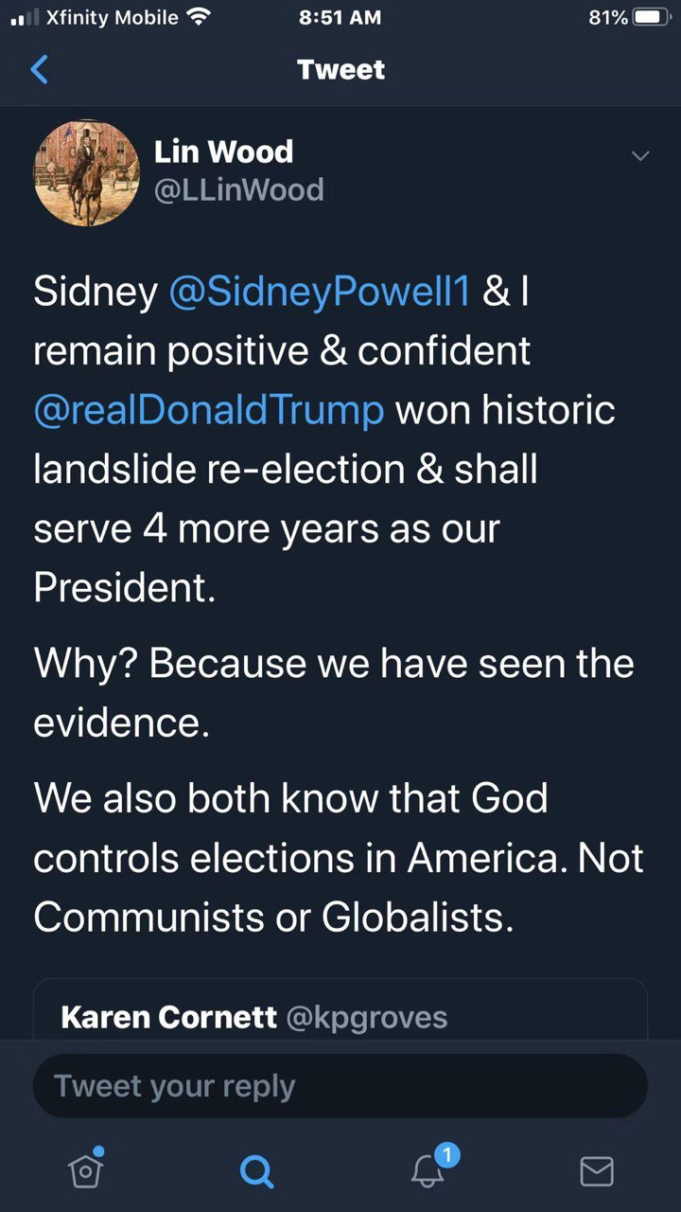

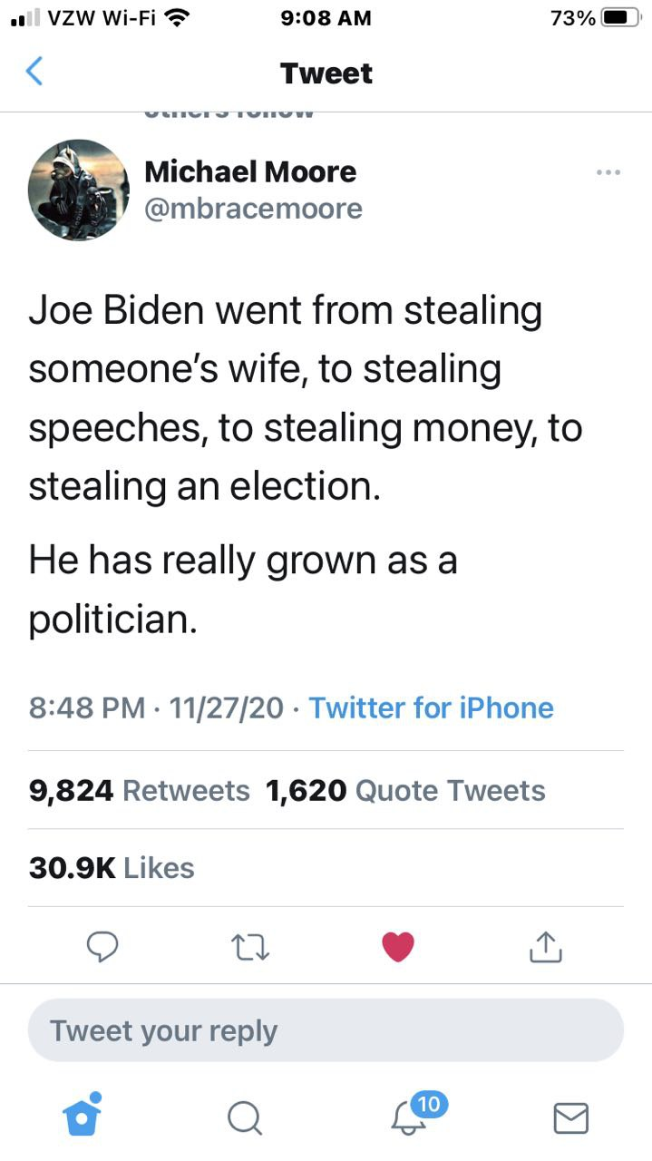
----------------------------------------------------------------------------------------------------------------------------------------

此地无银三百两 | 连浓眉大眼的司法部长巴尔也这么说？
Jerry Zhao 萧笙客 Today 12/6/2020
先是主流媒体众口一词说这次大选是有史以来最安全的大选，任何大选舞弊的指控都是捕风捉影。

再是劈柴哥的公司，Fakebook 和Twister 公司在网上提到大选舞弊的地方都要加上说明说拜登已经赢了大选，任何关于大选舞弊的提法都是有争议的。

最后是浓眉大眼的司法部长 Bill Bar “巴尔” 说他没发现有“可以改变大选结果”的舞弊行为。

这不是三人成虎吗？

最让人崩溃的是教会里有人在群里说川普律师团队的指控是莫须有！我怎么也无法把拜登和岳飞的形象放在一起，倒是想起了通俄和通乌门的闹剧中民主党的做法和秦桧的整岳飞的操作很像。

说起证据，不外乎两种。一种是间接证据（线索），一种是直接证据（实锤）。

比如说县上小张几次下班时，都发现自己太太从隔壁老王家里出来，神情慌张，衣冠不整。

老王理直气壮地说他只是给小张太太补习俄语。小张打听了一下，老王根本没学过俄语，而小张的太太对俄语从来没兴趣。

小张怀疑太太和老王有染，他有没有实锤证据？没有，因为没有抓奸在床。可小张有间接的证据（线索），所以他到派出所报案。

派出所的毕所长对小张的处境比较同情，可人家老王是县人大代表啊，毕所长抬头不见低头见。所以毕所长连走廊上的监控也懒得看，就放话给小区的街坊邻居说没有发现老王和小张老婆通奸的证据。

小张要上法院，他得有有实锤证据。他找私家侦探帮忙，可私家侦探还没来得及在老王家的卧室安装针孔摄像头，小张老婆就抢先一步在老王的陪同下到法院要求离婚，说和小张没感情了。

小张此时的心情大约等于川普在大选后的心情。

但这次大选舞弊案，川普团队不仅有间接证据（线索），更有很多实锤。

由于主流媒体包括狐狸台都选择 忽视任何川普律师团队的诉讼，而各州的法院都像躲瘟神一样躲着，川普的律师团队改变策略，开始带着证人向各州的议会做公开的听证会。

美国的选举是民主集中制，由选民投票，但538张选举人票是由各州的议会来定的。一般议会是会随从民意，但如果议会认为选票有诈，可以自行决定把选举人票给川普。

听证会一方面可以争取议会的支持，也可以造势对法院尤其是最高法院造成舆论上的压力。但我认为听证会最大的作用是让美国人民了解了第一手的选举舞弊证据。
Rudy Guiliani 和 Jenna Ellis 马不停蹄在关键的几个州穿梭，迄今为止已经在宾州（1场），亚利桑那州（1场），乔治亚州（1场），密西根州（2场）举行了听证会。

这是了解大选舞弊的最佳途径，强烈建议观看至少一场。油管上都有，我把链接附在文章的最后。

Rudy 和 Jenna 在密西根的议员前作听证会。一共5 个证人，前后5个小时。因为这次证人较少，每个证人都有充足的时间（不像上次听证会每个人只限3分钟）。油管上这个听证会已经有一百万万的观看量。

第一个证人叫Jessy Jacobs. 她是来自印度的移民在底特律政府某个部门作首席工程师。可以算上是人生赢家， 三个孩子都上医学院。这是她第一次公开作见证。可以看出来，她是挣扎很久才决定出来的。她是一个虔诚的天主教徒，见证过程中她一直握着天主教徒用的念珠。

她心情沉重地告诉大家这次民主党在选举的每个环节全方位作弊。

她和其他几十个人一起被民主党安排在邮寄选票的申请日期上作假，数量高达十几万张。

后面她在投票站工作时发现民主党的志愿者明目张旦诱导选民填拜登，来投票的人没有任何证件而且在签名与花名册上的签名差十万八千里的情况下也可以填选票。
邮寄选票必须在11月三号晚上八点前寄到否则作废，但她发现连四号收到的票都被改为收件日期为二号。

验票时每张桌子上要求有一个民主党和一个共和党监督，可她发现很多桌子上两个人都是民主党人。

她做完见证后，每个议员都可以提问。有个奇葩民主党议员CA Johnson, 对选举的事一个问题都不提，却盘问Jessy 的 名字，Jessy Jacobs 是不是她的真名，有没有中间名，分明是用来人肉的。议会主席赶快提醒不可威胁证人，Jessy 看起来身体很虚弱，但她这时分明把个人安危置之度外，不卑不亢地把她长长的印度中间名报了出来，没有一丝的惧怕！

第二个见证人叫Mellissa Carone, 她是有两个孩子的妈妈，在大名鼎鼎的Dominion 投票机公司的合同工。她在底特律TFC 中心计票站工作，看到计票员把同样的票扫很多遍。她听说有一个地方叫芝加哥仓库，假票都从那里出来。
11月4日凌晨川普领先时，她的主管说有数据丢失，所以要去芝加哥仓库，一去就是几个小时。

Mellissa 是个川粉，政治倾向比较明显，所以对她的见证不是很利。后来无数的左媒对她的人格进行疯狂攻击。

她的指控都是有名有姓，而且她是宣了誓的，也就是说如果和其他人对质证明她的指控有误，她会进监狱的。与其对她进行人格攻击，强大的左媒难道不该去找这些人对质，把她送入监狱吗？

接下来的证人是一男一女两个印度裔的年轻人。女的叫Hema, 男的叫Andrew. 他们看到共和党的监票员被歧视并被民主党人以各种借口赶出去。

他们看到邮寄选票有各种的猫腻，比如很多张连号（邮寄选票寄回来的时候不可能很多张连号，除非有人造假），信封上的号码和选票上的号码不同（应该是一个号码），很多的信封上签名一模一样。
很多邮寄选票上的日期有年份（2020），月份（11月），但日期却是一个空格。

Andrew的重磅证词是4日凌晨4点半时，民主党的主管Mr. Baxter 从后面的地下室拿出大量的选票。五点钟时前一班人下班后，后一半从5点推到6点，而且计票员绝大部分都是民主党人。
这个时候民主党的主管向大家宣告 “现在真正的民主开始了！”

这是四日凌晨最大两批邮寄选票计票结果。3:50AM 那一批计票结果，近六万张票，拜登占92%，6:31AM 那一批计票结果，近14万张票，拜登占96%！

拜登同学的支持率要赶上金正恩同学了。
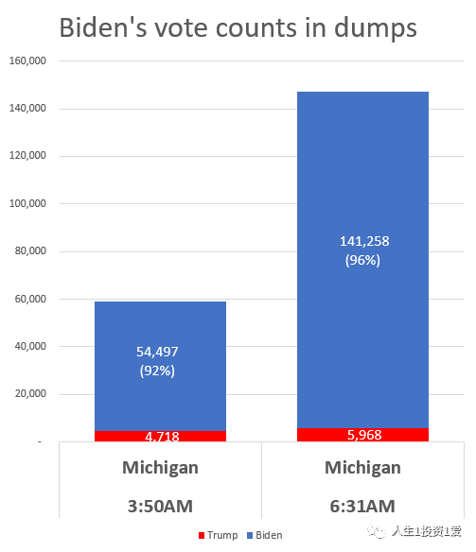
CA Johnson 同学又开始耍泼了，说证人没有宣誓。（密西根州议会听证会不要求证人宣誓）。Hema 毫不胆怯，说她可以马上宣誓！

接下来是一位专家证人叫Phil Walden。他的团队做了仔细的调查分析：
- 11月4日凌晨的计票数量超出了计票机的最大计票能力。
- Dominion 的计票机连接的电脑按规定是要离线，但这些电脑（Windows)的右下角图标显示这些电脑是在网上。另外U盘被用来在电脑间传输数据，而U盘极易被用来黑客。
- 有一个县把6000张的川普票算作拜登的，说是文书错误（Clerical Error), 但Phill 认为可能是算法上的猫腻，因为前后两次打印出来的计票单不一致。

另外一个是实锤。我们知道死人出现在选民登记表上不奇怪，因为很多县的选民登记表很多年没清理了。可死人投票就有问题了，大量死人投票肯定是选举欺诈了。
Phill 团队中的专家利用公开的讣告信息（报纸和社交媒体）发现密西根州投票的选民中有一万七千三百二十七人是死人！

最后一位作证的是大名鼎鼎的Monica Pallmer，她是Wayne County (底特律所在的县）选举委员会的主席。

11月20号她发现70% 的选区（Precincts) 现场选举的选票数量平衡不了（比如这个区有106张空白票，100张被选民正确填好，3张未用的空白票，3张填错的废票），当时她拒绝对此次选举签发合格证明。

后面她收到死亡威胁，而且民主党的律师告她，要挟她辞职。迫于压力，她为这次选举签发了合格证，但前提是要进行审计。当然，民主党压根就没想要审计。
我真心希望她能像那几个证人一样不在压力下屈服，我们的软弱常常是对手的破口！

最后回到老王和小张的纠纷上，你要是住在那县上，要不要参加老王和小张媳妇的婚礼？

佐治亚州听证会：https://www.youtube.com/watch?v=Ur4vl5UTN8g
密西根听证会:1：https://www.youtube.com/watch?v=eZXkAv7yKgw
密西根听证会:2：https://www.youtube.com/watch?v=ZPrV_QPTtrk
宾州听证会：https://www.youtube.com/watch?v=ohe2dQbNJwM
亚利桑那州听证会：https://www.youtube.com/watch?v=KXyOtzADUCU

---------------------------------------------------------------------------------------------------------------------------------------- Teachers in San Diego volunteer for 'white privilege' training where they are told they're racist and to accept the US is built on stolen land - then asked to commit to becoming 'anti-racist' activists
- San Diego Unified School District said training is voluntary for district teachers
- In the training, the teachers are asked to discuss how they would feel if they are called racist and asked to acknowledge that they meet on land stolen
- The teachers are also asked to commit to developing 'anti racist' practices
- The district said so far hundreds of teachers have attended the training session
By Dailymail.com Reporter
Published: 14:39 EST, 6 December 2020 | Updated: 10:22 EST, 7 December 2020

Hundreds of teachers in San Diego have attended a 'white privilege' training in which they were asked to commit to becoming 'antiracist' and acknowledge that they meet on stolen land taken from Indigenous peoples.
An article written by journalist Christopher F. Rufo, claimed the training is 'mandatory' for all teachers within the San Diego Unified School District.
Initially it was reported that the documents were leaked, but a spokesperson from the San Diego Unified School District told DailyMail.com that the book the session is based on is available on Amazon.
'Following the murder of George Floyd, we provided teachers with voluntary trainings from the Racial Healing Handbook. The contents were not secret,' a spokesperson for the district said.
According to the district, 'the training was not mandatory' and 'hundreds of teachers participated voluntarily'.
As part of the training, the teachers are to discuss how they would feel if they were told: 'You are racist.'
Teachers were also asked to discuss how they'd feel if they were told: 'You are upholding racist ideas, structures, and policies.'
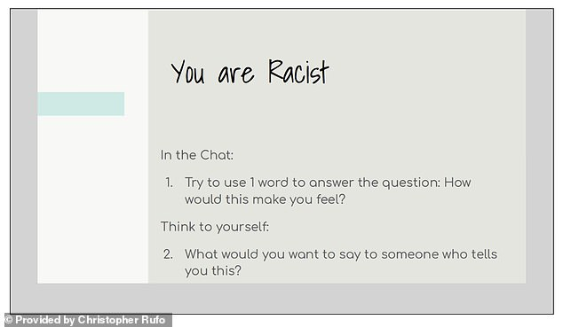
+8
Hundreds of teachers in San Diego have attended a 'white privilege' training in which they were asked to commit to becoming 'antiracist' and acknowledge that they meet on stolen land taken from Indigenous peoples
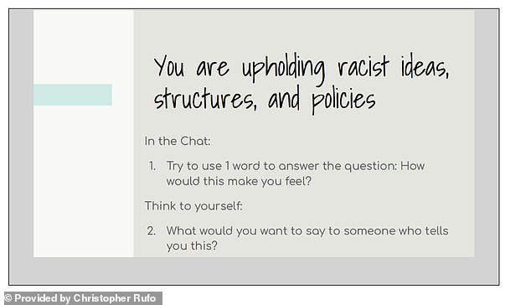
+8
As part of the training, the teachers discussed how they would feel if they were told: 'You are racist'
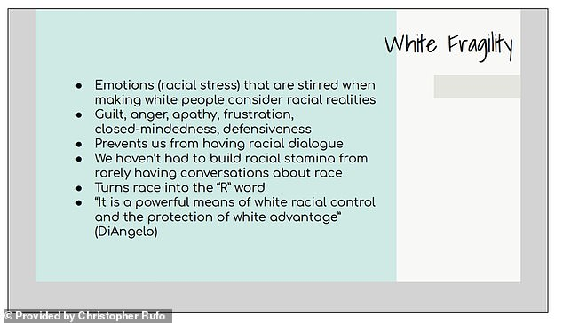
+8
The documents show the outline of the discussion and the talking points, including 'how to become antiracist' and defining 'white fragility'
'We are a majority minority district with a majority white teacher workforce. The ability to hold honest conversations about race with grace is important, which is why we offered the training and why so many teachers elected to enroll,' the spokesperson told DailyMail.com.
'Our students benefit from being able to talk about race and other difficult issues, regardless of their background. Most of all, we believe every open and sincere conversation about race -- no matter how it begins -- provides an opportunity to learn from one another, for hearts to open, and for minds to grow,' the statement continued.
According to the spokesperson, the district also created a tool 'to help families talk about race and to help students who have been hurt by racism'
The documents show the outline of the discussion and the talking points, including 'how to become antiracist' and defining 'white fragility'.
In addition to the aforementioned, the seminar also included a section on 'land acknowledgement'.

----------------------------------------------------------------------------------------------------------------------------------------川普胜选的宪法途径已经明确
Original 方位 方位观察 2 days ago 12-9-2020

美国大选争端经过了一个多月的发酵之后，12月8日正式进入法律诉讼的决战阶段。

先是，川普的律师团队和以独立身份提起诉讼的鲍威尔律师一边搜集证据、一边在美国六个摇摆州对民主党大选舞弊发起诉讼，先后汇集了一万多名证人证词，但在实际诉讼中却屡遭地方法院的拒绝受理或判决败诉。

就在整个世界几乎都以为川普在这次大选中已经大势已去，拜登将顺利入主白宫的时候，形势突然发生了惊人的逆转——

当地时间12月7日，川普总统和彭斯副总统作为原告，起诉被告拜登和贺锦丽等人。川普和彭斯都签署了在威斯康星州密尓沃基巡回法院提起的诉讼，要求法官推翻该州密尔沃基县和戴恩县的选举结果！

当地时间12月8日，美国国会“（总统）就职典礼委员会”以3:3的票数否决了众议员多数党（民主党）领袖Steny Hoyer提出了一项旨在确认拜登为当选总统并启动就职准备典礼的动议。由于美国众议院是宪法规定最终确认当选总统的权威机构，因此，这次“确认拜登为当选总统并启动就职准备典礼的动议”被否决，就意味着到目前为止，这次美国大选还未确认两个总统竞选人当中的任何一人成为胜选者。

同日，美国德克萨斯州总检察长办公室官网发布的消息，德克萨斯州检察长肯·帕克斯顿今天直接在美国最高法院对乔治亚州、密歇根州、宾夕法尼亚州和威斯康星州提起四州选举违宪诉讼。

诉讼书指出，这四个州利用新冠疫情大流行，无视联邦和州选举法律，非法修改大选邮寄选票截止日期，从而歪曲了2020年大选的结果。

起诉书强调：“信任我们选举程序的完整性是神圣不可侵犯的，它将我们的公民和联邦的各州联系在一起。乔治亚州、密歇根州、宾夕法尼亚州和威斯康星州摧毁了这种信任，并损害了2020年选举的安全性和完整性。它们（四个州）违反了通过正式选举所产生的立法机构制定的各项法令，从而违反了宪法章程。这些州无视州和联邦法律，不仅损害了所在州公民投票的完整性，而且还损害了德克萨斯州以及举行合法选举的每一个州的完整性。”

美国最高法院官网显示，美国最高法院已接受德州诉四州大选违宪案，并要求被告必须在48小时内回复。

另外，再有10个州加入支持德州的诉讼行列（最新消息：已增加至17个州），认为4大摇摆州违反了宪法的"平等保护条款"。这10个州分别是密苏里州、肯塔基州、路易斯安那州、密西西比州、南卡罗来纳州、南达科他州、阿拉巴马州、阿肯色州、印地安那州和佛罗里达州都。

德州总检察长向联邦最高法院提出这项诉讼的关键点在于：诉讼的发起方无须向最高法院提供被诉的这四个州大选舞弊的证据，被诉的四个州的行政当局由于未能通过州议会决议、直接发布行政命令“修改大选邮寄选票截止日期”，已经构成对美国宪法的侵害，属于非法行为，从而对德州（也包括美国其他州）的宪法权利造成侵害。

宪法的“选举人条款”规定，州议会（立法机构）是制定有关选举人任命和选举规则的唯一合法机构，行政官员未经州议会批准、擅自修改选举规则，即构成对宪法的违背。

川普阵营的大招原来藏在这里！

最高法院受理此案，并不是要判定川普和拜登谁能赢得选举，而只是简单地判定被诉的这四个州的行政当局未经议会批准修改选举规则是否构成违宪。

现在，最高法院要求被诉的四个州的行政当局在48小时之内证明修改选举规则的合法性。如果四个州的行政当局无法向最高法院提供修改选举规则的法律依据，那么四个州的行政当局则必输无疑。这也就意味着这四个州的总统大选投票均属非法，投票结果无效。

目前，在这四个州阶段性的计票结果中，拜登是领先者。如果他能领先到底，则可获得这四个州的63张选举人票，从而以306张选举人票赢得大选。如果最高法院判定这四个州的行政当局修改选举规则属于非法，那么这63张选举人票就会暂时被搁置，直到依据宪法由立法机构做出最后的裁夺。其路径可能有以下两种。

1、 最高法院判定由这四个州的州议会决定各州的选举人；
2、 最高法院援引美国宪法第十二修正案，在两位总统候选人都未能得到法定当选的270张选举人票的情形下，判定由联邦众议院按照每州一票的选举规则直接选出第46届美国总统。

如果出现第一种判决结果，由于这四个州的州议会均由共和党议员占多数，这四个州共63张选举人票将归属共和党籍的总统候选人川普，川普也将因此赢得295张选举人票，最终胜选连任。

如果出现第二种判决结果，由于共和党议员在众议院占有26个州的多数席位，民主党议员目前占有23个州的多数席位，那么川普将以26:23赢得选举，从而胜选连任。

当然，最高法院还有第三种判决结果的可能性，即判决诉讼方——德州总检察长败诉。不过这种可能性要建立在被诉的这四个州的行政机构能够证明他们未经立法机构批准修改选举规则并不违法美国宪法。从现在显露出来的事实看，这种可能性是几乎不存在的。

到目前为止，美国大选的争端都在法律和宪法的层面上进行，宪法依然是美国选举制度的最后也是最高的保障。

按照目前的形势发展，唐纳德.川普将在美国宪法的护卫下最终当选为第46届美国总统，开启新的四年的连任之旅。

推荐阅读：
新型国家主权之一：金融主权；国家新型主权之二：货币主权；国家新型主权之三：市场主权；给胡锡进讲点军事课（1）；母亲与我；当今世界与春秋战国—静夜读史之二；油腻金的后台是谁；生命的告别期；我的起死回生之路；飞在天上的牛；闲话张召忠； 秋日感恩;中美之间对决的烈度将远超“冷战”/美国会不会制裁清华、北大？/千年契合 ——读老杜《秋兴八首》之四/毛泽东邓小平留下的四大政治遗产/一个闹着退群的人，他凭什么牵动世界？/第二次美国大选辩论谁赢了？/美国大选与世界格局/梁漱溟的风骨与悲凉/美国的新招数/上帝一直都在，祂在看着人间/“临危颂安”的害国学者/突发：老拜登被乌克兰法庭列为刑事案件嫌疑人/看，这头老狮王！/近距离观察美国大选，收获颇丰/硬汉川普，英雄归来/粗俗，也是民主政治的典型特征之一/彭佩奥突访台湾可能会成为未来两个月的大概率事件/川普的新职业/再谈美国大选——民主政治的特点就是生生不息/重磅——美军在西太平洋的新动作/美国真的大乱了吗？/国际重要消息汇总，个个劲爆/每一项科学创新的背后，都有一个自由飞扬的灵魂/美国的真面目——超级稳定/“穷逼”的加拿大，疫情期间突然有钱了！/这是往死里爱呀！/伊朗首席核专家被袭杀真相/
----------------------------------------------------------------------------------------------------------------------------------------
-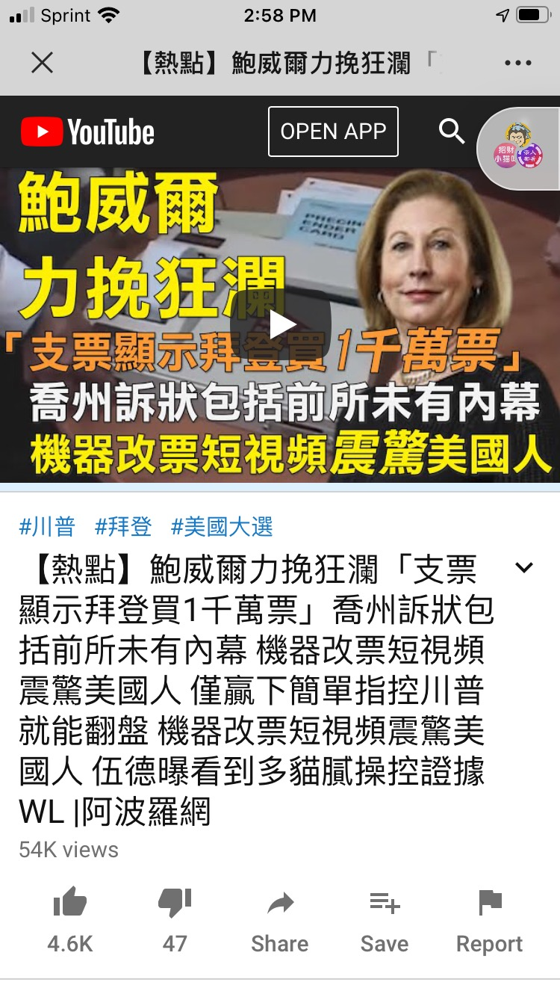
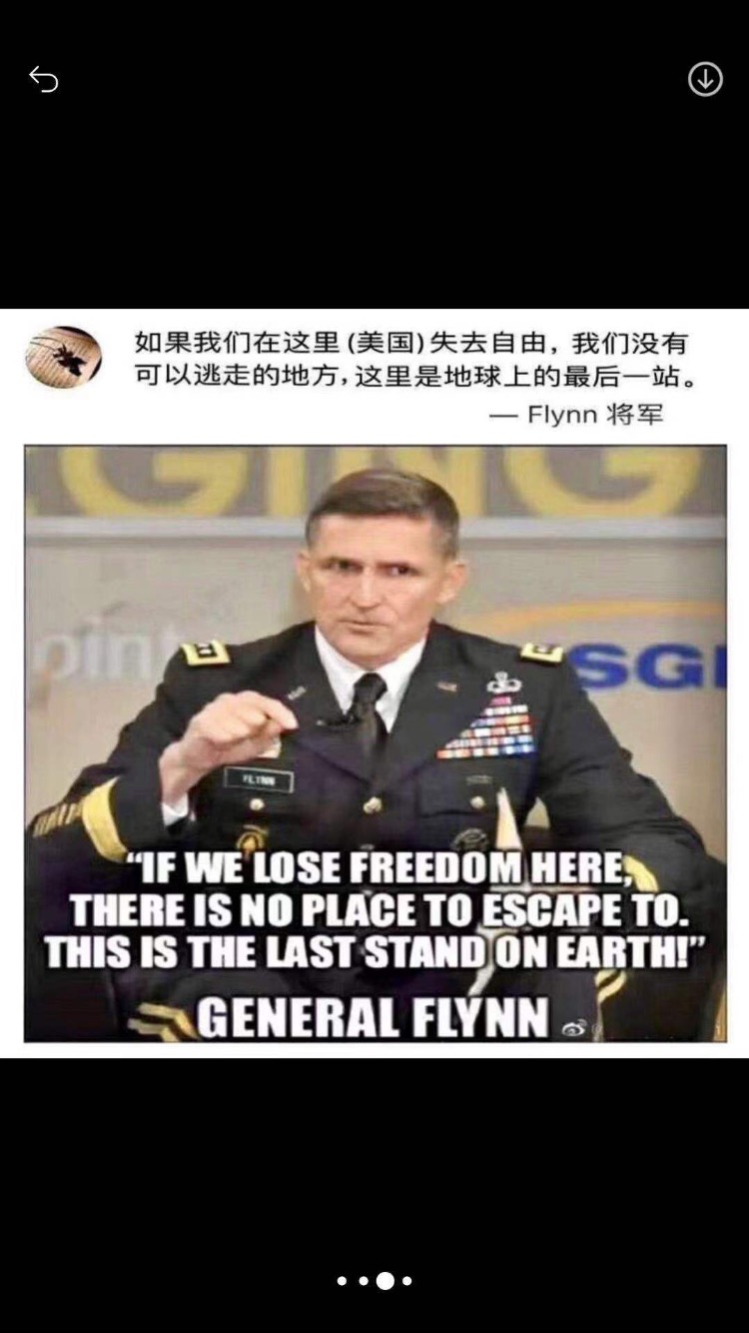

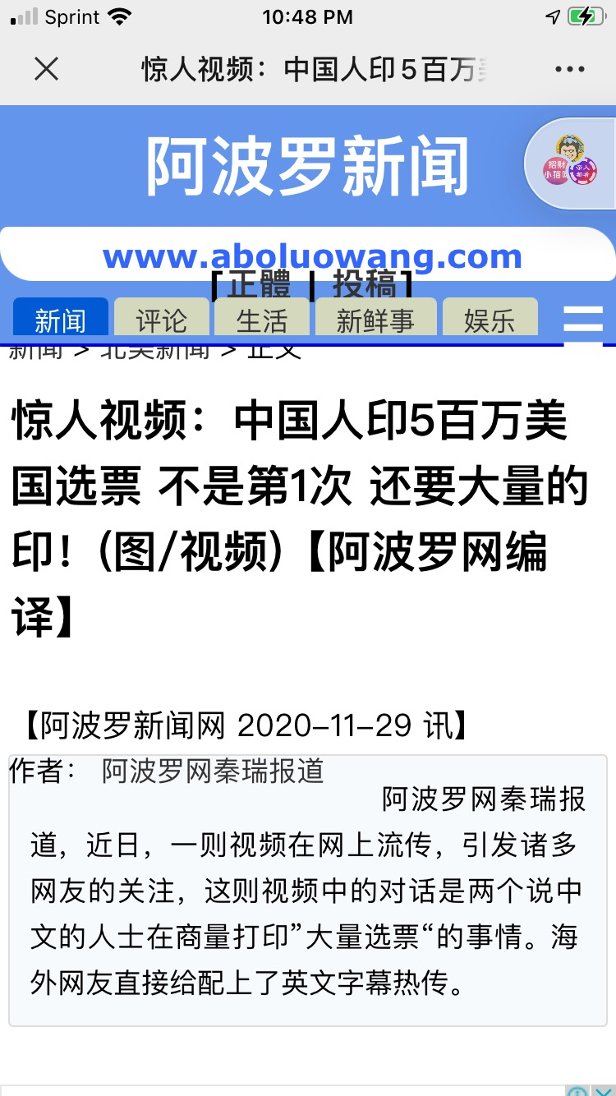
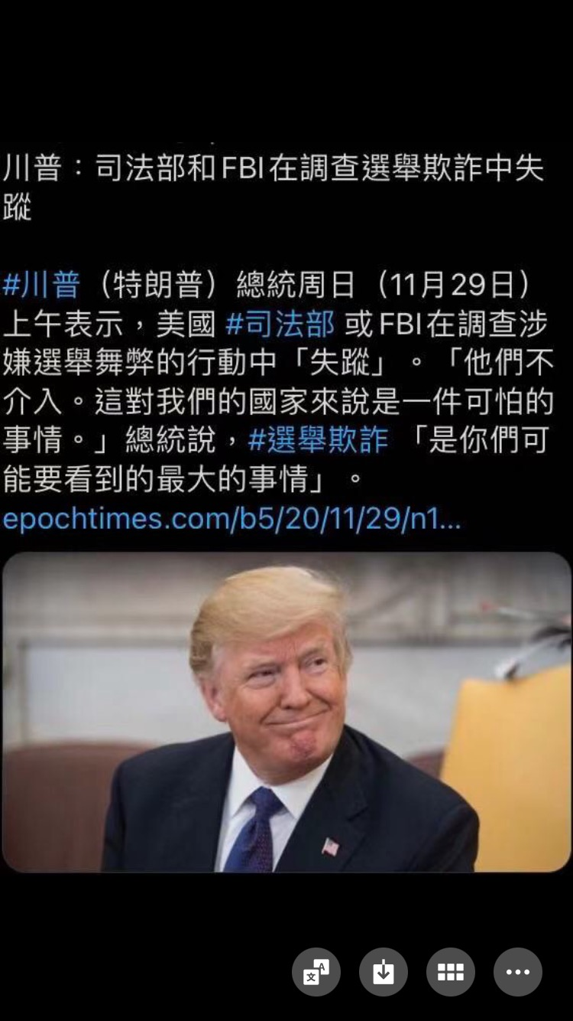
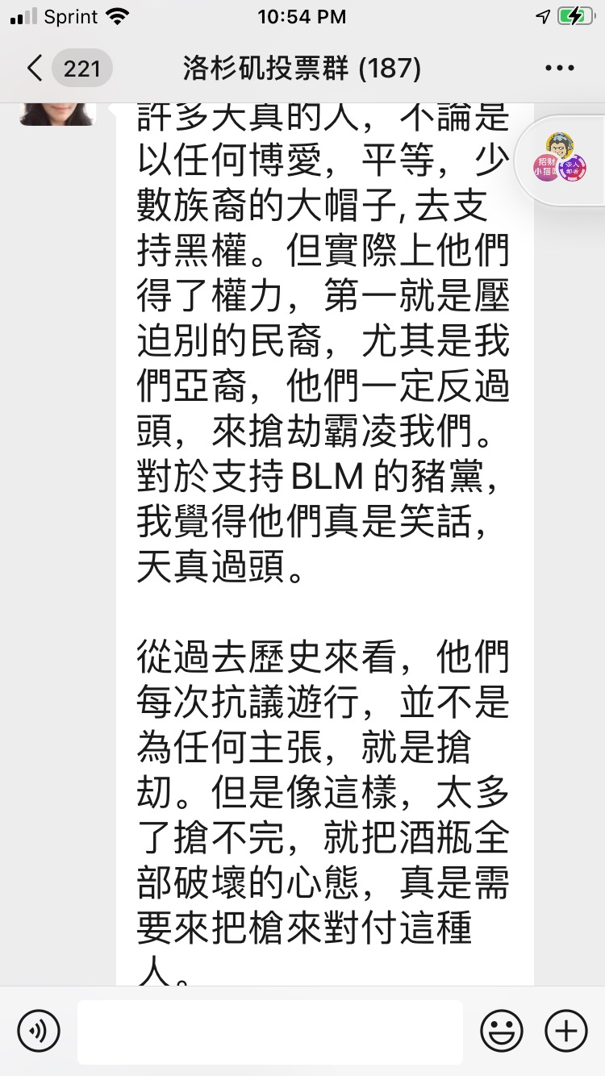

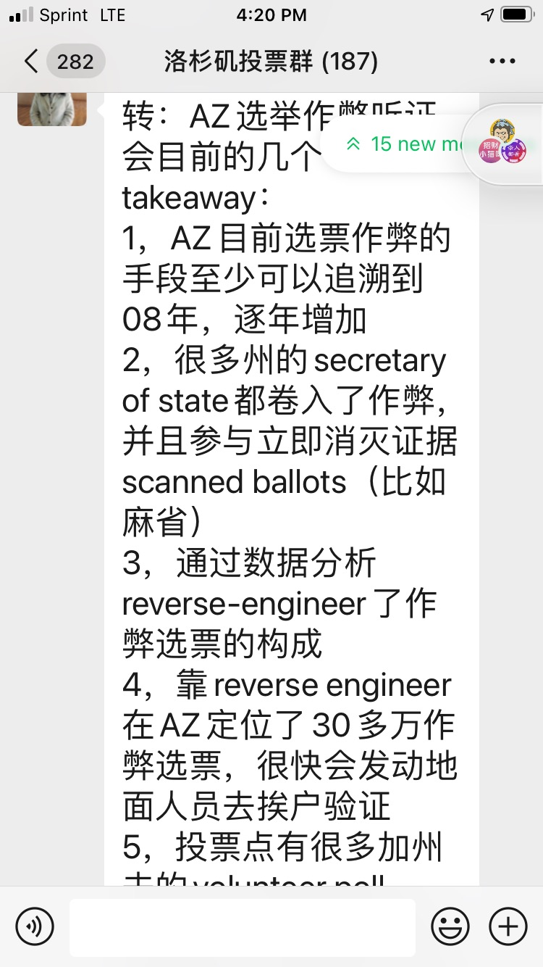
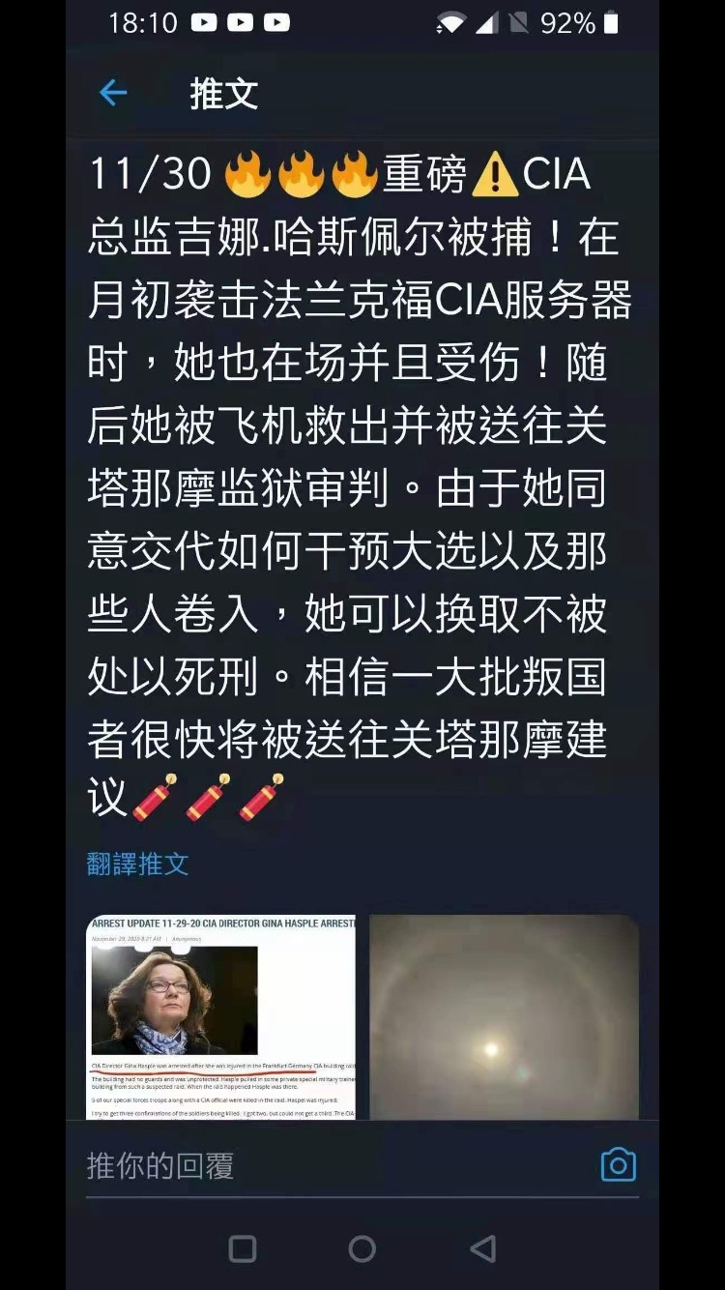
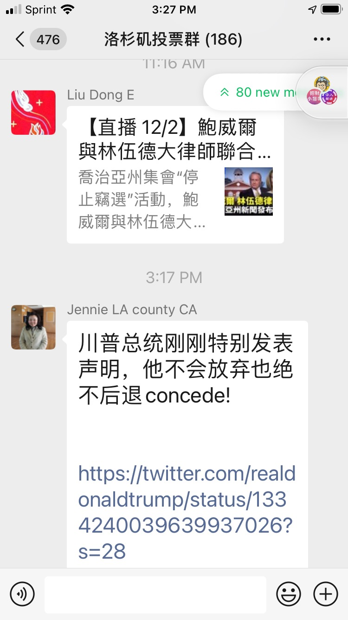
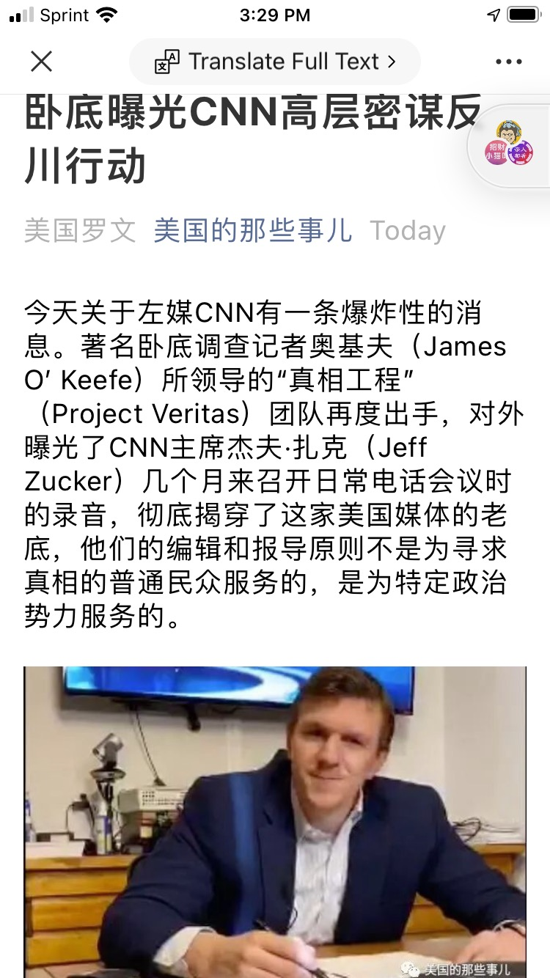
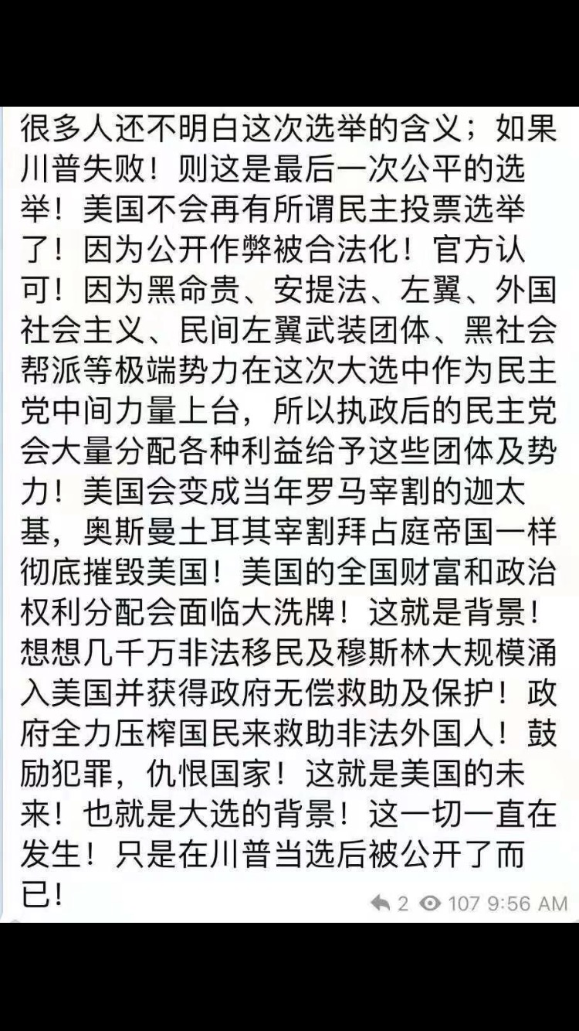

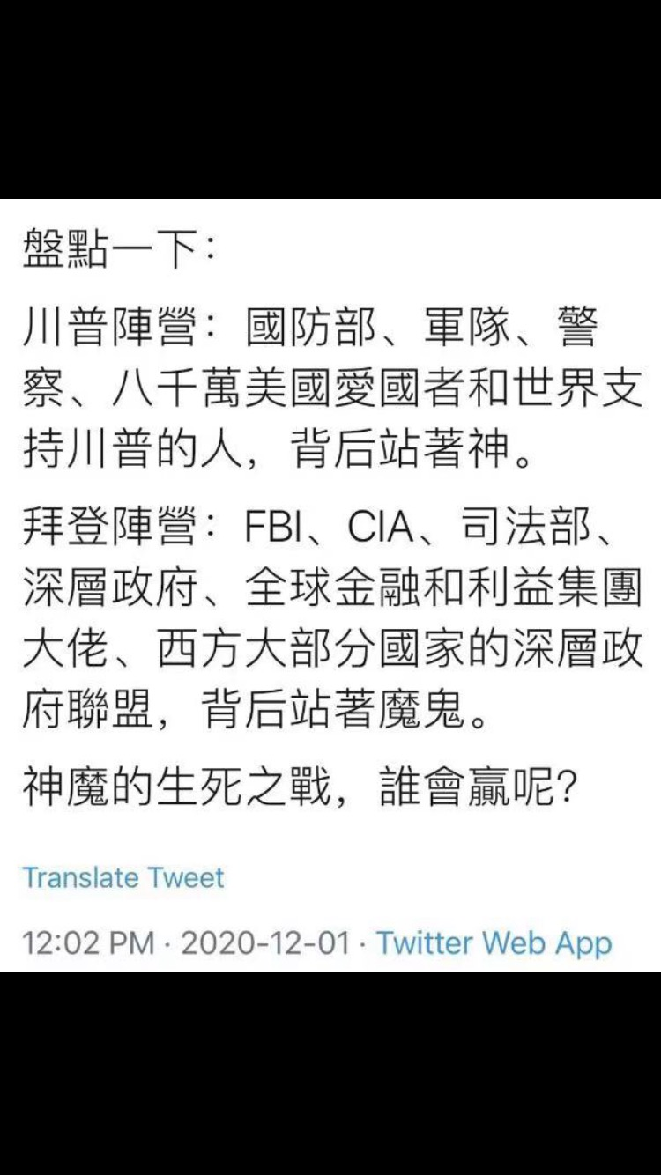
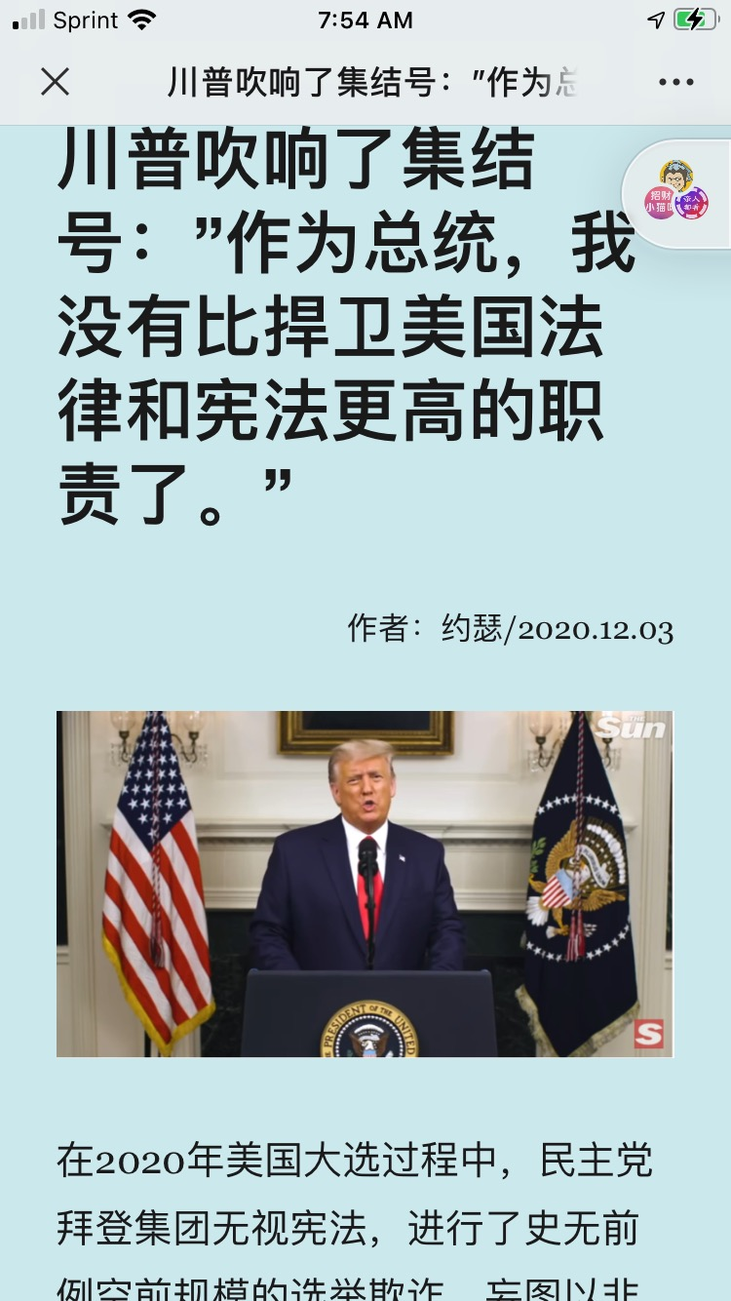
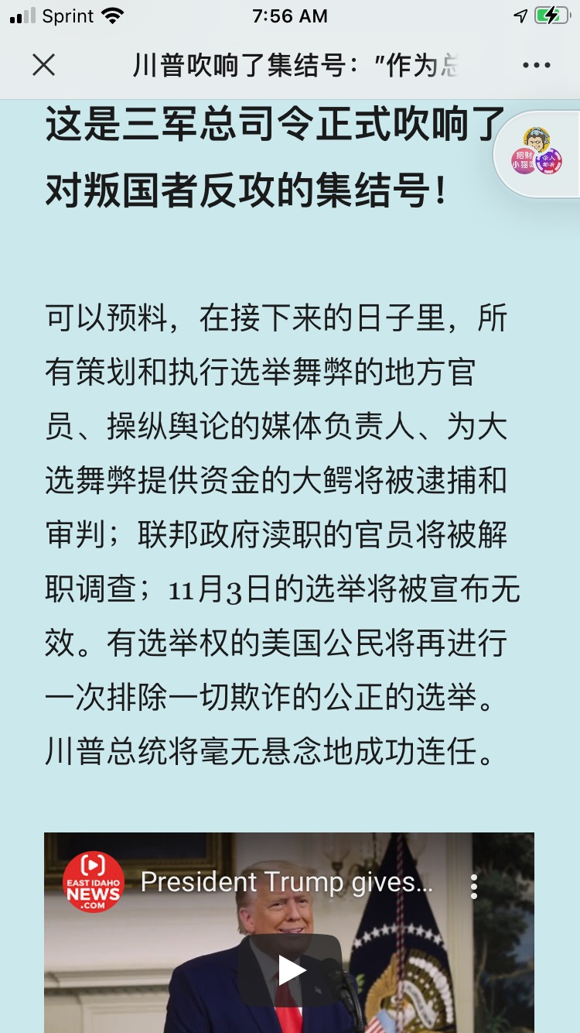
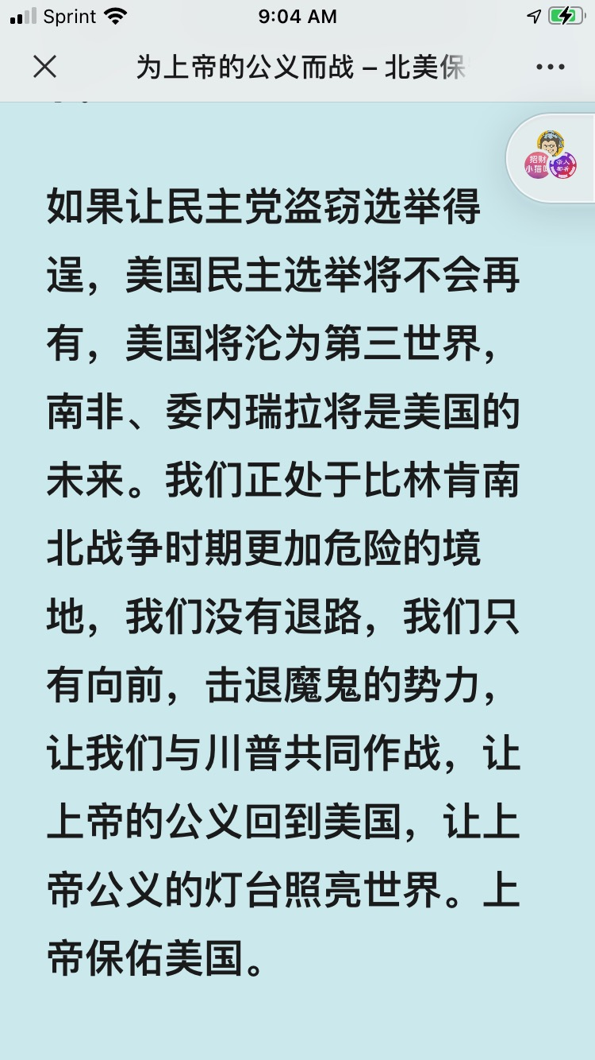
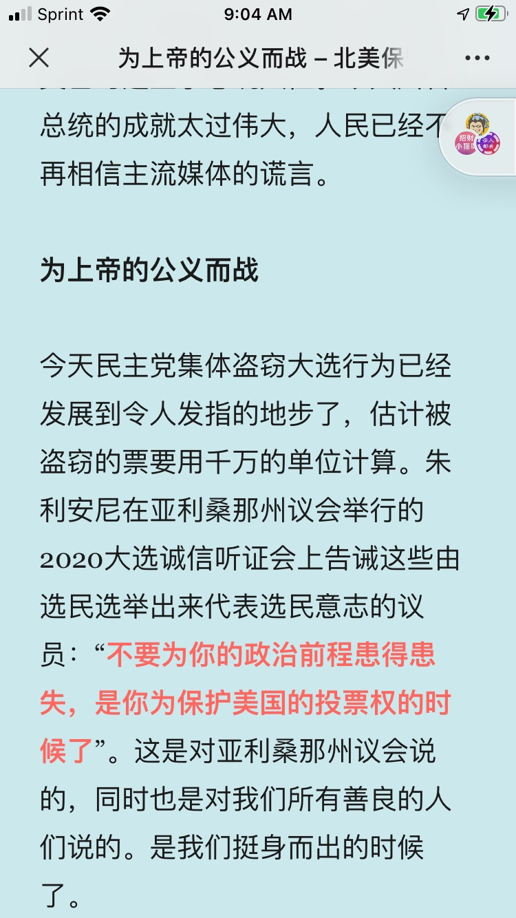
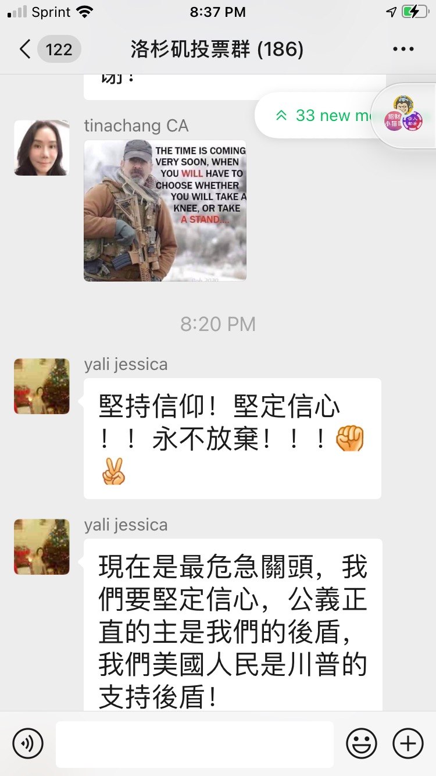
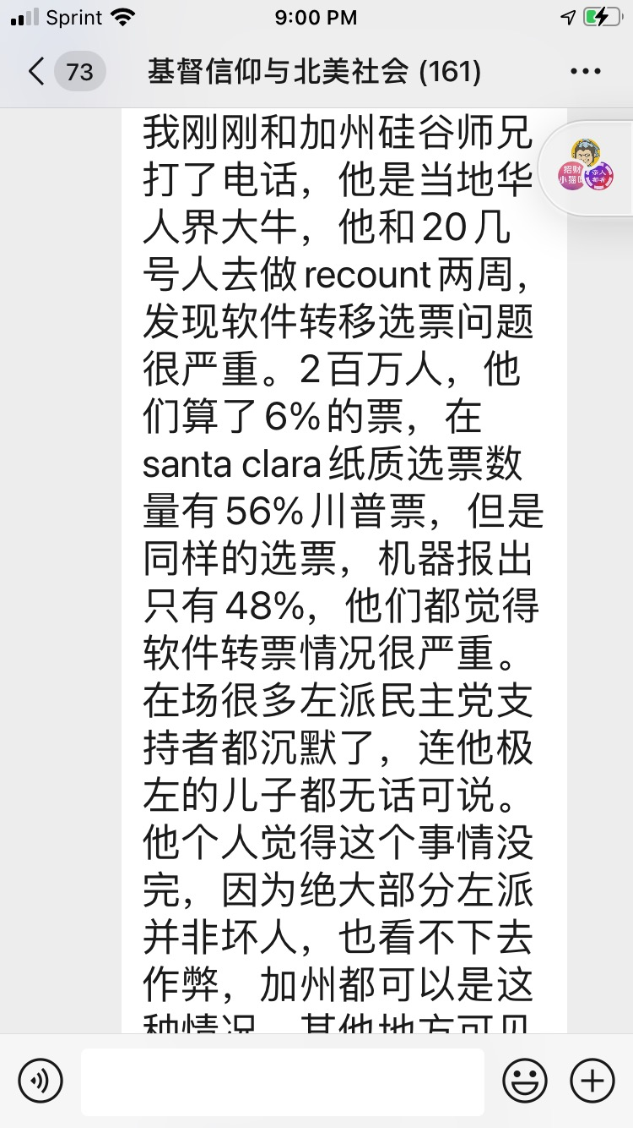
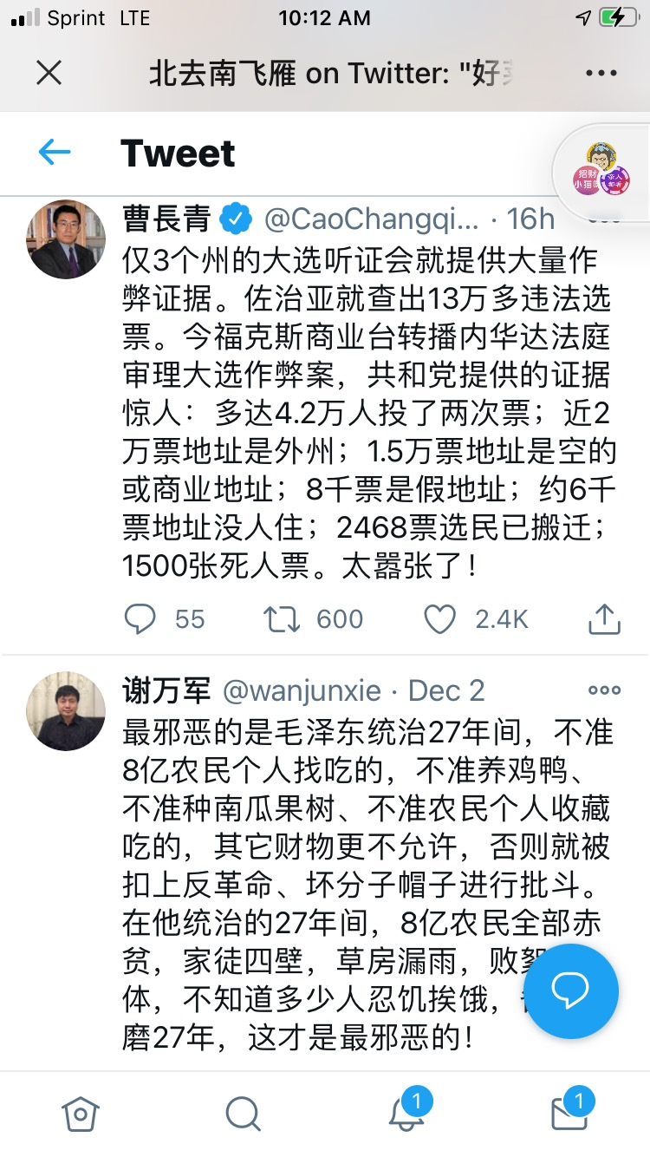

-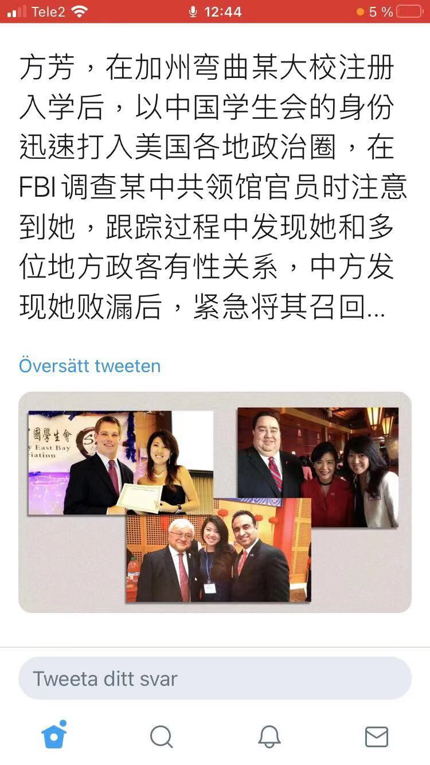
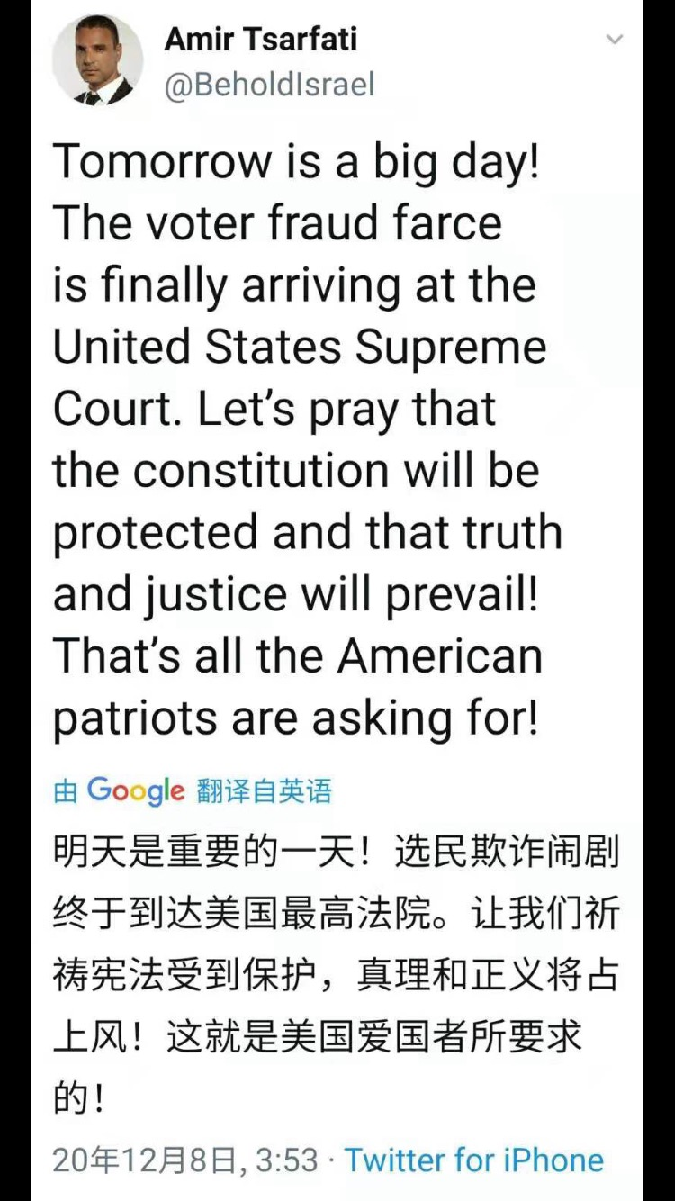

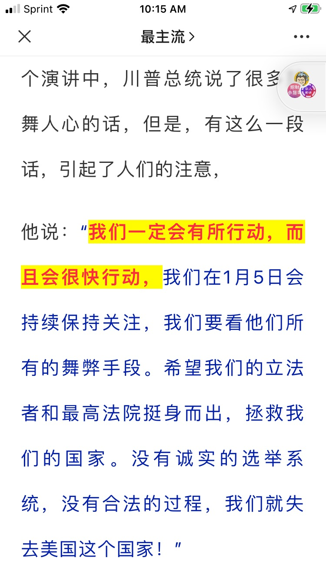

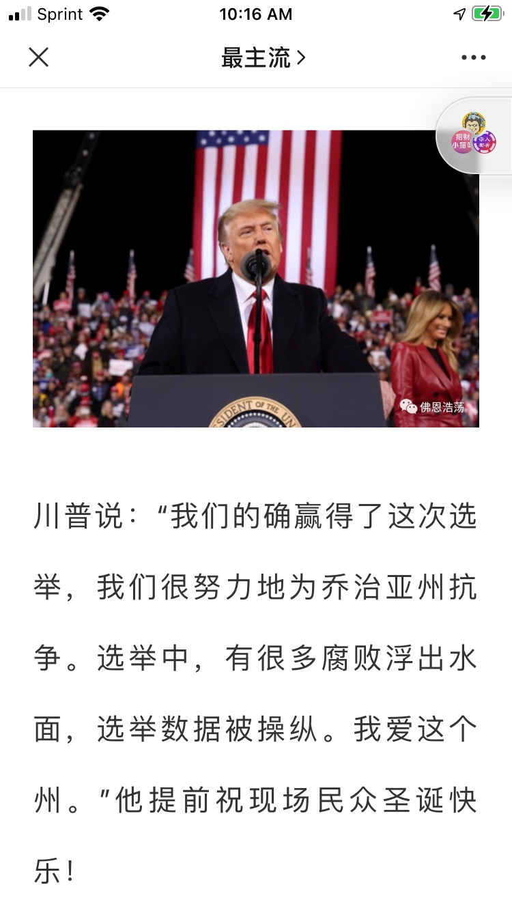
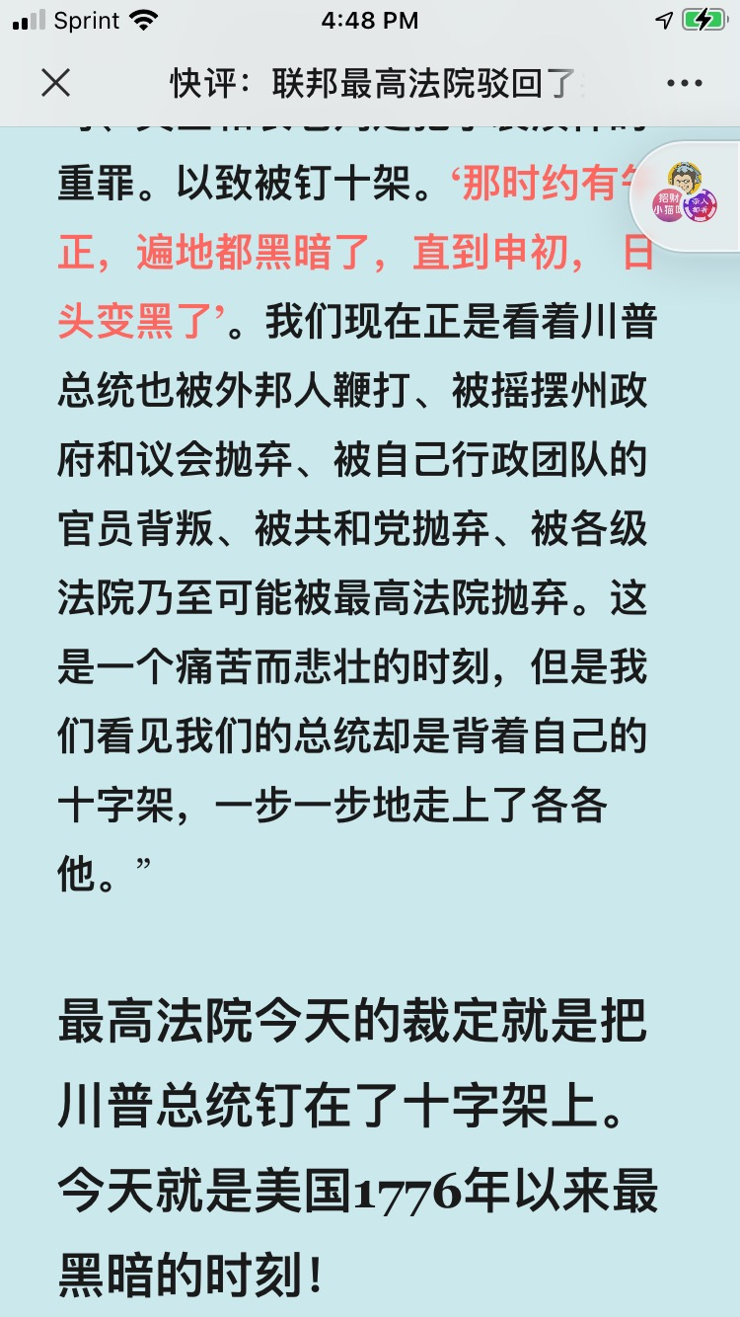

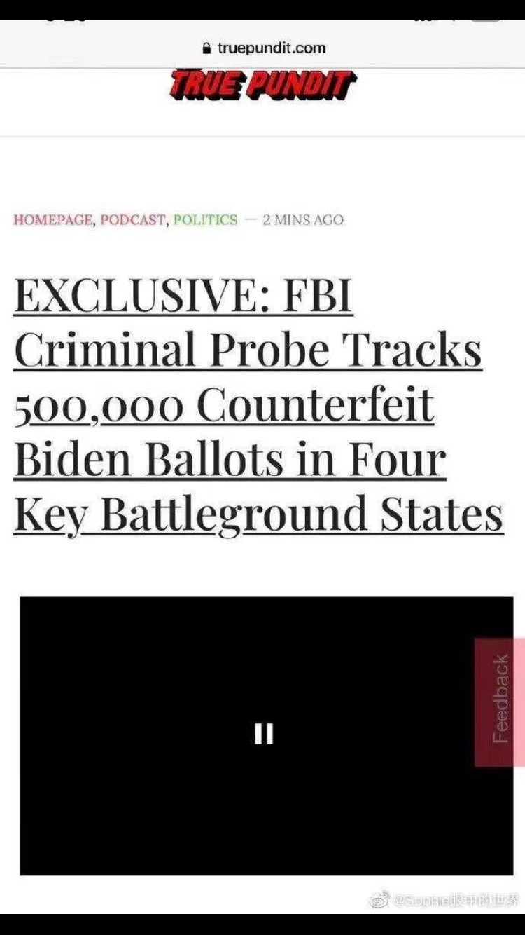
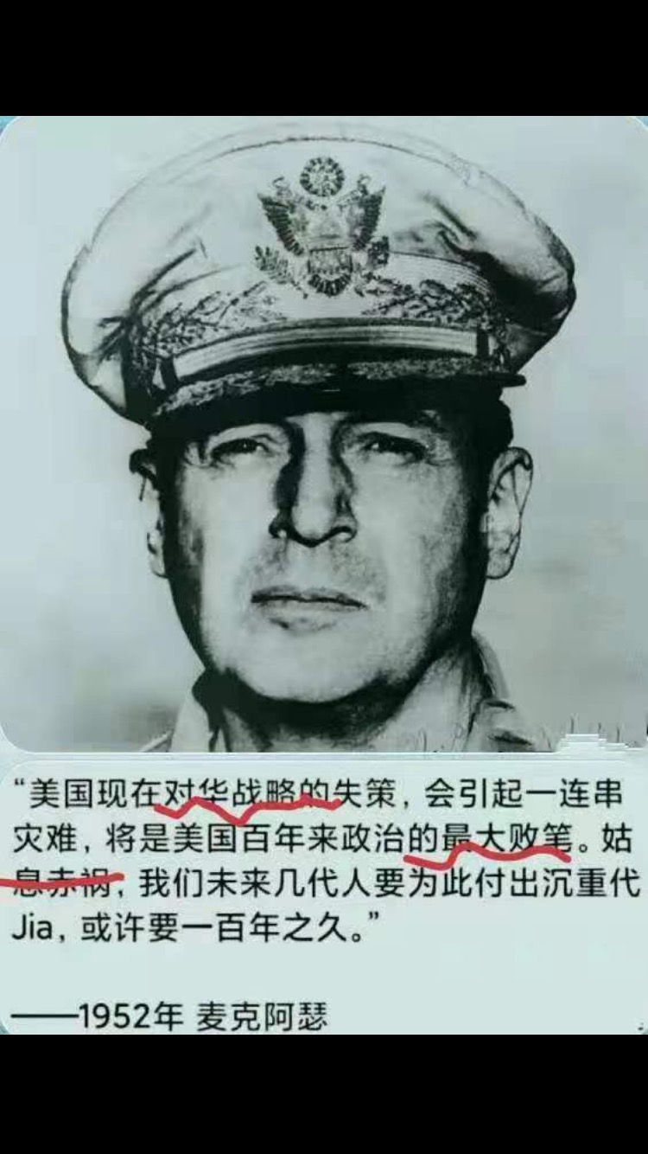
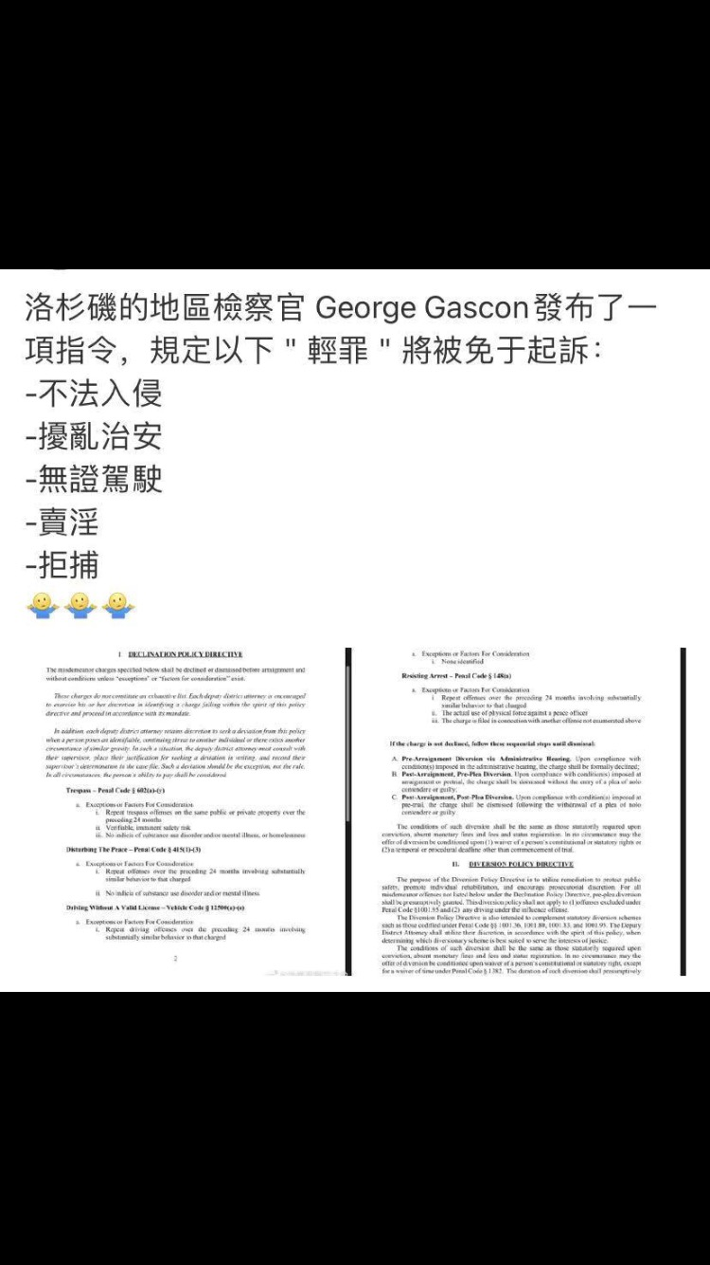
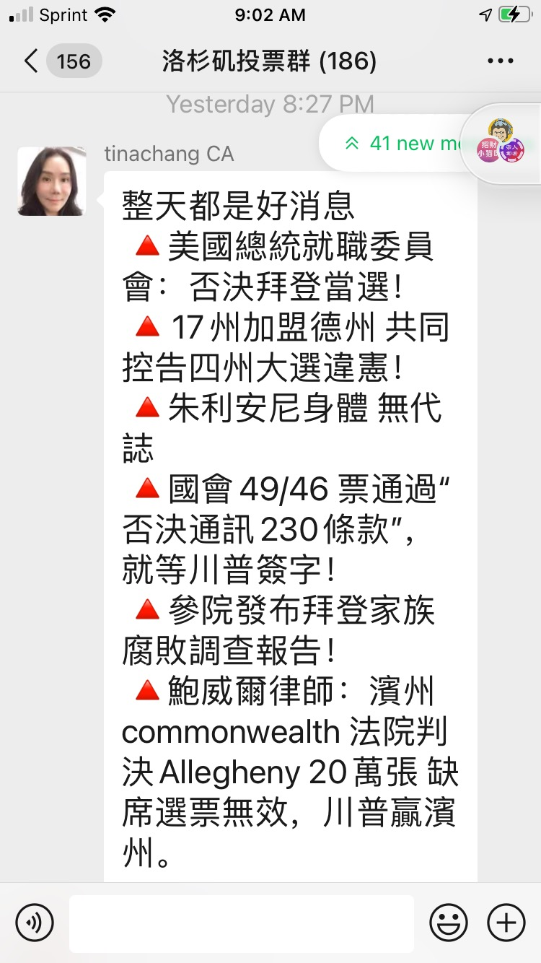
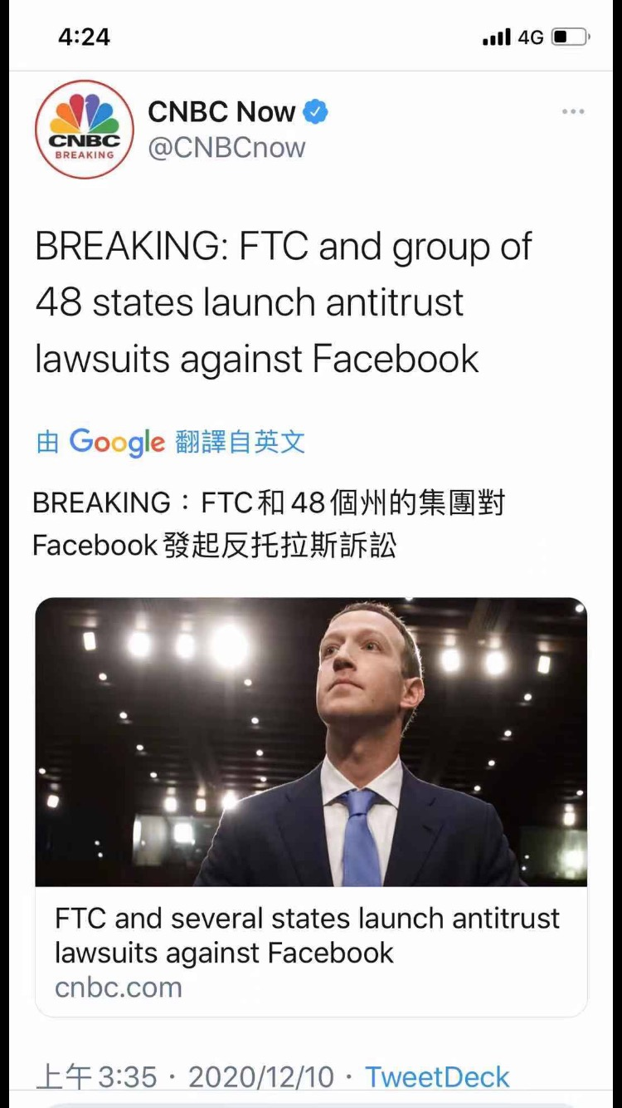

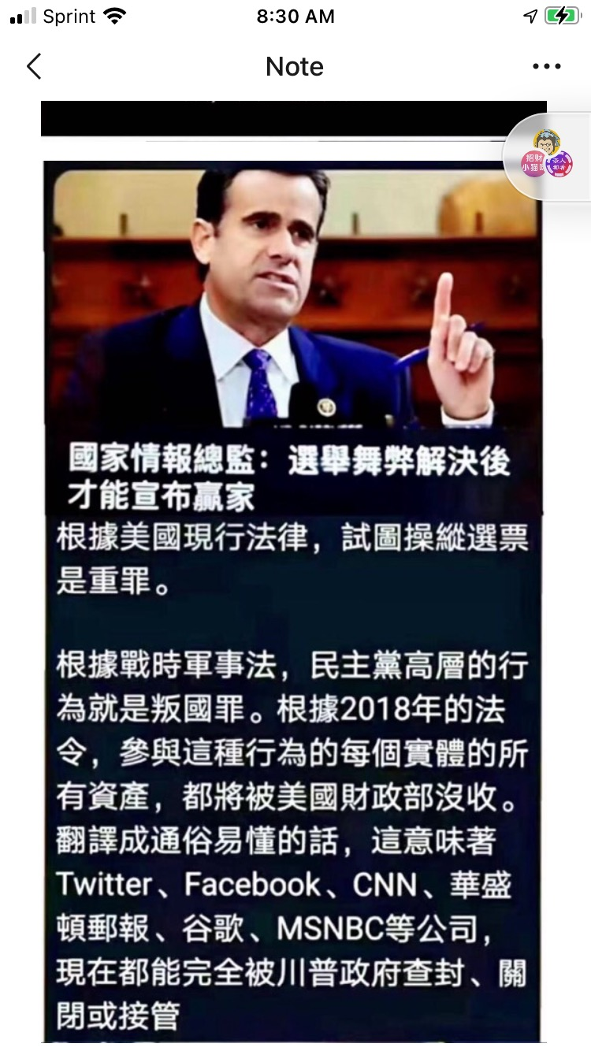

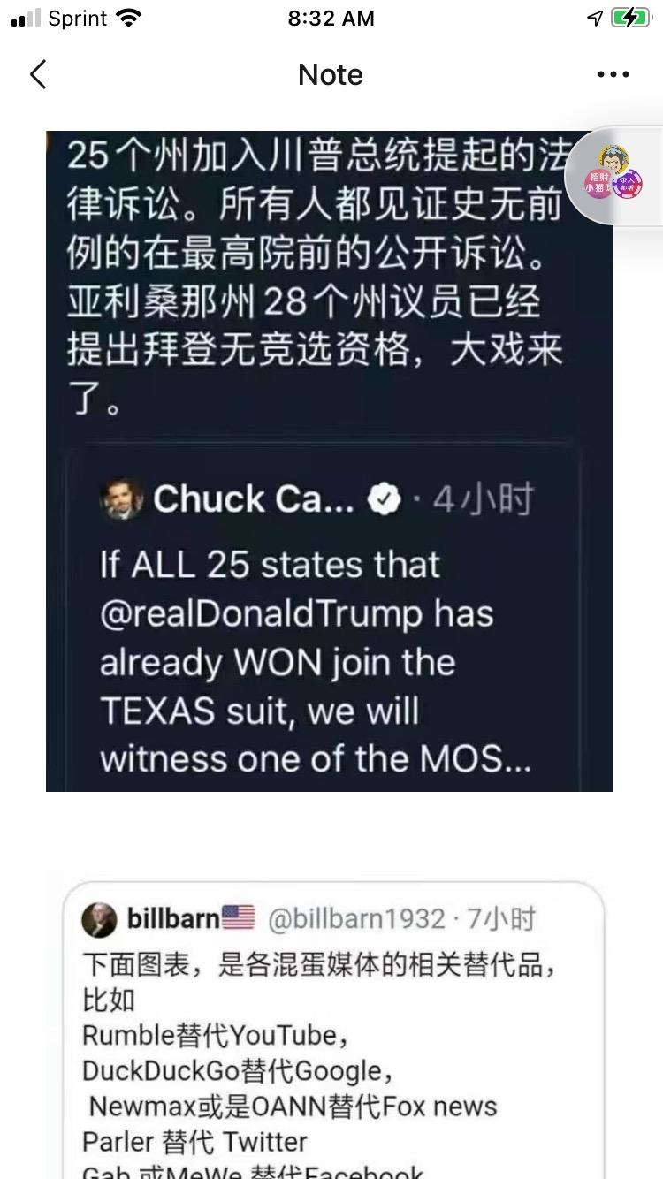
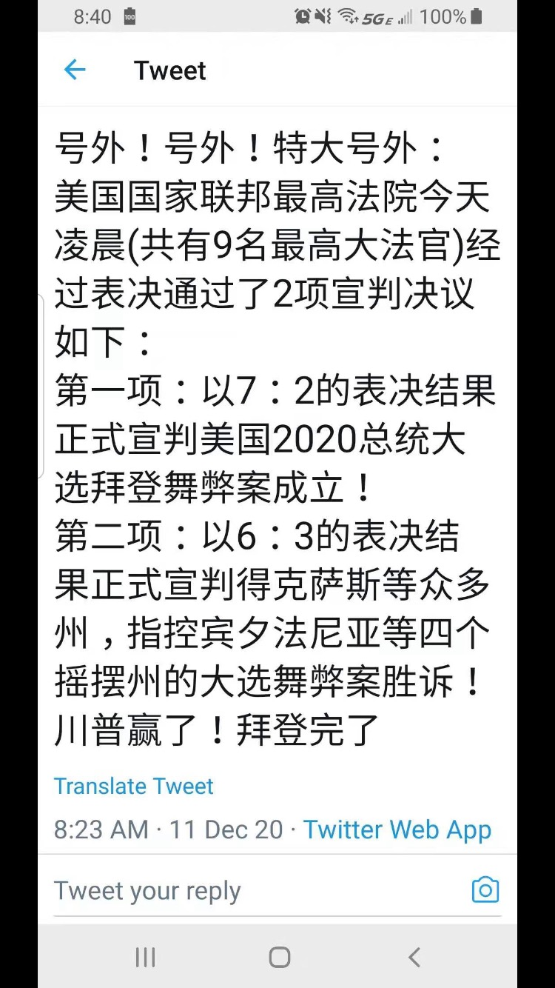
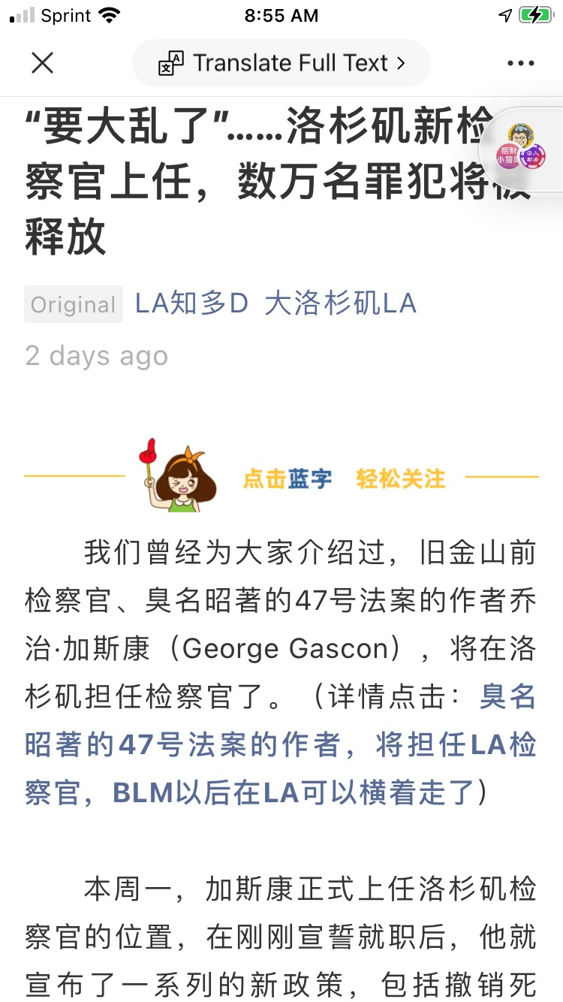

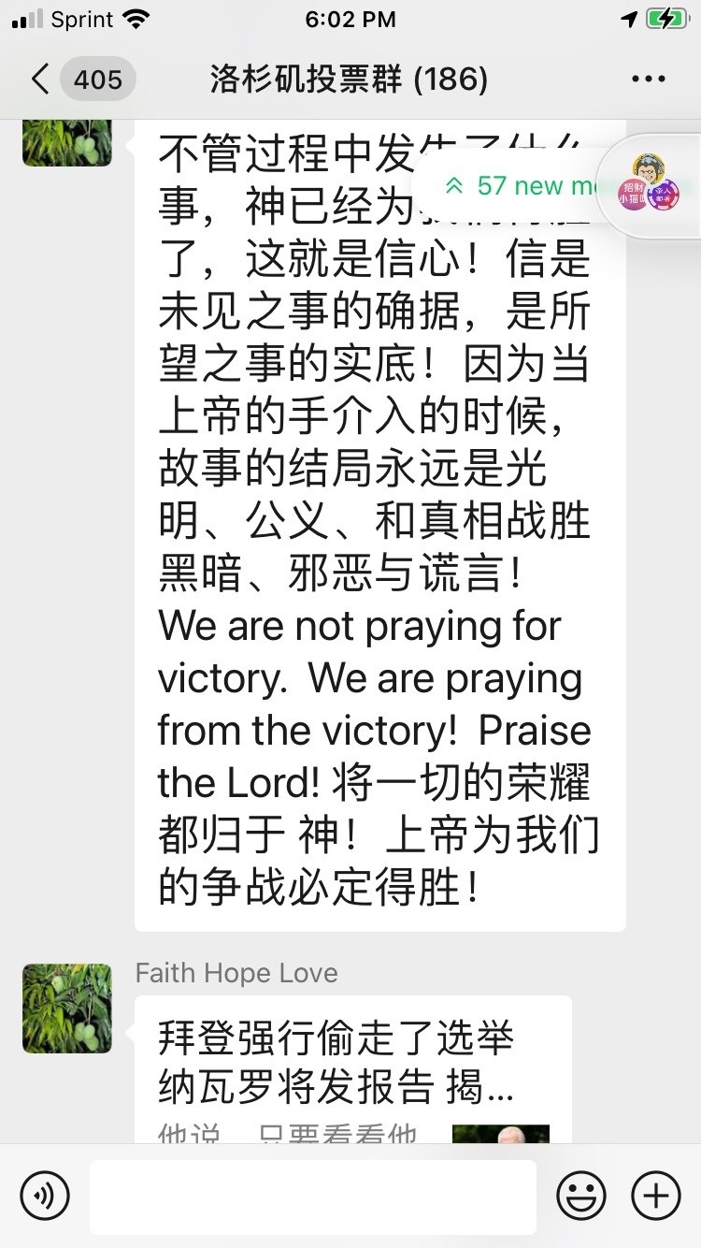
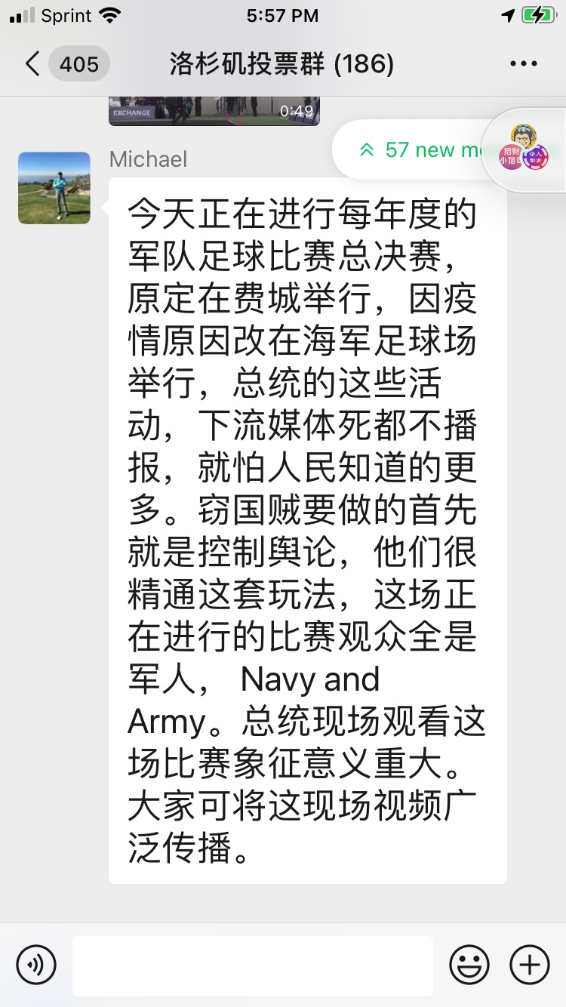


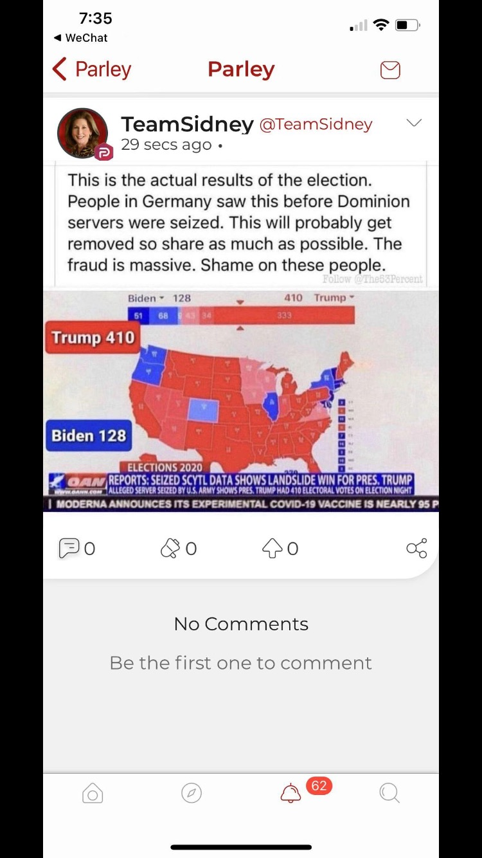
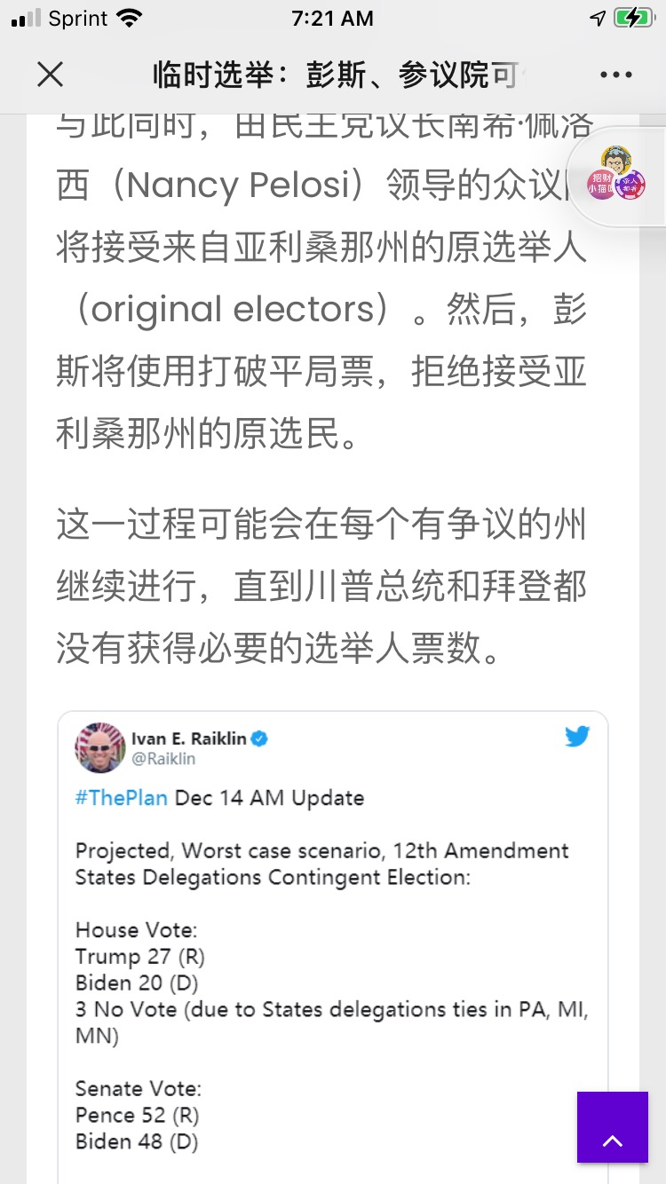

---------------------------------------------------------------------------------------------------------------------------------------

The Sermons from Science for February 2021 contains 15 presentations as follows:

You may choose any of the following to play. Copy the url link:
http://christcentergospel.org/SermonsFromSciencePowerPointSlides.htm
to your browser such as Google Chrome, Firefox, Opera, Explorer, Safari, or Microsoft Edge, and paste the link on the command line.
Select the PowerPoint or the video you want to download. It will take about 30 seconds to 1 minute or more to download a video depending on the speed of your internet provider.

1. Glacial-like striations formed in less than 90 seconds
在不到90秒的时间内形成类似冰川的条纹. 11 minutes 36" in length.

2. What is the meaning of dropstones in the rock record?
岩石层中的下落石是什么意思？. 15 minutes 58" in length.

3. Kelp could have produced abundant dropstones during the Flood
海带在洪水期间可能产生了大量的下落石. 6 minutes 04" in length.

4. Long-distance boulder deposits reveal Noah’s Flood -1
长途巨石堆积物揭示了诺亚的洪水 -1. 8 minutes 34" in length.

5. Long-distance boulder deposits reveal Noah’s Flood -2
长途巨石堆积物揭示了诺亚的洪水 -2. 9 minutes 35" in length.

6. At least some ‘tillites’ may be impact debris
至少有些“陶土”可能是撞击碎片. 14 minutes 24" in length.

7. Flat land surfaces are strong evidence for the Genesis Flood
平坦的地面是发生洪水的有力证据. 12 minutes 45” in length.

8. A classic tillite reclassified as a submarine debris flow
经典的陨石重分类为海底泥石流. 5 minutes 06" in length.

9. The first discovered Cretaceous glacial deposit
第一个发现的白垩纪冰川沉积. 11 minutes 58" in length.

10. Giant Submarine Landslides
巨型海底滑坡. 12 minutes 10" in length.

11. The Late Ordovician striated pavement in North Africa
北非晚奥陶纪横纹路面 10 minutes 53" in length.

12. ‘Gastroliths’ deposited by mass flow
大量流沉积的“胃结石. 10 minutes 04" in length.

13. Eolian erosion exposé
暴露风侵蚀. 15 minutes 28" in length.

14. Many arches and natural bridges likely from the Flood
洪水可能造成许多拱门和天然桥梁 19 minutes 52" in length.

15. Rapid cave formation by sulfuric acid dissolution
通过硫酸溶解快速形成洞穴. 8 minutes 35" in length.

The PowerPoint slides can be downloaded from the website http://christcentergospel.org/SermonsFromSciencePowerPointSlides.htm

It contains 204 slides. From 2011, we have accumulated 1741 short programs accessible in the previous link on the Christ Center Gospel website. The url link is

http://christcentergospel.org/SermonsFromScienceVIDEO-Feb2021.htm

Copy this link and paste it on the command line.

May God bless you and your family.
Pastor Chui

